Supplemental Stories
for pesach 5781
15 - 22 Nissan 5781/ March 28-April 4, 2021
Printed L’illuy nishmas Nechama bas R’ Noach, a”h

For a free subscription, please forward your request to keren18@juno.com

A Voice from the Warsaw Ghetto: The Life of
Cantor Gershon Sirota
By David Olivestone

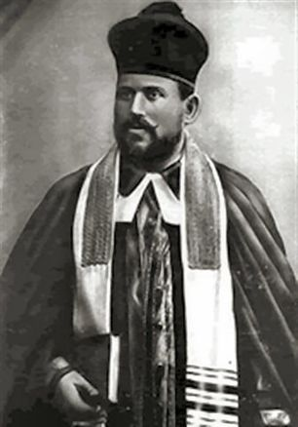

In the summer of 1939, on the eve of World War II, the world-famous cantor Gershon Sirota could look back on a glittering career spanning nearly four decades. He had sung before audiences of thousands all over the world, earning huge fees for his concert appearances and even for his synagogue services. But in December 1942, a few months before he perished during the Warsaw Ghetto Uprising, the Ringelblum ghetto archives tell us that he had to turn to a self-help committee for a hand-out, and was given 200 zlotys to buy food for his family.
Sirota was just one out of approximately 13,000 Jews who were killed in the uprising, which began 75 years ago, on April 19, 1943, and was finally put down four weeks later on May 16. About half of the victims were burned alive or suffocated as German troops torched their hiding places, while the rest perished in the fighting or soon after. The remaining 56,000 Jews were transported to Treblinka or other death camps as the ghetto was systematically emptied and its buildings destroyed.
The summer of 1942 had seen the deportation of some 300,000 Jews from the ghetto. There was little doubt in the minds of those who remained about their terrible fate. A group of young people, led by 23-yearold Mordechai Anielewicz, decided to resist the next round-up and managed to convince members of the Polish resistance on the other side of the ghetto walls to smuggle in some weapons. In January 1943, when German troops arrived to round up more Jews for transport to the camps, they found themselves fired upon and had to retreat.
On April 19, when German troops again entered the ghetto, they came under fierce attack. Using all kinds of real and improvised weapons, the ghetto fighters continued to resist, and it took nearly a month for the greatly superior force of the Germans to overcome them. As David Kopel wrote in The Washington Post, “The Germans had to spend more time subduing the Warsaw Ghetto than they did conquering the entire nations of Poland or France.”
Ironically, and sadly, it was not inevitable that Sirota should be trapped in the Warsaw ghetto during its last tragic days. He had been abroad on a concert tour when he received word that his wife was very ill. He rushed back to Warsaw and was there when the war broke out. Although he himself might still have been able to leave, he would not abandon his wife and family and so he was among the 400,000 Jews trapped in the ghetto when the Nazis sealed it in November 1940.
SIROTA WAS quite possibly the most gifted virtuoso hazan in history. He possessed a dramatic tenor voice of great beauty and immense power, with climactic top notes. He was a master of coloratura; his superb voice control enabled him to produce trills of exceptional length and to move up and down his wide range with effortless and consummate skill.
Inevitably, he was often compared to the leading operatic tenors of his day. Serious music critics would mention Caruso, or other great tenors, and “the cantor from Warsaw” in the same breath. Caruso is said to have once remarked how fortunate he was that Sirota, who received many offers to sing in opera, chose to stay in the synagogue.
Writing in The Record Collector, music critic Arthur E. Knight proclaimed Sirota “one of the most highly trained tenors of all time.” Reviewing his rendition of “Veshamru,” he writes that on this record Sirota “does everything that is possible in the human voice... and is unrivaled by any other recording tenor.”

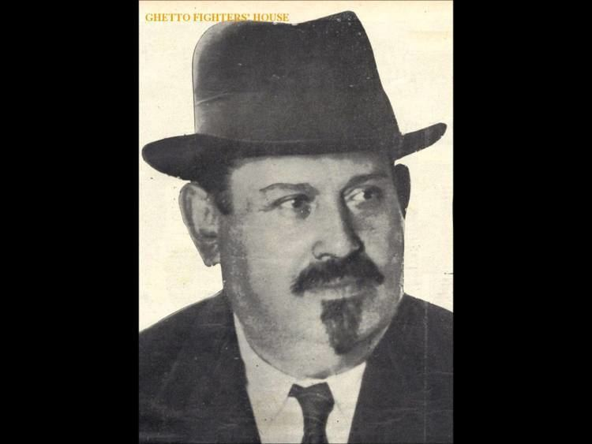
The great hazon and choirmaster Gershon Sirota, hy’d

It was not only because of his magnificent voice that he excelled as a cantor. Although he himself never composed, he was a master of improvisation, always remaining faithful to the appropriate steiger (musical theme). His congregants were often deeply moved by the emotional intensity of his rendering of the liturgy.
Born probably in 1874 in Podolia in Western Ukraine, Sirota was a cantor’s son. His extraordinary talent was recognized at an early age, and when his father took a position in Odessa the young Gershon was able to experience and learn from the many cantors in that city.
He became a synagogue chorister, much in demand, and was offered a scholarship at the Odessa Conservatory of Music, where he studied for a time. When he turned 18, he was married and became the cantor of a suburban Odessa congregation. He continued his musical studies at the Vienna Conservatory but had to return to Odessa when his father became deathly ill.
When he was only 21, with his reputation rapidly spreading, he was chosen to become the cantor of the enormous Vilna Synagogue, a prestigious position that had been filled by famous cantors before him. He remained in Vilna for nine productive years, and it was there that he formed a partnership with the talented choirmaster Leo Leow, whose energy and creativity impacted Sirota’s career for much of his life.
It was through Leow’s initiative that in 1902 Sirota began to give concerts outside the synagogue, of both Jewish and secular music, an innovation that was not without its critics, but which were a resounding success.
When local officials and members of the nobility began to attend them, word of his amazing vocal artistry soon filtered upwards and he was invited to sing for the Czar, an engagement that became an annual event.
In 1903, Sirota may have become the first cantor to record phonograph records. By this means, Jews around the world – and gentiles – became familiar with his voice and his abilities. In 1905, at age 31, he was chosen to become the Oberkantor (chief cantor) of Europe’s most prestigious synagogue, the Great Synagogue of Warsaw.
Known also as the Chorshul, but seemingly referred to most often simply as the Tlomackie Street Synagogue, it had seating for upward of 2,000 and its services were attended by the most prosperous elite of Warsaw Jewry. When it was dedicated in 1878, it symbolized the culmination of more than 1,000 years of vibrant Jewish life in Poland.
Designed by the eminent architect Leandro Marconi, the graceful building, with its colonnaded portico and two large candelabra flanking its entrance, was located near the edge of what was later to become the ghetto.
Although officially Orthodox by denomination, the palatial synagogue was attended, in the main, by assimilated Jews who flocked to hear the magnificent musical services offered by Sirota, assisted by a 100-strong male choir led first by David Aisenstadt and later by Leow. The synagogue even had an organ, but it was used only for weddings.
Aisenstadt once led a visitor, Issachar Fater, into the synagogue where, unseen, they observed Sirota vocalizing.
“For a moment it seemed that the entire synagogue had been ensnared in a clap of thunder,” wrote Fater.
“As suddenly as it had erupted, the storm subsided. In its place came a stream of soft soul-searching pathos; delicate falsetto... piano tones stringing out like pearls.”
Another eyewitness recounts that on Rosh Hashana, during the section of the musaf prayer beginning with “Ata Nigleita,” which describes the awesome scene at the giving of the Ten Commandments on Mount Sinai, Sirota “went into such a fire-like state that worshipers began to tremble with fear.” Writing of this same moment in the service, Pinchas Szirman recalls that when Sirota reached the words kolot uvrakim (thunder and lightning), “...Leow used to instinctively duck his head in a reflex to miss the barrage of sound he knew was coming.”
GENEROUS BY nature, Sirota never abused his status as Oberkantor, always cooperating to the full with his choirmaster. But so great was his stamina and so powerful and dramatic was his singing, that he was sometimes accused of overly embellishing the prayers.
(One wit remarked that Sirota’s style should not be described as “bel canto,” but rather “can belto.”) Yet Szirman, who became the assistant cantor at the Tlomackie synagogue in 1910, writes, “Thanks to him, I had the occasion of hearing true Jewish cantorial art, not just acrobatic showmanship.”
With Leow at his side, Sirota began to accept concert engagements throughout Europe and America. Event after event – at New York’s Carnegie Hall or the Metropolitan Opera House, and at London’s Royal Albert Hall among them – was sold out and enthusiastically received.
He traveled extensively, much to the growing annoyance of the trustees of his synagogue in Warsaw. Each time he came back, he relied on his huge popularity among the congregants and sheepishly begged forgiveness, but eventually his absences became too frequent and too long to overlook, and in 1927 another great cantor, Moshe Koussevitzky, was appointed in his stead.
Now a free agent, Sirota continued concertizing and conducting services around the world, including the initial service at the still-unfinished Great Synagogue in Tel Aviv in 1928, and Rosh Hashana services held at the Mograbi Theater there in 1935, together with Leow and a choir.
Perhaps tired of not having a synagogue he could call his own, he later took the position of chief cantor at the Nozyk synagogue, which was the only synagogue building in Warsaw left standing after the war. Still, this did not impede his traveling far and wide to satisfy the demands of audiences worldwide to hear him.
But he always returned home to his family in Warsaw and was the only one of Europe’s great cantors of that era not to eventually accept a position in the US.
Thus it was that when the fateful telegram arrived telling him of his wife’s illness, it was to Warsaw that he hurried home.
The uprising When the ghetto gates snapped shut, there was no escape. According to cantor Samuel Vigoda, in his book Legendary Voices, Sirota “succeeded in sending off pleas for help” to his American concert managers, to Leow, and to others, desperately seeking affidavits for him and his family members so that they could obtain American visas, but it was to no avail.
Inside the ghetto, the Jews attempted to maintain as much normalcy as was possible under the harsh and oppressive conditions. Among the many cultural activities, there were five professional theater companies, both Yiddish- and Polish-speaking, and a symphony orchestra, and numerous concerts and informal musical events were held. Sirota, too, gave concerts, some in the Tlomackie synagogue building, consisting both of liturgical pieces and operatic arias.
He also led services.
In his diary entry for September 21, 1942, Hillel Seidman, who was transferred out of the ghetto before the uprising began, relates how the Jews were able to pray on Yom Kippur despite the fact that they were forced to work on that day. In one workshop, says Seidman, Sirota conducted the service. Even if his voice had diminished with his advancing age, on this occasion there was no holding him back. The gabbaim tried to get him to lower his mighty voice to prevent the Germans from hearing them, but he was too rapt in the prayers to take heed.
In order to protect Sirota from being drafted for a forced work assignment, he was given a uniform by one of the semi-official Jewish organizations. According to Jonas Turkow, in his book Azoy Iz Es Geven (This Is How It Was), “The heart hurt as one looked at the aging world-honored hazan Gershon Sirota, masquerading in order to protect himself from the danger of being captured by the Germans.”
In the spring of 1943, as secret preparations were under way to launch the uprising, the Sirota family was hiding in a bunker at 6 Wolynska Street. Miriam Preiss-Feigenbaum arrived at that bunker on April 19, the eve of Passover, the day the uprising began. In testimony she gave to Yad Vashem, she relates how she wanted to spend the festival with the Sirotas. This resourceful woman even brought along a chicken that she had obtained from a friend outside the ghetto for the Seder meal. The friend threw it over the wall at a prearranged location where the Jewish policeman on guard was open to taking bribes to look the other way.
According to Preiss-Feigenbaum, Sirota’s wife had already died a month earlier, apparently from natural causes. But still with him in the bunker were one of his sons, a daughter-in-law, and two grandchildren, as well as his single daughter and two or three other individuals.
She confirms that Sirota and his daughter had returned to Warsaw immediately before the outbreak of the war. She herself stayed in that bunker for only three days before moving to another location. Captured and sent to Majdanek, and from there to other camps before ending up in Bergen-Belsen, Miriam Preiss- Feigenbaum “adopted” several orphaned girls and helped them survive before she was eventually liberated and made her way to Israel, to live out her days in Ramat Gan. But she was aware that Sirota and most of the others at 6 Wolynska Street perished there when the bunker was torched soon after she left, on April 27, the last day of Passover.
In his journal entry for April 27, the infamous General Jürgen Stroop, sent by Himmler to suppress the rebellious ghetto, notes that “Today, a total of 2,560 Jews were apprehended in the former Jewish quarter and 547 of them shot. An undetermined number of Jews perished, as usual, in the fires or when the bunkers were blown up.”
Among the “undetermined number of Jews” on that day were Sirota and his family.
Stroop was ruthless and utterly cruel. He gave instructions that the ghetto was to be emptied and its buildings razed, and did not rest until his goal had been achieved.
When it was all over, he had killed the great cantor and all the heroic Jews who had dared stand up to him.
Now, on May 16, as a grand gesture of victory over the Jewish revolt, he blew up Sirota’s beloved Great Synagogue on Tlomackie Street.
Prior to his own execution for war crimes in 1952, Stroop took obvious delight in describing the scene to an interviewer.
“What a marvelous sight it was. A fantastic piece of theater. My staff and I stood at a distance. I held the electrical device that would detonate all the charges simultaneously... After prolonging the suspense for a moment, I shouted ‘Heil Hitler’ and pressed the button.
With a thunderous, deafening bang and a rainbow burst of colors, the fiery explosion soared toward the clouds, an unforgettable tribute to our triumph over the Jews. The Warsaw Ghetto was no more. The will of Adolf Hitler and Heinrich Himmler had been done. (Kazimierz Moczarski, Conversations with an Executioner, 1981.)
The will of the Nazi leaders may indeed have been done. But the voice of Gershon Sirota lives on through his many recordings, a magnificent voice that continues to inspire the Jewish people as it did in life until it was brutally cut off 75 years ago.
The writer, who formerly worked in publishing and print communications in England and the US, made aliya in 2013 to Jerusalem, where he continues to design and produce books. He is the author of the entries on Gershon Sirota and other cantors in the Encyclopaedia Judaica, and has published many articles on Jewish religious and cultural topics.

Reprinted from the June 23, 2018 website of The Jerusalem Post.
From Haifa to Reykjavik – Kohanim and Flying
By Rabbi Yirmiyahu Kaganoff

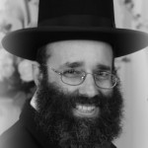

Parshas Emor teaches about the halachos prohibiting a kohen from becoming contaminated by contact to a corpse, a mitzvah that, as a kohen, I am privileged to observe. In the nearly 20 years since our aliyah, I have traveled to the US many times – generally combining business and pleasure by attending family simchahs and fundraising in the same week.
Since I now have two married children in the States, these visits have become more frequent, but they are also for the most part uneventful. That word cannot be used to describe my most recent trip to the East Coast, scheduled for two weeks after Sukkos.
The “fun” began on erev Sukkos, when my son forwarded me a news item that, due to runway repair construction at Ben Gurion Airport, all flights for 16 days in November would be flying over the Holon Cemetery and thereby pose a problem for kohanim.
Since I am a kohen, I quickly contacted several rabbanim I know who are in the loop on these matters. Each one answered that we were indeed facing a serious problem. I then e-mailed my travel agent and put the matter to rest until after Sukkos, confident that something would straighten out way before the situation became germane to me.
When I fly El Al out of the New York area, I usually travel via Newark Airport (EWR), since El Al does not carry cargo from EWR, thus avoiding any tumas meis issues as a kohen. My original booking had been a simple, round-trip flight from Tel Aviv to Newark.
The fare was very reasonable, there were no issues for kohanim, and the connection times were excellent. I planned to leave Wednesday night, attend a family chasuna in Lakewood on Thursday, and spend two Shabbosos with my children and grandchildren in the New York area. My wife was also planning to attend the wedding and be in the US at the same time, so we could also plan on spending some much-needed vacation time together.
As the old expression goes, man plans and G-d laughs. After Sukkos, I contacted the travel agent again. Runway repair work was still scheduled; the airport had not made any concessions for kohanim; some airlines were so nice as to offer to refund any tickets for flights during that time. But rescheduling the trip would mean missing the wedding and changing all of our vacation plans.

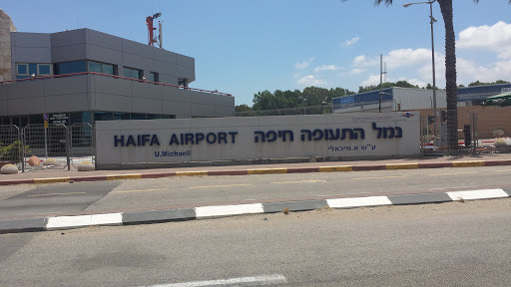

What other options did I have? And since my wife is not a kohen, her ticket was not refundable. I soon discovered that it was possible to fly out of Israel from Haifa, which has an international airport with daily flights to Cyprus on an airline called Tus. But when my travel agent attempted to find me a connection through Haifa, he could find only a convoluted travel path that would involve four flights, an overnight stopover in Cyprus’s Larnaca Airport, and two one-hour plane changes in Athens and Frankfurt.
This seemed neither logical, nor wise. What if I missed one of the flights and ended up missing all the connections as well? My agent told me that some kohanim were planning to continue their flights as planned and place themselves in plastic bags during the trip over Holon Cemetery. This approach is based on the concept called tzamid pasil which means that a sealed vessel can prevent tumah from entering it.
While this procedure has been followed, the rabbanim I consulted agreed with me that placing oneself a large plastic bag and closing the top does not qualify as a tzamid pasil. So, it was Haifa or nothing. But how? Looking online, my resourceful son found me several connections on, shall we generously call them, discount airlines, without an overnight in Cyprus.

+4Larnaca International Airport in Cyprus

My new travel plans would involve a one-hour flight from Haifa to Cyprus, a three-hour stopover for a connecting flight to London’s Stanstead airport, an overnight layover in London, and finally a connection to the US. The new travel plans meant that I would be leaving for the US three days earlier than I had originally planned and would land on Tuesday night for a Thursday night wedding in Lakewood.
Since I had no reason to be in Lakewood three days before the wedding, I found a connection via Reyjkavik to Baltimore, where I was planning to fundraise. I planned on renting a car there and then driving to Lakewood for the wedding. I booked the flight, hoping for the best. Of course, all the tickets were nonrefundable.
I quickly found overnight accommodations in London with a former talmid of mine, now doing kiruv work in London, and figured I was all set up. I would leave home in Yerushalayim Sunday night, two days earlier than planned, spend one night at my son’s house in Haifa so that I could catch my 9 am Monday flight on Tus Airlines from Haifa to Larnaca, Cyprus.
Monday night I would sleep over in London, and Tuesday night I would arrive in Baltimore, where I would have time to do some fundraising before the wedding. Who gets to fly from Eretz Yisrael to the US or back without missing a proper night’s sleep in a proper bed? I would.
After all these non-refundable tickets were ordered and paid for, we received an e-mail from Tus that my Monday morning flight had been cancelled. The airline offered to book me on alternative flights later that day or refund my money. But leaving on the next available flight wouldn’t do me any good – I would miss my connection to London!
Instead, I said that I had to leave the day before, and only if the airline provided me with a hotel room in Cyprus and transportation to the hotel. They agreed.
Thus, instead of leaving Sunday night to Haifa to spend the night in my son’s house, I davened early Sunday morning so that I could get to Haifa in time for a 12:30 pm Sunday flight from Haifa International Airport to Larnaca, Cyprus. I would then have a 24-hour stopover in Larnaca before proceeding to London. Trying to make the best of it, I decided to view my stopover in Cyprus as an adventure. My flight from Haifa, on a prop jet whose air conditioning was on the blink, took only an hour. Upon landing, I located the ticket agent desk and asked her about my hotel reservation. She said she would follow up. Less than five minutes later, she told me that arrangements had been made, and that a courtesy cab would be coming to the cab stand and the driver would hold a handwritten card with my name on it.
The drive to the hotel took about ten minutes. The driver, who was my age but looked twenty years older, was a Greek resident of Cyprus from birth. He told me that Larnaca is not the largest town in Cyprus. The capital, Nicosia, located in the middle of the island, is. However, the cabbie explained that during the civil war in 1974 the Nicosia airport had been destroyed, and since that time the Larnaca airport, which is only about a half hour drive from Nicosia, has been used as the primary one for the Greek part of the island.
Since I would be in Cyprus for a whole day, I had thought about renting a car in Cyprus and touring the country, which is only one hundred miles from east to west. I discovered that one can cross the border between the two countries that comprise Cyprus, the Republic of Cyprus and the Turkish Republic of Northern Cyprus.
However, I soon realized that I would be landing only two hours before sunset, and in the morning I wouldn’t have much time to go anywhere before I it would be time to head to the airport to catch my next flight. In addition, although the spoken language in Cyprus is exclusively Greek, since it was once a British colony, they drive on the left side of the road, which, for me, would have proven to be a challenge. I decided to do without a car.
My hotel room turned out to be a beautiful, small suite, two-and-a-half rooms, including a nice-sized sitting room with two couches, a coffee table and another small table; a small kitchenette outfitted with a stove and refrigerator, cutlery, carving knives, can openers, pots and even china, as well as a bedroom. The room also had a beautiful porch. The apartment was in the heart of Larnaca.

A rendition of the future Jewish Educational Cultural Center in Lanarca, Cyprus

Once I had settled in, I went for a brief walk to feel out the town and try to find the Chabad House, which, according to Google Maps, was not far away. Initially, I had difficulty finding it. The road signs were all Greek to me, but I was able to hold my Google map printout in the direction of the sign and try to compare the symbols of the Greek alphabet to try to figure out which street I had just located. Asking passersby was not successful, since they all spoke only Greek.
I was about to give up, when I tried one more turn, and finally hit upon the tiny side street on which the Chabad House was located. The building was unmarked and protected like a fortress, although I saw no indication of this being necessary.
I arrived at the building called “The Jewish Community of Cyprus,” which is also the Chabad House, about ten minutes later than Mincha had been scheduled. In a stroke of tremendous hashgacha pratis, I found nine people there despairing of having a minyan. I was the tentziger, the tenth man for the minyan that evening, the only minyan in the entire country!
Only three of the attendees looked like your usual shul-goers (the others removed their yarmulkes when they left the building). The brief shiur between mincha and maariv was conducted in Hebrew. It seemed that the Chabad sheluchim present were Israeli, and that some of the attendees were originally Israeli as well.
After davening, I asked one of the attendees for a ride to my hotel, since I was afraid of getting lost in the dark in an unfamiliar city. I asked him about his background during the brief drive, and he told me that he was originally from Romania and had moved to Cyprus for a job. Returning to the hotel, I ate dinner, which I’d brought from home, worked on my computer and went to sleep early. The electric outlets were very strange-looking, but the hotel desk gave me an adapter, and I was able to plug in my computer and recharge my phone. Shacharis at the Chabad House was called for 8:00, and I was awake well in advance of this time. I walked back to the shul in the morning, observing the local population as I did so.
Although Larnaca is a tourist town, I saw very few tourists – perhaps because of my location, or perhaps because of the time of year (November). The town itself gave me an impression of being a bit grimy, and not glitzy. Few people in the street spoke any English, although the hotel clerk spoke with a perfect British accent.
There were nine people at the minyan, but one of sheluchim called someone to make a minyan, so we had kerias haTorah, borchu, and kadeishim – not a common occurrence during travel! While most of the attendees did not seem particularly frum, there was one religious Israeli from Bnei Brak, a middle-aged baal teshuvah who, together with his wife, had accompanied his mother to her vacation home. He introduced himself to me and offered me a ride to the airport, a suggestion that I took him up on.
My flight to London, on Cobalt Airlines, was unremarkable. In London, I was happy to reconnect with the talmid who hosted me, and we had the opportunity to discuss a number of matters pertaining to his kiruv work.
My continuing flight out of London was out of Gatwick. In addition to Heathrow, London is serviced by a tiny airport called “City Airport” and three airports outside the city – Gatwick, Stanstead, and Luton – all quite a distance outside London.
When I made my reservation out of London, I booked a flight out of Gatwick for 10:55 am, figuring this would allow me plenty of time to make a trip out of the city in the opposite direction of morning traffic. Little did I realize what was in store…
The car service was booked for 7:05 am, and the driver was on time. Still stuck in London traffic at 9:05, I asked the driver how far we were from the airport, and he told me about another hour! After much driving heroics, the driver left me off at what he told me was the correct terminal at 10:05.
When I entered the airport and looked for my airline, I was informed by security that I was at the wrong terminal! (With non-refundable tickets!) Airport security was very helpful and showed me how to catch the internal rail service to the correct terminal. I’m not sure how, but I indeed was able to get onto the plane! The fly-by-night airline I traveled on charged me for two bags – one for my checked luggage, and the other for my carry-on, which they ruled was oversized. In the announcements made by the airline in the terminal and on the flight, passengers were always referred to as the airline’s “guests.” Since they charged for everything, including bottled water, I wonder how they treat their paying customers!
They announced that they would accept all standard currencies, including dollars, euros, and pounds, at the airline’s special exchange rate, and that all items available for sale are priced in the online magazine. Indeed, everything is priced there – in the currency of the airline’s main hub, Icelandic Krona. So you had no idea what an item costs until you ordered it, asking them what it costs in the currency that you had handy.
But, baruch Hashem, both of my flights – London to Reykjavik and Reykjavik to Baltimore — were uneventful, and I arrived in Baltimore only two and a half days after I’d left Yerushalayim. Almost every day we have experiences in life where Hashem’s hashgacha pratis is there waiting for us to see it. Sometimes we do see it, and sometimes we miss it. This trip, which was supposed to be so simple, ended up being very complicated, yet I was privileged to see several obvious instances of hashgacha pratis along the way, and for that I am very grateful. And all of this because I am zocheh to being a kohen!

Reprinted from the May 12, 2017 (Parshas Emor 5780) blog of rabbikaganoff.com

Diaspora
A Memory of the
Last Jews of Yemen
By Myriam Tangi
In the 1980s, photographer, painter and poet Myriam Tangi took three separate trips to Yemen in the hopes of photographing the last Jews living in the country.

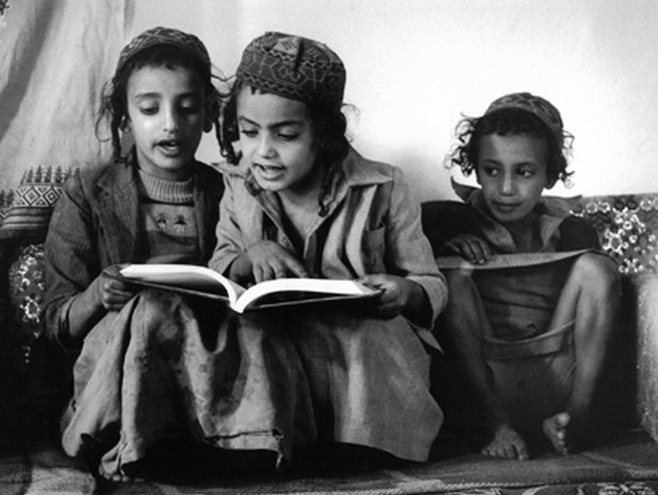
Three young Jewish boys studying, Al Hajar, Haydan, Yemen, 1983. The one in the center is Lewi Faez, who was around 6 years old at the time. He arrived in Israel in 1992 at the age of 16, with his 14 year-old wife and an infant. Photo by Myriam Tangi.
According to legend, Jewish history in Yemen dates back to the time of King Solomon and the request of the Queen of Sheba to see Hebrew craftsmen settle in her country. Indeed, some historians identify Sheba with the ancient Kingdom of Saba in the southern Arabian Peninsula.

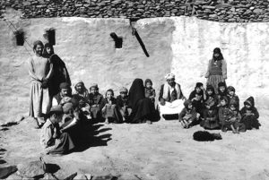
Visits to these regions by foreigners were extremely rare, meaning the villagers were just as curious as the tourists. The boy with the book in the foreground, who refused to stop reading for the sake of the picture, was an exception. Al-Hajar, near Haydan, Yemen, 1983, photo by Myriam Tangi.

More recently, in 1949-50, about 49,000 Yemeni Jews were brought to the nascent State of Israel on secret flights during Operation Magic Carpet. As of 2017, it was believed that there remain approximately 50 Jews in the entirety of the country with most of them living in in a compound adjacent to the American Embassy in Sana’a, Yemen’s largest city and its capital.
As non-Muslims living in an Arabic country, the Jews of Yemen, one of the most ancient Jewish communities in the diaspora, were considered dhimmi, which literally means, “protected class.” As dhimmi, Jews had certain rights but also had to contend with a number of restrictions, including limits on their freedom of movement – For example, Jews were only permitted to travel within Yemen and could not venture beyond the borders of the country.
The Jews of Yemen were also forbidden from carrying the djambiha, a dagger-like sword carried by all Yemenite Muslim men around the waist. This restriction clearly indicated who among the men was not Muslim. Jews were restricted to certain crafts: jewelry making, leather working, shoe repair and metal works. Jewish women were permitted to weave baskets to sell at market.
Yemenite Jews were not allowed to own land and were under the protection of the sheikh of the village or the city where they lived. This meant that the sheikh was responsible for their safety and was obligated by law to protect them. The relationship between the community and the sheikh was often warm and sometimes even friendly.

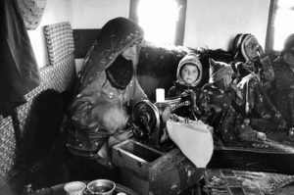
A Jewish woman working. Yemen, 1986, photo by Myriam Tangi.

In the 1980s, we set out on a journey to photograph the last few remaining Yemenite Jewish communities that were scattered throughout the country. There were at the time, approximately 300 to 400 Jews left in Yemen and only a few foreigners had travelled through this remote country at the tip of the Arabian Peninsula.
We made our way to different villages across the country including Beit Sinan in the Arhab district, about an hour north of Sana’a, the capital. The villages closer to Sana’a had stricter rules for code of dress. The Jewish women in the far off villages did not wear full niqabs, which covered the whole body, like the Muslim women did. Instead, they wore veils that covered only their heads. But as we drew nearer to the capital, the veils grew larger and women were expected to cover more. Muslims could enter Jewish homes at any moment, except on Shabbat.

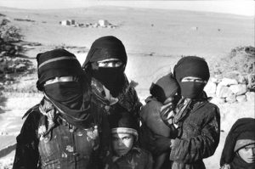
Beit Sinan, Arhab, Yemen, 1983, photo by Myriam Tangi.

We also travelled in a big truck through the steep roads of the mountainous regions to reach yet un-explored villages such as Al-Hajar, near Haydan and west of Sa’dah, a large city located in northern Yemen. The village of Wadi Amla was another destination; both are not far from the border of Saudi Arabia.
We were traveling as tourists. We made no mention of our Jewish identities for our own safety and for the safety of the local Jews. We were allowed to visit with the Jewish communities as we said we were looking to buy jewelry – a trade held by the local Jews. We also mentioned that we were vegetarians which gave us an opportunity to join a Jewish family for a meal.
Not all of these small and dispersed Jewish communities had their own synagogues. We understood from our interactions with a particular community that one family owned a Torah scroll and that other Jews would gather in this family’s home for prayer services, as it was forbidden to visit the local synagogue.
These photos are a testament to the peaceful lives led by the Jews of Yemen at that time. The children would spend their days studying with their Mori, a teacher chosen by the community, or with their father who would multitask in maintaining control over the reading and studying while working. Since there was usually only one copy to read from, the local children often developed the ability to read a book from any angle.

A Jewish girl (left) and a Muslim girl (right), Al Hajar, Haydan, Yemen, 1983, photo by Myriam Tangi.

While the situation in Yemen has changed, just a few decades ago this same country, which was so detached from the modern, Western way of life, gave us the impression of traveling back to biblical times, and allowed us to experience a different rhythm of life, typified by laid-back afternoons spent chewing Khat leaves.

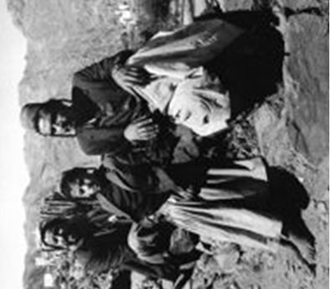
Jewish men in Al-Hajar, Haydan, Yemen, 1984, photo by Myriam Tangi.

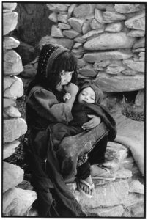
Al Hajar, Haydan, Yemen, 1983, Myriam Tangi.

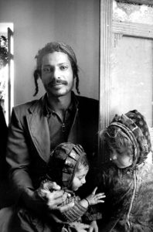
Yemen, 1983, photo by Myriam Tangi.

This series of photographs has been recognized by the IPA (International Photography Awards) organization.

Reprinted from the March 28, 2019 email of The National Library of Israel.
Going Out of Business
What is Lost when Department Stores Face Extinction? A Chapter of American Jewish History.
By Jenna Weissman Joselit

A man walks past a store going out of business in Brooklyn, on May 5, 2020 ANGELA WEISS/AFP/GETTY IMAGES

What will life after COVID-19 look like? Will most of us simply pick up where we left off and continue on our merry way, or will the virus leave a permanent imprint upon us as well as on the body politic, redefining its contours? I wish I had a crystal ball, but even in its absence, one thing is already clear: Shopping has been transformed into an almost exclusively digital phenomenon and the fate of department stores, already in parlous shape pre-COVID-19, hangs in the balance. The social distancing and quarantining occasioned by the virulent menace has left these former “cathedrals of commerce” high and dry, beached like a whale.
Yes, all things have their day, a limited shelf life, and department stores are no exception. They’ve been around since the mid-19th century and have had a good run. How many institutions, especially in the United States, can make that claim? Maybe it’s high time, then, to bid them a fond adieu?

The All-Too-Imminent Passing of the Department Store
Or maybe not. There’s something about the all-too-imminent passing of the department store that gives me pause. I, for one, will rue the consequences of a world bereft of its presence: For me, the enduring appeal of the department store rested as much, if not more, on its symbolic freight—the allure of the city and the embrace of modernity—than on the quotidian act of shopping, which, come to think of it, might not be so quotidian, after all.
Rooted in the urban fabric, the department store gave rise to transactions that were as much cultural as they were economic. When novelists, sociologists, and cultural critics speak of the public square and of a sense of place, of urbanism and urbanity, they have the department store in mind.
A purveyor of abundance and possibility, a destination in its own right, the department store translated the humdrum business of shopping it into an occasion. The grand scale of the building; the presence of newfangled amenities such as escalators, elevators, and huge plate-glass windows; the dazzling profusion of goods, a rising tide of gloves and hats and shoes and dresses and suits and shirts and ties and jewelry and rugs and furniture, expanded shoppers’ sense of the world, generated visual delight and excitement and heightened the meaning—and value—of sociability.

When the Department Store Defined Our World
Once upon a time, the department store “defined a world, little duchies of commerce, with their faith in literal display,” noted Adam Gopnick of The New Yorker in a celebrated 2003 article titled “Under One Roof.” Where else might people “stride in with pleasure?” The notion of striding in, a physical gesture bound up with energy and expectation, strikes just the right note, underscoring the department store’s tug on our imagination.
Not everyone was a fan. Small shopkeepers, who could not keep up with rising demands for novelty and variety, railed against the economic juggernaut, often banding together, ineffectually, to curtail its power; they succeeded only in nipping at its heels. Clergymen, too, demonized the department store for preaching the gospel of want rather than discipline and lamented its seductive hold over their female congregants who, in the face of so much abundance, reportedly went weak in the knees.
More damning, and persuasive, by far was the critique leveled by members of the African American community for whom the department store was a citadel to be breached rather than a welcome port in the storm. Shadowed and surveilled while taking in the sights; denied store credit; discouraged, and in some instances actively prevented, from trying things on or returning them; ignored at the sales counter or refused service altogether, banished to the bargain basement, consumers of color were made to feel more like interlopers than guests or, for that matter, valued customers.

Singled Out For Protests to Desegregate
Still, it was not for nothing that the NAACP and other civil rights groups such as the National Urban League made a point of singling out these formidable institutions for desegregation. What guided their efforts, from public protests to lobbying behind the scenes, was the moral conviction that unfettered access to the department store—that anchor of the civic square—should be within everyone’s reach. At stake, explains historian Traci Parker in her eye-opening book, Department Stores and the Black Freedom Movement, was the “right to freely experience all that … American consumer culture offered.”
Central to the smooth functioning of the social order, the department store was also a central component of the history of the Jews in America, dozens of whose names—think Abraham & Strauss, Macy’s and Gimbels, Neiman Marcus, I. Magnin, Bloomingdale’s, Filene’s, Bamberger’s, Hutzler’s, Rich’s, Hecht’s—proudly adorned its exterior. Some observers were inclined to Judaize the department store, characterizing it as a Jewish phenomenon, through and through.

The Reason for So Many Jews at the
Help of the Department Stores
They were right—but for the wrong reasons. The ring of the cash register wasn’t a Jewish sound per se, nor was the fast-paced, jangly rhythm of the selling floor a particularly Jewish rhythm. The presence of so many Jews at the helm of the department store was a consequence of history, of marginalization, rather than a function of biology, or an organic predisposition toward the restless pursuit of money-making.
For starters, it was the age-old economic segregation of the Jews that led to their trafficking in commodities in the first place, instead of their taking up craftsmanship or agriculture. Couple that with their newfound belief in the beneficence of modernity, the blessings of change, and the vitality of the city, and you can more readily understand how it came to pass that Jews in the United States and abroad took to urban retailing on a grand scale.
Consider the career of Louis Bamberger, the founder and presiding marketing genius of L. Bamberger & Co, the “always busy store” in Newark, N.J., whose logo was emblazoned on a fleet of green and gold delivery trucks. Born in 1855 into a Baltimore Jewish family who would go on to establish Hutzler Brothers, one of that city’s leading department stores, Bamberger opened his own establishment in 1892 in Newark, then a leading manufacturing center and a city on the rise, entwining his success with that of the emerging metropolis. Bamberger’s, an observer noted at the time of its first major building expansion, in 1912, “has cast its spell over New Jersey—admiration runs riot,” adding that the store should be commended for its “usefulness as a public institution.” Later still, in 1944, in the wake of Bamberger’s death, The New York Times went so far as to liken the New Jersey department store to a “public utility,” highlighting its relationship to the commonweal.

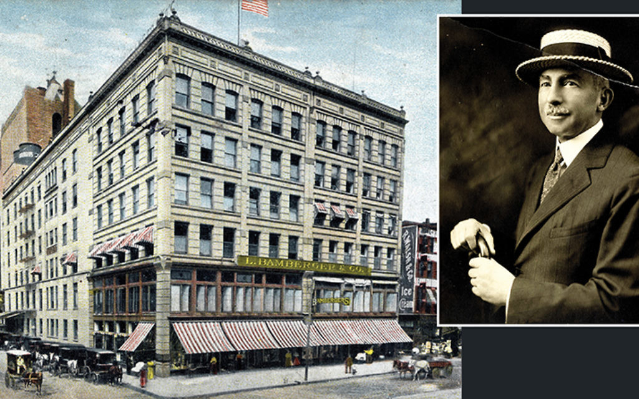
Louis Bamberger and the once majestic L. Bamberger & Co. Department Store in Newark, NJ

In his salute to department stores such as L. Bamberger & Co. and Bloomingdale’s, Gopnick predicted that their “diminishment leaves us with one less place to go and to hope in.” We’ve gone way beyond that now and, in confronting the prospect of their impending demise, what lies ahead is their erasure from history.
Jenna Weissman Joselit, the Charles E. Smith Professor of Judaic Studies & Professor of History at The George Washington University, is the author of Set in Stone: America’s Embrace of the Ten Commandments, now out in paperback.

Reprinted from the June 30, 2020 email of Tablet Magazine.

It’s Never Too Late
To Honor a Hero

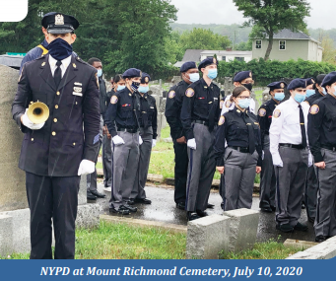

Ten-year-old Tobias Gellis was inducted into NYPD’s Junior Police Force (JPF) in 1916. On July 10, 2016, he was ordered by the precinct captain to warn neighborhood children about recent cases of infantile paralysis.
Most parents couldn’t speak much English; the children were to convey the threat to their families. Standing on the roof of his tenement at 209 Fourth Street, Tobias began to yell as his audience became noisy and unruly. In reaction he stepped back from the crowd, fell off the roof — and plunged to his death.
One hundred and four years later, this tragic event was commemorated at HFBA’s Mount Richmond Cemetery. Few people are aware of this footnote in NYPD history. The JPF functioned from August 1914 to July 1918, engaging 6,000 mostly Jewish boys in “police work” to keep them out of trouble.
Their duties included “preventing swearing in public streets and games of craps as well as stopping the building of bonfires and smoking” among the neighborhood youth. They also acted as lookouts, alerting police officers to possible crimes. It was clear to the public and to the NYPD that they improved the day-to-day quality of life in the city.

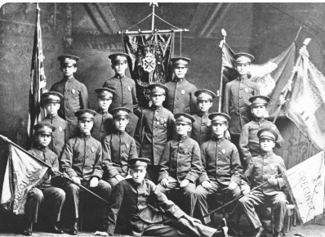
Officers of the New York Police Department’s JPF (Junior Police Force). 15th Precinct

On July 10th, a century after his death, Tobias received the funeral he should have had, the one accorded all members of the police force who die in the line of duty.
The NYPD, preparing to celebrate its 175th anniversary, decided to commemorate Tobias’ death by according him full NYPD honors. A procession, including members of the Shomrim Society (the organization of Jewish police officers), Explorers (today’s version of the JPF) and a Jewish chaplain, solemnly marched to Tobias’ gravesite.
Under rainy skies, bagpipes sounded a sorrowful melody and a trumpeter played the mournful tune of “Taps.” A cloth was removed to reveal Tobias’ gravestone. In the moving ceremony, young Tobias Gellis was formally recognized by the NYPD as a hero who made the ultimate sacrifice. The presiding officer, Inspector Terence Hurson, ended his remarks by saying, “All members of the NYPD salute you Captain Gellis. Please rest in peace.”

Reprinted from the Rosh Hashana 2020/Elul 5780 edition of Chesed, the newsletter of The Hebrew Free Burial Association.
1948-2020

The Contradictions of
Rabbi Jonathan Sacks
By Anshel Pfeffer

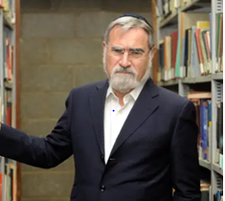
Former U.K. Chief Rabbi Jonathan Sacks, 1948-2020 Photo Credit: Rami Shllush

As one of the stream’s most prominent and influential rabbis, Jonathan Sacks personified the contradictions and limitations of Modern Orthodoxy, especially in the Diaspora – not being traditional enough for Haredim, too cautious for non-Orthodox Jews, and too foreign for Israelis
Rabbi Jonathan Sacks, who died on Shabbat [November 7, 2020] at the age of 72, had the unlikeliest beginning in life for one the generation’s most renowned Orthodox rabbis and philosophers. Despite growing up in a traditional family, going from his Church of England primary school to Christ’s College high school and then Gonville & Caius College at Cambridge, until his early twenties – when he traveled to Israel and spent time in a Chabad yeshiva – he had no formal Jewish education.

The Six-Day War that Changed Everything
It would be the Six-Day War that changed everything. At 19, gathered together with other students in Cambridge’s synagogue, he prayed for Israel’s deliverance from a feared second Holocaust. The experience, he said, “planted a seed in my mind that didn’t go away,” and opened up “a burden of responsibility” to the Jewish nation.
He would spend the next decade studying and lecturing on moral philosophy before he finally joined the Rabbinate. But his ascent in his belated vocation was meteoric. His sparkling oratory, natural charisma and the originality of his sermons and books, fusing Jewish canonical texts with a wide range of Western thought, made him just the kind intellectual and spiritual rock star that Britain’s fusty and hidebound Orthodox mainstream United Synagogue sorely needed to raise its stature.
After serving as the rabbi of two synagogues in London, he was selected chief rabbi at the age of 43.
Sacks said he was “reluctant” to accept the position, but his ambition was clear: After taking the reins of the Rabbinate, he outlined a “decade of renewal” for British Jewry. He was very conscious of the fact that he was the rabbi of a community shrinking in number due to assimilation, emigration and lower birth rates, and also shrinking in influence.

Losing Its Centrality to Israel and the United States
Along with post-imperial Britain, the community had lost its centrality as Israel and the United States – two countries he loved and admired – had become the main centers of post-Holocaust Jewry. He set out to be an ambassador for Britain’s Jews to the wider British society, a role he was arguably better at than unifying his deeply divided community.
He was a unique combination of an ultimate communicator and original thinker with an incredible breadth and depth of knowledge. Upon his appointment as chief rabbi, he swiftly learned how to make a deep impression within the short attention span of television, becoming the British media’s most sought-after religious leader.
His mellifluous tones were to become a near-constant feature on BBC Radio 4’s three-minute "Thought For the Day" for many years. His books featured in the bestseller lists, popular among non-Orthodox Jews and non-Jewish readers alike, and his advice was sought by British prime ministers who became his confidants.
The chief rabbi’s wide acclaim made many British Jews proud, and his writings inspired thousands of young Jews – particularly those who had not grown up in religious settings and had no rabbis of their own – with his vivid descriptions of Judaism as an empowering tradition of hope and the original radical faith of freedom.

The Richness and Diversity of His Learning
His books, like his speeches and media appearances, were marked not only by the richness and diversity of his learning, but also catchy sound-bite titles like “Radical Then, Radical Now,” “The Dignity of Difference” and, long before Barack Obama, “The Politics of Hope.”
But his media savviness and scholarly showmanship also provoked the oft-muttered criticism that he was “the chief rabbi of the goyim.” There was some truth to this. While his non-Jewish admirers and listeners always saw him as the leader of all British Jews, his official congregation consisted only of a minority of the community.
He wasn’t the rabbi of the progressive streams and certainly not that of the growing ultra-Orthodox community. He was too aware of his ultra-Orthodox rabbinical critics saying of him that he was “more Cambridge than Etz Chaim” – the small London yeshiva where he studied for a few years for his ordination.

Was Fearful of Crossing the Haredi Rabbis
During his 22 years as chief rabbi, he was fearful of crossing the Haredi rabbis, including the members of Beth Din (rabbinical court) of which he was nominally the president. Few if any Jewish intellectuals of the generation could rival his knowledge, but he seemed to suffer from an inferiority complex toward those rabbis who had spent their entire lives in yeshivas and, unlike him, had the self-confidence to issue rulings in halakha (Jewish law).
In an attempt to maintain cordial relations with them, he refused to attend the annual Limmud conference of Jewish learning, due to the presence of Reform, Liberal and Masorti (Conservative) rabbis (despite his having been involved in Limmud before becoming chief rabbi), and referred to them in private letters to the ultra-Orthodox rabbis, which were gleefully leaked, as “intellectual thieves” and “those who destroy the faith.”
He agreed to revise some sentences in “The Dignity of Difference” when ultra-Orthodox rabbis accused him of heresy for implying there that there was truth in other religions besides Judaism.
As chief rabbi, he repeatedly delayed a report on the role of women in religious services and prevented the participation of Jewish LGBTQ groups in communal events he endorsed. His successor, Rabbi Ephraim Mirvis, would be the first chief rabbi to attend Limmud and issue groundbreaking (by Orthodox standards) guidelines on the duty of care for Jewish schools and institutions toward LGBTQ students.

Personified the Contradictions and
Limitations of Modern Orthodoxy
Sacks may have been the most prominent and influential Modern Orthodox rabbi, way beyond the British Isles. But he also personified the contradictions and limitations of Modern Orthodoxy, especially in the Diaspora – not being frum (traditional) enough for the ultra-Orthodox; too cautious for non-Orthodox Jews; and too foreign for Israelis.
While some of his books were translated in Israel, he himself was surprisingly stilted in Hebrew, and frustrated that he never achieved anything near the recognition there that he had in English-speaking countries.
Sacks never lost his talent to inspire thousands of Jews with his speeches and writings, but also for dismaying many Jews when they felt he let them down. In November 2016, five days after Donald Trump’s surprise victory in the U.S. presidential election, he roused a shell-shocked audience as the keynote speaker at the General Assembly of the Jewish Federations of North America (JFNA) when he spoke of the “acrimonious” nature of the election campaign (without mentioning Trump) and told them that the Hebrew word for “crisis” – mashber – originally meant a birth stool.

Helped Vice President Pence Write His
Speech During His Visit to Jerusalem
“Every crisis, for Jews, is chevlei leida (the pains of childbirth), something new is being born,” he explained. A year later, many were disappointed to discover that Sacks had helped Vice President Mike Pence write the speech he had delivered during his visit to Jerusalem.
Perhaps it was too much to expect. As it was, few if any rabbi ever succeeded in navigating far away from his home community and comfort zone, and communicating with as diverse a range of audiences, as Sacks.
“He had a status that perhaps no other rabbi in the world attained – a wide global Jewish voice, in demand from Jewish and non-Jews,” said Yair Ettinger, one of Channel 11’s state and religion commentators and author of “Unraveled: The Disputes that Redefine Religious Zionism.”
“Unlike anyone else, he was listened to both by Orthodox and Reform Jews, a cosmopolitan rabbi, revered by the widest range of Jews,” Ettinger added.
Sacks fully came in to his own at the age of 65, when he finally retired from the Rabbinate and became a globe-trotting public intellectual, freed from the restraints of office. He still wouldn’t challenge Orthodoxy, but he had been evolving.
Much of his early writing had focused on advancing the cause of Jewish Orthodox tradition. In later books, he broadened his theme to arguing in favor of all monotheistic religions as a bulwark against the modern crises of society, caused in his view by secular moral relativism, as he claimed in one his last books, “Not in God’s Name – Confronting Religious Violence,” a response to popular militant atheists like Christopher Hitchens and Richard Dawkins.
Israeli philosopher and author Micah Goodman, an admirer of the former chief rabbi, said that “in his philosophical writing over the last 15 years, Rabbi Sacks transformed from being just a Jewish theologian to becoming a major Western philosopher, without losing his Jewish patriotism in the process.”

Reprinted from the November 9, 2020 website of Haaretz.

Opinion
Rabbi Jonathan Sacks, the Modern Orthodox Ideal Who Couldn't Thwart Orthodoxy's Slide to the Right
By Samuel Heilman

The former UK Chief Rabbi was a model for a modern Orthodox generation, excelling in both Jewish and secular learning, and elucidating Jewish thought to a global audience with intellect and grace. But he bent those principles with the compromises he made with religious conservatives to his right.
Lord Jonathan Sacks, who died Saturday after a third bout with cancer at the age of 72, represented what had once been the ideal of modern Orthodoxy: a religious leader who was both rabbi and Ph.D, with a foot firmly placed in both the worlds of Jewish and secular learning, and who excelled at both, demonstrating that these two universes could co-exist and inform each other.
Despite the confidence in which he inhabited this space, it was not always an easy ride; the secular world honored him, but some of the compromises he made with religious conservatives to his right laid him open to charges of appeasement.
Sacks, chief rabbi of the United Kingdom from 1991 to 2013, and a member of the House of Lords from 2009, was in many ways the epitome of a modern Orthodox rabbi.

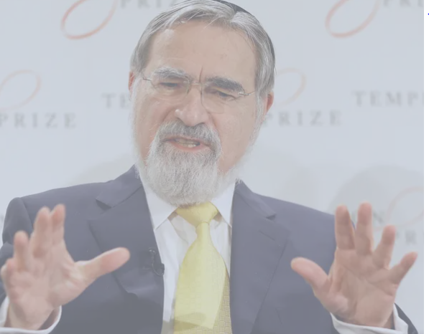
Rabbi Lord Jonathan Sacks speaks at a press conference announcing his winning of the 2016 Templeton Prize, in London. March 2, 2016 (Photo Credit: Kirsty Wigglesworth, AP)

Steeped in Torah learning, he both attended the Etz Chayim Yeshiva in Golders Green, London, where he received his semicha (rabbinic ordination), and Jews' College. But he also received a proper "English" education at St. Mary’s Primary School and Christ’s College, and went on Caius College at the University of Cambridge gaining first class honors.
He received his doctorate in 1982 from the University of London, and taught at Kings College, London, Yeshiva University, New York University as well as the Hebrew University of Jerusalem.
He began his career as a rabbi of the Golders Green synagogue, but soon became the rabbi of the prestigious Marble Arch Synagogue in central London as well as the Principal, or head, of Jews' College (now the London School of Jewish Studies) a seminary for Orthodox rabbinical studies and a college in the liberal academic tradition.
It was in this capacity that I first met him during the 1980s and was powerfully impressed by his genuineness, knowledge, and powerful commitment to the synthesis of critical thinking and Torah.
He went on to be a prolific author of more than 24 books, spanning the range from prayer books including the Koren series for the High Holy Days, a Haggadah and books on the weekly Torah portion to volumes about God, science and the search for meaning as well as the persistence of faith, tradition modernity and Jewish unity.

An Outstanding Embodiment of Outward-Looking Orthodox
Rabbi Sacks became an outstanding embodiment of outward-looking Orthodoxy, a religious identity that saw its responsibility to serve not only the community of those who believed as he did, but also to speak to the world at large and show what Judaism had to offer to general culture.
Indeed, his book "The Dignity of Difference" articulated this view most vividly. He wrote there: "No one creed has a monopoly on spiritual truth." That sentence triggered a controversy with the religious right.
At the same time, Sacks often saw himself as reaching out to the general society to offer the wisdom of Judaism as a spiritual guide for all people. This was the essence of his message during the years he served as a commentator on BBC 4’s widely heard program "Thought for the Day."
And it undoubtedly was an important part of the reason he was awarded the £1 million Templeton Prize in 2016, one of many trophies he collected that included, in 1995, the Jerusalem Prize, the prestigious Grawameyer Prize for religion in 2004, and the Kuyper Prize from the Princeton Theological Seminary, as well as many others.

Praised by the Prince of Wales
His success in elucidating Jewish thought, not least to a largely unaware UK audience, can be clearly seen in the tributes that have come from all corners of Britain.
The Prince of Wales called him "a steadfast friend" and "a valued adviser" and praised his "spiritual awareness and [his] comprehensively informed philosophical and historical perceptiveness," while Prime Minister Boris Johnson described him as having "a profound impact on our whole country and across the world." Labor leader Keir Starmer called him "a towering intellect whose eloquence, insights and kindness reached well beyond the Jewish community."
But while he championed modern Orthodox principles, he also – as so many of today’s Orthodox rabbis – was powerfully aware of the slide to the right in Orthodoxy and often tried to placate, if not bend to, the demands of Haredi Orthodoxy.
Thus, after his comment about no creed having a monopoly on spiritual truth was attacked by several UK Orthodox rabbis, who demanded that he "repudiate the thesis of the book" in which the statement appeared, and withdraw it from circulation, they were joined by Rabbi Yosef Elyashiv of Jerusalem, a leading Haredi rabbi in Israel.
Sacks backed down, and issued a revised edition of his "The Dignity of Difference" book (ironically perhaps, in the light of events, subtitled, "How to Avoid the Clash of Civilizations") in which he removed statements suggesting that Christianity and Islam are as valid as Judaism, and with that any doubt that he was relativizing Judaism's message.

His Reversal Sat Uncomfortably with
Many in the Modern Orthodox Community
That reversal sat uncomfortably with many in the modern Orthodox community, and with the title of the book itself, a phrase that he had made his own.
Perhaps even more significantly, while Sacks was Chief Rabbi he refused to attend Limmud, the worldwide cross-denominational Jewish educational program which was founded in the UK that seeks to educate, inspire and entertain people of all levels of observance on their Jewish journeys, with lecturers on Jewish topics from the broadest range of backgrounds.
The Haredi rabbinate has consistently refused to participate, and Sacks joined that snub (even though his son-in-law was a leader of the conference). His successor as Chief Rabbi, Ephraim Mirvis, defied the pressures of right wing Orthodoxy from the start of his tenure and made a point of attending Limmud. In an echo of the book affair, Sacks was accused by some of lacking the courage of his modern Orthodox convictions.
Nevertheless, no contemporary Orthodox rabbi maintained more universal respect and affection in the English-speaking world. No doubt his presence and his ideas will be missed by many in the modern Orthodox world as a model for Jews who wish to remain steadfastly attached to halakha and Jewish tradition, yet neither remote from nor untouched by the modern world – rather, enthusiastically engaged with it.
Whether Sacks managed to (re)establish a sufficiently robust outward-looking form of modern Orthodoxy that can survive his passing, and what the chances are for this worldview to survive the polarization of the Jewish world, are open questions that only the next few years, or decades, will answer.

Samuel Heilman is Emeritus holder of the Harold Proshansky Chair in Jewish Studies at the Graduate Center and Distinguished Professor of Sociology at Queens College of the City University of New York

Reprinted from the November 8, 2020 website of Haaretz.

Jewish Growth
By Rabbi Berel Wein
I look in wonder at the growth of Orthodox Jewry in my lifetime, not only in terms of intensity of Jewish life, but numbers and population.

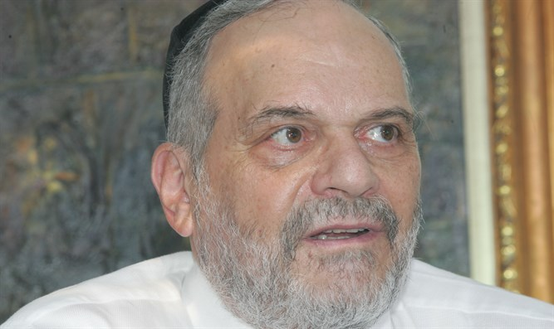
Rabbi Berel Wein

Numerically, the Jewish people are only an exceedingly small part of humanity. Even at the height of the most optimistic of surveys, we were and are a small constituent in the overall picture of the numbers of humans who inhabit this planet. This is always been so, for the Torah itself guaranteed that we would be the least numerous amongst nations.
Nevertheless, at the very same time, we were promised that we would be as numerous as the stars of heaven and the sands of the earth. For many centuries, the commentators and great Jewish thinkers have proposed ideas as to how to bridge these two seemingly contradictory predictions. Jewish tradition has redefined the idea of the stars of heaven and the sands of the earth in terms of quality and not of quantity, and out of proportion to their numbers.
It certainly is true that for such a small number of people, we have made a lot of noise in the story of human civilization, both as individuals, as a religion, and as a nation. So, in terms of influence and contribution to human society, there is no doubt that we are the stars of heaven and the sands of the earth.

We Are Still the Smallest of All People Numerically
But as far as numbers are concerned, we certainly are still the smallest of all people numerically and, tragically, except for Jewish population growth in the state of Israel and amongst the Orthodox community and the exile, the statistics regarding the Jewish birthrate are very depressing and pessimistic. In fact, for most of American Jewry, the Jewish family is not even reproducing itself at a rate of replacement.

What is happening for the majority of secular and assimilated Jews, and certainly for those in the Reform and Conservative communities, is to ignore the handwriting on the wall and whistle past the graveyard.
There is no doubt that this demographic disaster will, if it continues, have all sorts of consequences on the future of the Jewish community in the Diaspora. The tendencies to marry later in life, have few if any children, and the general negative attitude of much of modern society towards traditional family life, all have combined to take a severe toll on Jewish numbers.

Most Secular and Assimilated Jews are
Ignoring the Handwriting on the Wall
In effect, what is happening for the majority of secular and assimilated Jews, and certainly for those in the Reform and Conservative communities, is to ignore the handwriting on the wall and whistle past the graveyard.
If present trends continue, there will undoubtedly be a smaller Jewish community in the United States numerically and that will undoubtedly also have political and social consequences. That community will become increasingly Orthodox and traditional. The Orthodox Jew, contrary to all predictions and expert opinions voiced in the past, is simply not going to disappear.
It is part of the promise of eternity that the L-rd made in His covenant with us. Not only will the Jewish people remain eternal, but that the presence of Torah life would also always be preserved, no matter the challenges and difficulties that would arise.
It is remarkable that there are Jews in organizations and Federations in American Jewry, even though they may be non-Orthodox and non-observant in their own personal behavior, that recognize that the salvation of Jewish society and Jewish neighborhoods is completely dependent upon the continued growth of Orthodoxy and Orthodox educational and social institutions.
There are many neighborhoods in large cities in the United States that have been completely revitalized by young Orthodox Jewish couples who have moved into those neighborhoods, establish schools there and created a vibrant Jewish life on the streets and in the homes in these areas. These are the outposts of Jewish growth, not only spiritually but numerically as well.

One Can Never Predict the Future
One can never predict the future in a truly accurate or meaningful fashion. That certainly applies to everything that I have written above. There are many unforeseen forces and factors that lurk in general society that will certainly influence the growth and resilience of Jewish society as well. Nevertheless, I look back in amazement at the growth of Orthodox Jewry in my lifetime, once again, not only in terms of influence and intensity of Jewish life, but merely in terms of numbers and population.
The Jewish world was decimated by the events of the 20th century – by Germany, the Soviet Union, intermarriage and assimilation, etc. – to an extent that many despaired of any future for Jewish society at large, let alone for its growth and strengthening. One of the basic tenets of Jewish life is never to despair over the future, once again, not only individually but even nationally. Because of this, all steps should be taken again to continue to revitalize Jewish communities and Jewish life, so that we will truly be like the stars of heaven and the sands of the earth.

Rabbi Berel Wein is a noted scholar, historian, speaker and educator, admired the world over for his audio tapes/CDs, videos and books, particularly on Jewish history. After many years serving as a community rabbi in Monsey, NY, he made aliya and is rabbi of Beit Knesset Hanassi in Jerusalem.

Reprinted from the November 10, 2020 edition of Arutz Sheva.
Nathan Lewin, the Man Who Kept the Menorah Shining, to Keynote Chabad Conference
By Dovid Margolin

A conversation with the famed jurist, who will address the virtual Kinus Hashluchim

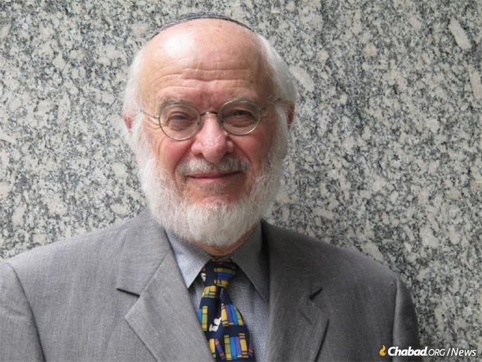
Nathan Lewin (Photo: Rikki Lewin )

When Nathan Lewin addresses the virtual International Conference of Chabad-Lubavitch Emissaries (Kinus Hashluchim) as its keynote this Sunday afternoon (November 15, 20200, there will be no need for an introduction. Over the past half-century, Lewin has made a name for himself as a talented litigator and become famous as one of the nation’s preeminent defenders of the Bill of Rights, particularly the religious liberties enshrined in the First Amendment.
Having started his legal career clerking for Supreme Court Justice John M. Harlan II in the late 1950s, then going on to work in Robert F. Kennedy’s Justice Department—Kennedy sent the young Shabbat-observing man to Nashville, Tenn., to help prosecute Jimmy Hoffa, and he later served as deputy assistant attorney general for civil rights—before spending decades in private practice, the 84-year-old Lewin continues to make headlines.

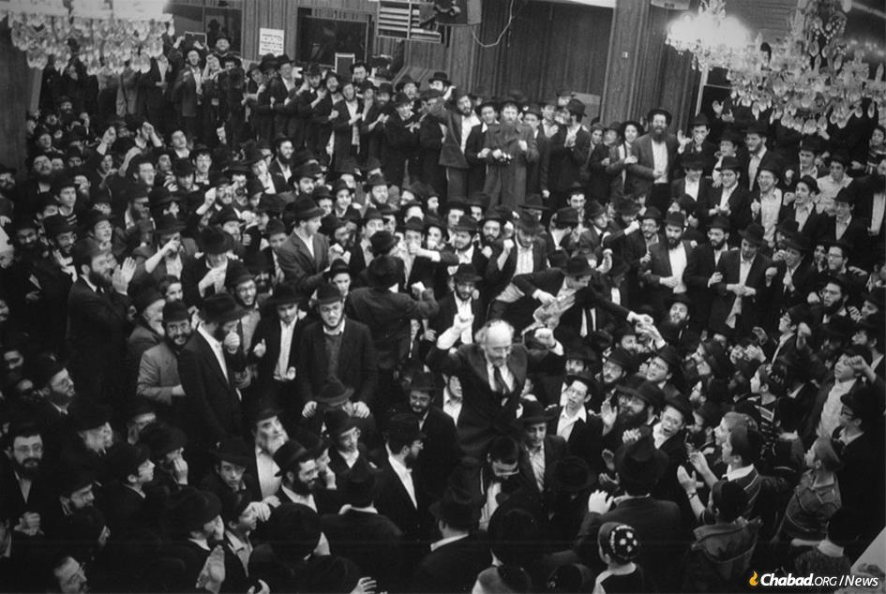
Nathan Lewin held aloft by students at 770 Eastern Parkway on Hei Tevet 5747 (Jan. 6, 1987), after a judge ruled that the Chabad-Lubavitch library in its entirety belonged to the Lubavitch movement.(Photo: Nathan and Rikki Lewin)

Lewin and his daughter, Alyza Lewin, represented Menachem Zivotofsky for 18 years in his family’s quest to have Jerusalem, Israel, written in Zivotofsky’s U.S. passport. Zivotofsky was just granted such a passport at the U.S. embassy in Jerusalem this October.
Lewin likewise came up during the recent Supreme Court nomination process, describing now-Justice Amy Coney Barrett’s work on behalf of Jewish causes while she was a young associate at Lewin’s law firm in 1999-2000, including the pro bono defense of a public menorah display in Jersey City, N.J. Barrett filled the seat of the late Justice Ruth Bader Ginsburg, with whom Lewin had a long and warm relationship. In fact, Ginsburg’s office called Lewin shortly after she joined the Supreme Court for his guidance in affixing a mezuzah to her chambers.
Throughout his career, Lewin has been known to be a passionate advocate for causes he believes to be just. “In interviews,” The New York Times wrote about him in a 1988 profile while he was defending U.S. Attorney General Edwin Meese, “several lawyers, most unabashed admirers of Mr. Lewin, faulted him for sometimes being too ardent in his advocacy—a criticism Mr. Lewin accepts. ‘I get ... carried away by what I think is right,’ ” he told the paper.

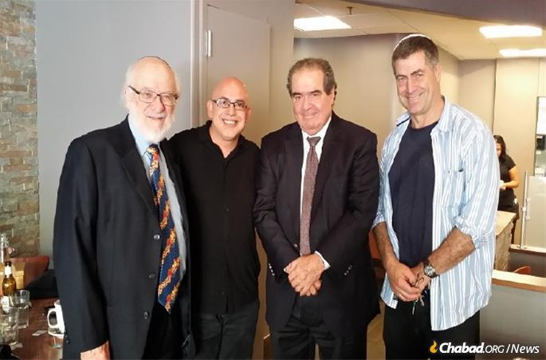
Lewin with the late Supreme Court Justice Antonin Scalia

Perhaps it was this, as well as his reputation for tenacity—a decade earlier, Lewin sued the Times into admitting it had erred and issuing a correction pertaining to Lewin’s time defending former President Richard Nixon—that in the summer of 1985 caught the attention of Rabbi Yehuda Krinsky, chairman of Merkos L’Inyonei Chinuch, the educational arm of the Chabad-Lubavitch movement, and a secretary of the {Lubavitcher] Rebbe, Rabbi Menachem M. Schneerson, of righteous memory.
Some months earlier, librarians at the Library of Agudas Chassidei Chabad had noticed that rare books from its priceless archive collection were going missing. Surveillance footage showed this to be the work of the estranged grandson of the Sixth Rebbe, Rabbi Yosef Yitzchak Schneersohn, of righteous memory, who after being confronted claimed the books to be his personal inheritance. When he refused to stop selling these valuable books on the open market, Krinsky turned to Lewin.
“I got a call in the middle of the night from Rabbi Krinsky,” Lewin recalls to Chabad.org. “That’s how it began on my end.”
Lewin immediately sought and obtained a restraining order enjoining the grandson from selling any more of the books in his possession, and then filed suit in federal court in Brooklyn to establish, as the Rebbe maintained, that the library was a communal possession belonging to the Chabad-Lubavitch community. The Rebbe did not weigh in on every step of the defense’s work, insisting this was the role of the team of lawyers led by Lewin, but did provide insight that proved to be crucial.

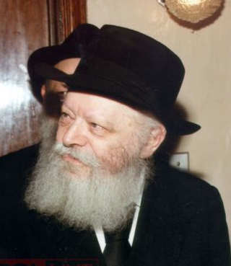
The Lubavitcher Rebbe, zt”l

“In our initial meeting [of lawyers] with the Rebbe he pointed at the letter written [by the Sixth Rebbe] to [Alexander] Marx [the librarian of Jewish Theological Seminary in New York] as the key,” says Lewin. In it, the Sixth Rebbe had made clear that the library was not his own personal property but a valuable resource for the entire Jewish people, and belonged to the movement he led. “We highlighted that piece of evidence and Judge [Charles] Sifton subsequently quoted it in its entirety.”
“The Rebbe was totally cognizant of every step we were taking, he read the transcripts, all the pretrial proceedings,” recalls Lewin. “I was astounded by how familiar he was with everything that had been said during the hearings.”
The months Lewin spent shuttling back and forth between Washington, D.C., and New York preparing for the case, followed by the 23-day-long trial, ultimately paid off. On Hei Tevet 5747 (Jan. 6, 1987), Sifton ruled that the library in its entirety belonged to the Lubavitch movement.

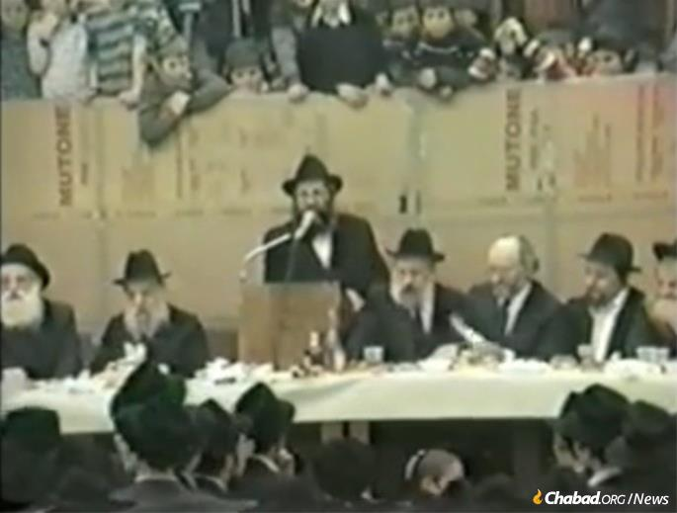
Lewin on the dais at 770 on Hei Teves

In an age before WhatsApp, the news rocketed around the globe with jubilation breaking out at Chabad headquarters in Crown Heights, Brooklyn—a short distance from the federal courthouse in downtown Brooklyn—as well as synagogues and Jewish communities everywhere.
“I want to say that the Nat Lewin I met a year-and-a-half ago is not the same Nat Lewin ... that we’re about to hear from,” Krinsky told a packed, euphoric audience at a celebratory event held two nights after the court victory. “This is the Nat Lewin—Reb Nosson Lewin—who will be written about for generations ... in the history of Lubavitch as one of the heroes of this [painful story].”
“I think every other lawyer in the United States has envied me for the last two days,” Lewin told the crowd to great applause. “ ... There’s no lawyer in the United States whose victory in court has been met by ... days ... and nights of dancing and singing and joy in the streets!”
Ten months later, on Nov. 17, 1987, the 25th day of Cheshvan—exactly 33 years ago—the United States Court of Appeals for the Second Circuit unanimously upheld Sifton’s district court ruling.
“I thought we had a very, very strong ground for sustaining Judge Sifton’s decision, so I was pretty confident in terms of the appeal,” reflects Lewin. “But it was certainly a brachah [blessing] that it was affirmed.”

Menorahs and Light
Lewin has fought countless religious liberties cases in his decades of practice, particularly those pertaining to the Jewish community. Among the cases he has argued, including dozens before the Supreme Court, have been the rights of Jews to wear kippahs and beards in the military; the humaneness of shechitah; and the right to place a Chanukah menorah on public property. As his daughter and law partner at Lewin & Lewin, Alyza, has pointed out, “there is no legal issue that has faced the Jewish community in the United States in the past half-century that does not have Nathan Lewin’s fingerprints on it.”
Of course, the landmark menorah case and the many follow-ups Lewin fought have a particular connection to the 5,000 Chabad emissaries he will be speaking to on Sunday. Not long after the Rebbe first launched his Chanukah awareness campaign in the early 1970s, Chabad emissaries—first in Philadelphia and San Francisco, then around the country—began erecting giant public menorahs to share the message and inspiration of the Chanukah lights with one and all. This included a 36-foot-high menorah erected outside of the White House, inaugurated by President Jimmy Carter in 1979.
Chabad of Western Pennsylvania followed suit in 1982, placing a menorah outside of Pittsburgh’s City Hall with the mayor’s permission and participation. Four years later, the American Civil Liberties Union sued Pittsburgh and Allegheny County, a case that wended its way to the Supreme Court of the United States. Lewin would be the one to defend the Jewish peoples’ right to place a menorah on public property.
Ultimately, Lewin explained to an audience at One-to-One, a 12-hour symposium held at the New York Public Library in 2016 exploring the Rebbe’s social impact, it was the story of “how the Rebbe prevailed ... and changed the course of First Amendment law in the United States.”

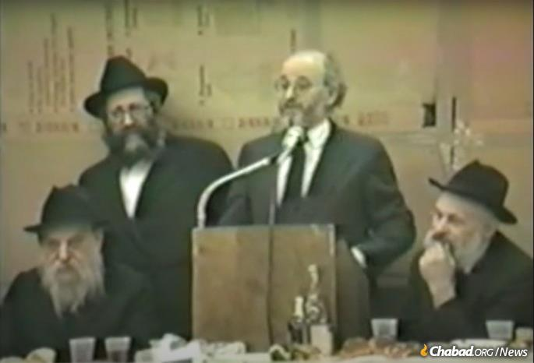
Lewin addresses the crowd at 770 on Hei Teves.

In a 6-3 decision handed down on the last day of their session in July of 1989, the Supreme Court ruled for the constitutionality of the menorah. Justice Henry Blackmun’s majority opinion even contained the blessing for lighting the Chanukah menorah—twice. The case did not end there. When the new mayor of Pittsburgh denied the menorah request the next year, Lewin ultimately got an emergency ruling from Justice William Brennan, received an hour before Shabbat and the start of Chanukah that year, allowing the menorah to go up once again.
In Pittsburgh’s case, the menorah had stood next to holiday symbols of other religions, and so in 1992, Chabad’s menorah in Grand Rapids, Mich., was challenged on the grounds that it stood alone, unaccompanied by any other symbols. Once again, Lewin successfully defended the menorah, as he did in cases that followed. While Lewin continues to assist anyone wishing to place a menorah on public property to this day, by now, thanks to his work, the legalities surrounding the topic are a matter of settled law.

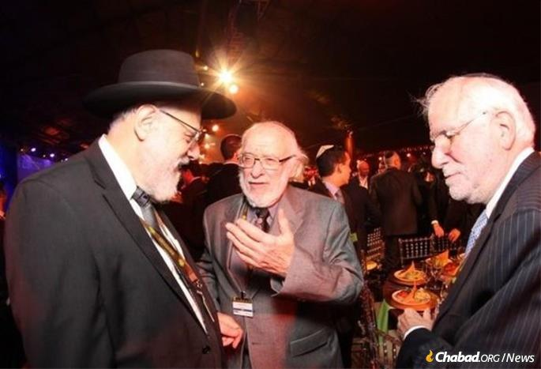
Lewin, center, at a previous International Conference of Chabad-Lubavitch Emissaries

“The menorah litigation in the United States was a perfect example of how the Rebbe’s insistence on an attitude towards religion in America ultimately prevailed,” Lewin told the audience at One-to-One.
Lewin has long been a familiar face at the Kinus. “I make an effort to come because this is always an amazing show of Jewish spirit and the worldwide impact that Chabad has,” he told this writer at the 2013 conference. “You sense it in the room when you come here together.”
His addressing this year’s gathering—all virtual and so different than the palpable energy felt when the thousands of emissaries and their guests fill one giant room—is all the more poignant considering the hope and light that springs forth from the lights of the Chanukah menorah, and his part in protecting their flickering flames.
“During these days of the pandemic, it’s all the more important to keep the light of the Chanukah menorah burning,” says Lewin. “Even though the number of people who will appear at Chanukah menorah-lightings will be smaller, the lighting itself is very, very significant because of swhat it conveys … . It’s a blessing for me to be able to be a part of this, maybe particularly at this time when otherwise the world seems to be so dark.”

Reprinted from the November 13, 2020 dispatch of Chabad.Org News

Collecting Jewish History
The Hebrew-Based Judaism and Zionism of Eliezer Ben Yehuda
By Saul Jay Singer

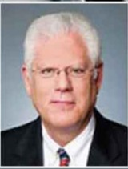
Saul Jay Singer

Eliezer Ben Yehuda (1858-1922), the “Father of the Modern Hebrew Language,” is almost single-handedly responsible for one of the greatest socio-linguistic events in world history: the revival of spoken Hebrew, which for millenia had been used only for Jewish prayer.
He accomplished this task at a time when not a single person conversed in Hebrew as his mother tongue, when the resurrection of a dead language had never occurred in all of human history, and when virtually no one else believed it possible. As one commentator pithily observed, “before Ben Yehuda, Jews could speak Hebrew; after him, they did.”

As a founding father of modern Zionism, Ben Yehuda was also a strong advocate of the right of the Jewish people to national self-determination, and he firmly believed that the creation of a Jewish state and the revival of the Hebrew language were inextricably connected. He explained that establishing Hebrew as the Jewish national language was the only way that olim arriving from the four corners of the earth could hope to communicate with each other. An inspiring speaker, he became recognized as an important voice of the Jewish nationalist movement.
Born Eliezer Yitzchak Perelman to an observant Lithuanian family (his father was a Chabad chassid), Ben Yehuda, showing signs of being a child prodigy and already well-versed in Torah and Talmud at age four, was sent to a yeshiva to become a rabbi. However, he later became attracted to the secular world, became a secularist, and completed his secular studies at Russian gymnasium (1877).
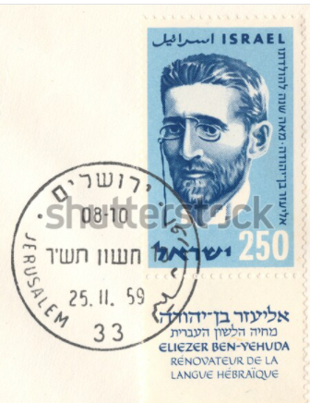
1959 Israeli postage stamp honoring Eliezer Ben Yehuda
Nonetheless, after reading Daniel Deronda (1876), George Eliot’s final novel in which the renowned author laid out his passionate call for a homeland for the Jewish people, Ben Yehuda concluded that the European concept of national fulfillment should also be applied to the Jews and he began to plan for both his own aliyah and for the Jewish return to Eretz Yisrael.

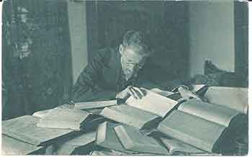
Ben Yehuda at work on his Dictionary.

He left Russia (1878), first going to Paris to study medicine (at the Sorbonne) so as to become more valuable to the Jewish community in Eretz Yisrael, but he was prevented from completing his studies due to tuberculosis and he left for Eretz Yisrael in 1881, settling in Jerusalem.
Few people know that one of his first projects upon making aliyah was printing the first Hebrew daily wall calendar (1885). He printed every Shabbat page in red, featured Jewish historical events on each page, and changed the date to reflect the number of years that have passed since the destruction of the Beit HaMikdash in Jerusalem (see featured correspondence, below).
Ben Yehuda’s plan for the rebirth of Hebrew emphasized spoken Hebrew at home. He and his first wife, Devora, pledged to speak only Hebrew to each other, and they decided to raise their son, Ben-Zion, as the first all-Hebrew speaking child in modern history. His fanaticism in this regard was such that when his wife was dying from tuberculosis and, in desperation, he smuggled his Russian-speaking mother in to help the family, he refused to let her speak so much as a word to his children.
When the Jewish public in Eretz Yisrael learned about his “extremism” in refusing to let his son even hear other languages, many believed that Ben-Zion would grow up to be a “disabled idiot.” Even famed Hebrew poets Yehuda Leib Gordon and Moshe Lilienblum believed that Hebrew would never again become a spoken language, and no less a personage than Herzl declared, after a meeting with Ben Yehuda, that the idea of Hebrew as the Jewish national tongue was “ridiculous.”

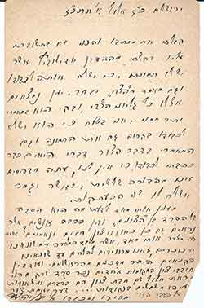

With a Hebrew-speaking child to raise, Ben Yehuda needed to find appropriate Hebrew words for the mundane things of everyday 19th century life; in fact, much of the inspiration for many of his “everyday” words came when his Hebrew-speaking young son would point to objects and ask, “Mah zeh? – What’s that?”
He further appreciated that for modern Hebrew to become a truly functional language, it had to meet the needs of educated Jews and that there had to be a Hebrew vocabulary that included academic and scientific expression. Accordingly, he coined many hundreds of new words, thus facilitating both the development of modern Hebrew vocabulary and the naturalness of Hebrew expression.

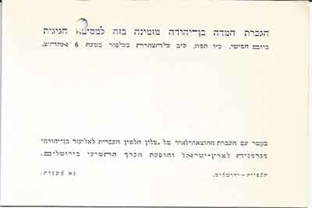
July 13, 1939 invitation to a party at Hemda Ben Yehuda’s home to celebrate the transfer of Ben Yehuda’s Thesaurus from Germany to Eretz Yisrael.

Sadly, Ben Yehuda’s greatest and most vociferous opponents were the charedim who knew Hebrew best from their intense Biblical and Talmudic studies and were perhaps the best candidates to adopt Hebrew as a native language. They believed that it was sacrilegious to use lashon hakodesh (the holy tongue) for everyday mundane purposes.
In contrast, the religious Zionists agreed that Zionism and Hebrew are inseparable and quickly adopted teaching Hebrew in their yeshivot. To facilitate the ability of their teachers to teach in Hebrew, Ben Yehuda initiated the idea of teaching Hebrew using Hebrew (“Ivrit b’Ivrit”) and wrote several Hebrew textbooks for teaching secular subjects.
Ben Yehuda determined that the best way to disseminate his plan for the Jewish nation to communicate in Hebrew was through a newspaper – even though there was not yet any Hebrew word for “newspaper” (or “printer,” “subscriber,” and the like). Accordingly, in 1884, he founded Hatvzi, his own weekly newspaper, and commenced printing a list of a few new Hebrew words in each issue. By the end of the 19th century, virtually every Jew in Eretz Yisrael could read and understand a Hebrew newspaper with little difficulty.
Hatvzi, however, generated great controversy as the result of the “Shemittah Affair.” A substitute editor ran an article urging farmers in Eretz Yisrael to obey the Biblical command to let the land lie fallow every seventh year, leading enraged farmers to argue that this would mean the end of the Jewish settlements, which were already struggling to eke out the first crops in two millennia from the infertile soil of Eretz Yisrael. Ben Yehuda sided with the farmers and published a renunciation of the article, arguing that the survival of the Jewish people and the establishment of Jewish settlements was more important, at least for now, than the laws of shemittah.

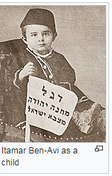

Not surprisingly, this move earned him even greater enmity from the charedim, whom he characterized as “zealots.” Ashkenazic rabbinic leaders pronounced a general ban on reading his newspaper, referred to him as a pagan and “the great heretic,” and pronounced writs of excommunication against him in their synagogues. However, through the support of less zealous Sephardic Jews, he was able to continue to print and disseminate his newspaper.
Ben Yehuda, though a secular Jew, had believed that the major obstacle to his goal of unifying all Jews through Hebrew was the separation – indeed, the alienation – of the charedi community from general society. Accordingly, to promote the unity of the Jewish people, he and his wife had become strictly observant, with him donning religious garb and growing out his beard and peyot and his wife covering her hair.

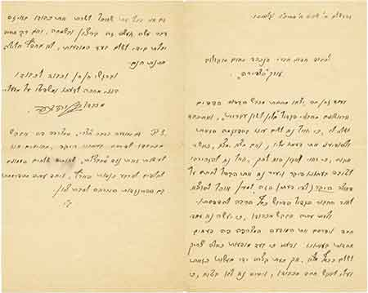
Jerusalem, 20 Shevat 1896,

After the Shemittah Affair, however, he decided that outreach to the charedi community was futile and he abandoned any pretense of observance, thereby providing further ammunition for his charedi opponents to use against him.
Moreover, he began to publish articles demanding that charedi rabbis provide detailed accounts of all donations received and that, rather than continuing to live off the charity of others, they use the money to buy land for their yeshiva students to build homes and farms. He became extreme in his anti-religious outlook, even going so far as to officially register as “a national Jew without religion.”
The unsurprising result was even more bans and excommunication orders, the creation of a permanent rift between Ben Yehuda and the charedi community, and a material deterioration of his already challenged finances. Even when Devora got a much-needed position teaching Hebrew at one of Baron Rothschild’s Alliance schools, she was summarily dismissed when the charedi leadership threatened to impose a general ban on the school.

The Hatred of the Chareidim
The hatred for Ben Yehuda in zealot circles was such that plans were hatched to murder him; in fact, he barely escaped with his life during an attack on him in the Old City of Jerusalem. The charedim misrepresented his articles so as to incite the Turkish authorities against him, which resulted in a charge of sedition that carried a possible death sentence (he was ultimately sentenced to one year in prison). They even went so far as to attempt to physically block his wife’s burial on the Mount of Olives and to celebrate his death as the Lord’s righteous revenge on a great sinner.
In this correspondence from Jerusalem dated 27 Elul 1897, Ben Yehuda writes to Gershom Bader that the charedim and anti-Zionist zealots are, sadly, more dangerous that “our Gentile enemies:”
It interests me very much to know the reason for the estrangement between the “Zionists” and many other people who also seem to be warm and loyal Chovevei Tzion (lovers of Zion). Truly, it disturbs me greatly that besides the battle against our Gentile enemies, we are required to fight against our zealot enemies, who are more dangerous than the former.
Gershom Bader (1868-1953) – an important Eastern European Haskalah figure, political commentator, author, playwright, editor, and Hebrew, Yiddish, German, and Polish journalist – was an enthusiastic supporter of Chibat Tzion and sharply critical of the pro-chassidic and conservative policies of the charedi community, sharing with Ben Yehuda a mutual disdain for the anti-Zionist charedi “zealots.”

Financially Saved by Baron Edmond de Rotthschild
Ben Yehuda’s financial salvation ultimately came in the form of an angel: the Nadiv Hayadua (“the Well-Known Benefactor”) Baron Edmond de Rothschild who, though deeply skeptical that Hebrew would ever again become a widely spoken language – and who actually forbade teaching Hebrew in his schools in Eretz Yisrael – nonetheless admired Ben Yehuda’s work and dedication. It was this support, and ambitious fundraising work by his wife, that enabled the poverty-stricken Ben Yehuda to continue to publish Hatzvi and to devote himself to working on his dictionary.

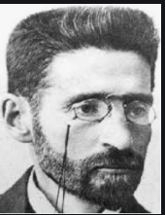

Ben Yehuda’s singular literary contribution may well be his dictionary – for which, ironically, no Hebrew word existed. His main source of income was from subscriptions to Hatzvi, but that proved inadequate, not only for the development and sale of his dictionary, but even to provide for his family, so he had to rely on financial support from others.
Turning himself into a scientific lexicographer, he was determined that each word would have its roots in Biblical sources to the greatest possible extent. However, in many cases, there were no analogs, so he had to create new words from whole cloth.
He compiled his dictionary using strict philological rules, and the results of his arduous labor was his 17-volume A Complete Dictionary of Ancient and Modern Hebrew, which was carried forward by his second wife, Hemda (his first wife’s sister), after his death and was not completed until 1958.
Exhibited here is probably the most incredible Ben Yehuda letter I have ever seen, a handwritten correspondence addressed to Nachum Sokolow, then editor of Ha-Tzfira in Jerusalem (1896):
1,826 years since our exile [in the year 70 C.E.]
In a short while, the first leaves of my great work, “Dictionary of the Hebrew Language,” will come out of the printing press and I would be honored to send to you to review this sample and for you to let me know your thoughts on it, and if you find, as I hope you will, that it is appropriately worthy and deserving, you will give it positive mention in your beloved newspaper and will rouse the public to support (what is in my opinion) this precious treasure so that I may bring to light this great work which requires considerable funds to print it.
And now, I will ask you to do a great kindness for me and publish the attached advertisement several times in your newspaper. And I believe that for such an announcement, one should pay in full, but right now I am short and cannot act accordingly, and I request kindness from you, and your heart should be certain that I will, at every possible opportunity where I can serve you in any matter, I will do so willingly and with great joy. Alas, were I only financially able to pay for the advertisement and (I am not], G-d forbid, seeking a free gift.
With feelings of boundless grace and respect, I await your thoughts and judgment on my work.
In a P.S., Ben Yehuda adds a request to publish in Ha-Tzfira an advertisement for his newspaper, Hatzvi, to help defeat its major competitor, Ha-Chavatzelet which, he writes, is against Chibat Tzion, the early founding organization promoting aliyah and settlements in Eretz Yisrael.
To assist with his dictionary and to solve various problems of terminology, pronunciation, spelling, and punctuation, Ben Yehuda founded the Va’ad Halashon (Hebrew Language Council, 1890), the forerunner of today’s Hebrew Language Academy at the Hebrew University in Jerusalem, currently the supreme arbiter and authority on approving new Hebrew words and passing on all matters pertaining to the Hebrew language.
The success of his endeavor was impliedly recognized by the British Mandate Authority when, on November 29, 1922 it recognized Hebrew as the official language of the Jews in Eretz Yisrael.

Reprinted from the November 11, 2020 website of The Jewish Press.

Kosher Pork Chops and Crypto-Jewish Identity
By Joel Haber

In Genie Milgrom's family, hidden Jewish identity was preserved for generations in the food they ate

Genie Milgrom showing off a recipe from her new cookbook.

One of the saddest chapters in Jewish history is also one of the more interesting on a gastronomic level. Following the forced conversions in 15th-century Spain, the Inquisition and subsequent Expulsion, many so-called New Christians secretly maintained Jewish beliefs. Practicing in secret to avoid arrest and torturous execution, they are now known as Crypto-Jews.
Foods that were considered “Jewish” could mean a death sentence when Crypto-Jews ate certain telltale dishes. Inquisition court documents repeatedly make this connection clear.

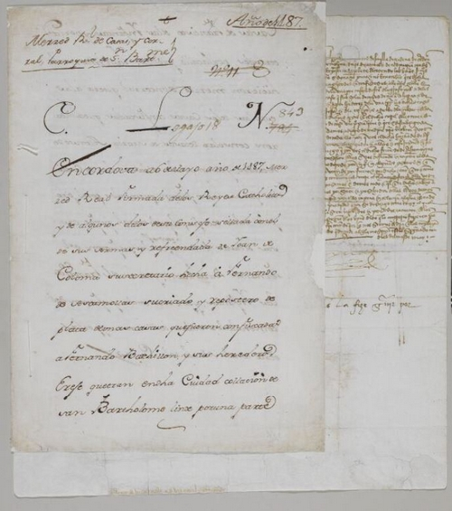
Inquisition document regarding the confiscation of “New Christian” property, Cordoba, Spain, May 1487. The Jewish Theological Seminary of America, Ms. NH 63; available via the National Library of Israel Digital Collection

Many Crypto-Jews conspicuously ate pork to “prove” their Christian faith, while others devised tricks to avoid such transgressions while not giving away their secret.
Nonetheless, clearly not everything Crypto-Jews ate was necessarily related to their true or assumed identity – most foods were probably neutral in this regard.
So what did Crypto-Jews eat? And how have those foods developed over the past 500 years?
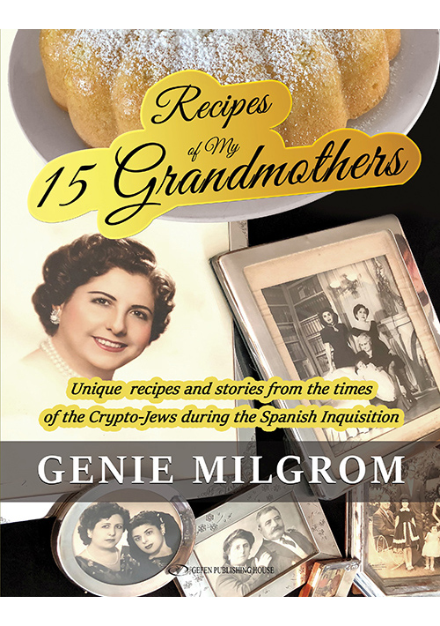
The recent book Recipes of My 15 Grandmothers by Genie Milgrom offers a fascinating personal window into the lives and foodways of the descendants of Crypto-Jews across the centuries.

Twenty-Two Generations
Milgrom’s story is a big part of what makes the book as interesting as it is. Born Catholic in Havana, Cuba, she felt Jewish from a young age. Finally, in her 30s, she converted to Orthodox Judaism. It was tough for a single mother of two, largely disconnected from her old life and still struggling to integrate into a new community.

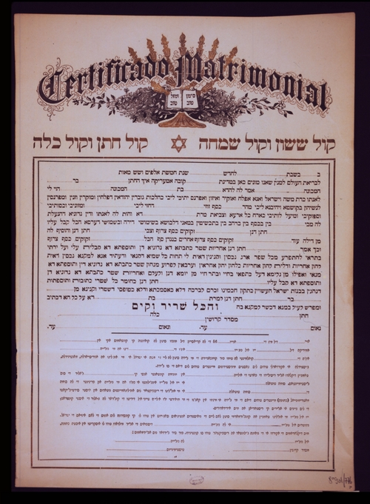
A Cuban ketubbah (Jewish marriage contract), ca. 1900. From the National Library of Israel collections

In time, she began to conduct intensive genealogical research, eventually uncovering “an unbroken maternal lineage going back twenty-two generations to 1405 pre-Inquisition Spain and Portugal.” It turned out that she had actually been Jewish all along!
Still, while names and cold biographical facts drawn from archival records may be significant, what Milgrom really yearned to discover were the more personal details. Turning to her mother, she asked for anything that might have been handed down from previous generations.
Her mom denied having anything. And then fate stepped in.
“Finally, the sad day came when my mom could no longer live in her home, and it was at that moment that I found many old books full of pages of handwritten recipes and scraps of paper with small writing and tiny notes written in light pencil. All of these pages were done in different handwritings, some with more flourishes than others, but always written by the women. With this, I found the recipes of the grandmothers.”

Culinary Connections
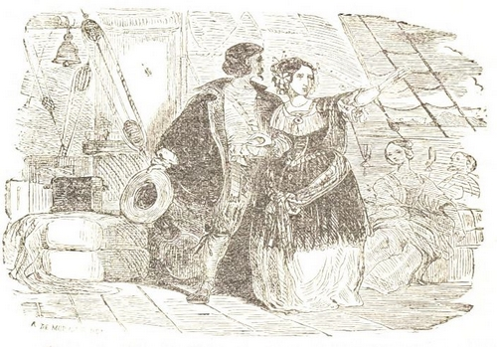
Depiction of Jews fleeing Spain, from a 19th century book on the Inquisition. From the National Library of Israel collections

While Milgrom had already written and spoken a lot about her genealogy and her research, this discovery led her to edit and compile the recipes into the cookbook.
Though an experienced home cook, Milgrom was neither a professional chef nor cookbook writer.
She recruited a cadre of friends and colleagues to help her test-cook the recipes, and throughout the book she repeatedly mentions that she had not even tasted all of its recipes herself.
While on the culinary level this might not hold up alongside other contemporary cookbook favorites, there are certainly unique and delicious recipes to be found within. But beyond that, the book is a great exploration of a certain blank spot in Jewish culinary history.
I know of one other book that looks at the subject. Husband and wife professors David M. Gitlitz and Linda Kay Davidson published the fascinating (and award-winning) A Drizzle of Honey: The Lives and Recipes of Spain’s Secret Jews, culling food facts from Inquisition archives and reconstructing the original dishes.
But their recipes, enlightening as they may be, were largely their own approximations and guesses. Milgrom’s book works as a perfect companion — personal recipes to pair with the broader archival research.
Kosher Pork Chops

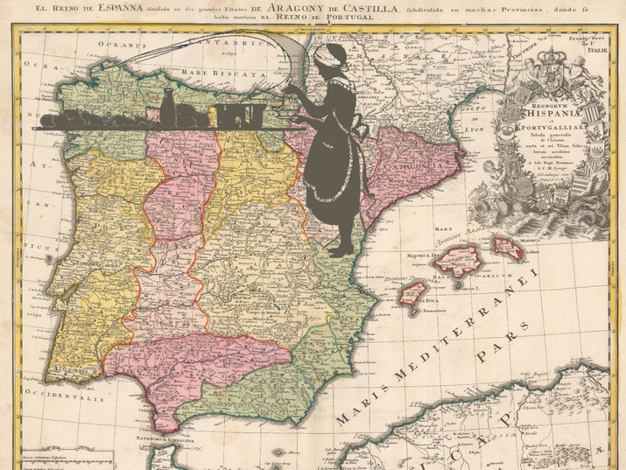
For centuries, food connected Crypto-Jews in Europe and the New World to their hidden heritage (Map: "Regnorum Hispaniae et Portugalliae", ca. 1769; from the Eran Laor Cartographic Collection, National Library of Israel)

Milgrom writes that she was surprised to find no recipes in the entire collection that mixed milk and meat. When I asked her about pork (a major ingredient in Spanish cuisine) she told me, “As a matter of fact, my family recipes only started having pork in Cuba in the 1930s and 1940s.”
Thus, one of the most surprising recipes she uncovered among the collection of hand-bound books and paper scraps was one for chuletas — pork chops.
She could barely bring herself to read the recipe, but when she finally did, she was greatly amused. Though they are called “pork chops”, the recipe is actually a sort of French toast that is disguised to resemble pork chops! Perhaps a more suitable name would be “imitación de chuletas”.

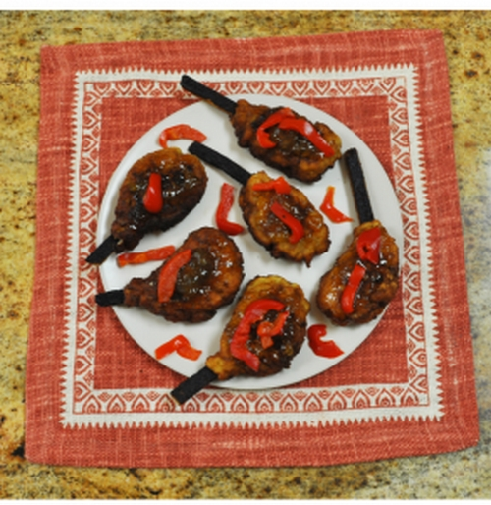
Milgrom’s kosher pork chops (Courtesy: Genie Milgrom)

Milgrom claims that they are “the best look-alike to a pork chop that I have ever seen,” and speculates this dish was designed to throw off suspicious neighbors.
I have not made these, nor do I know what pork chops should really look like, but I must admit that I find it hard to believe anyone could be truly convinced for more than just a passing glance. Smell and consistency would be dead giveaways. Still, whether or not this was actually their origin, there is undoubtedly an intriguing history cooked into this imitación.

Preserving Hidden Identity
Perhaps the most oft-repeated aspect of Crypto-Jewish life is the persistence of Jewish practices that generations performed, without even necessarily knowing why. Famous examples include lighting candles in a hidden place on Friday night, circumcision and sweeping towards the center of the room (rather than out the door, so suspicious neighbors wouldn’t know they are preparing for Shabbat).
Throughout the book, Milgrom mentions a number of food-related customs that her grandmother passed on to her, all of them quite clearly having Jewish origins. Examples include checking eggs for blood spots, strictly washing and checking lettuce leaves to avoid all insects, burning a small wrapped piece of dough in the back of the oven (“taking challah”) or even just describing a pareve cake as something that “could be eaten after any meal” with no further explanation.
Most of these were described to Milgrom simply as “family traditions” or things that would bring good luck.

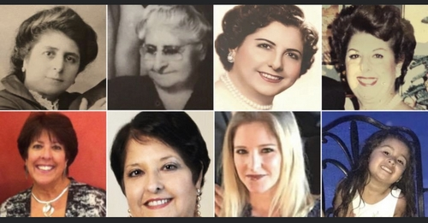
From great grandmother to granddaughter (Courtesy: Genie Milgrom)

She explains that her grandmother only taught these recipes and techniques to her, though there were four other grandchildren. This makes one wonder how much her grandmother knew about her Crypto-Jewish background. Reading through the grandmothers’ recipes we must ask whether she too pieced together the truth of their Jewish background, or whether something more subconscious was at play.
Unfortunately, we will never know.

For the Holidays and Beyond
On a broader level, there are many other crossovers between the recipes in this book and Jewish food in general. As Milgrom has pointed out, it is worth noting that her family’s recipes are distinct from Sephardic cuisine, as that community blended its Spanish roots with the influences of the areas in which they lived — Turkey, Italy, the Balkans and the Levant, largely. Primarily, her grandmothers’ food is typically Spanish, with adjustments and developments over time.

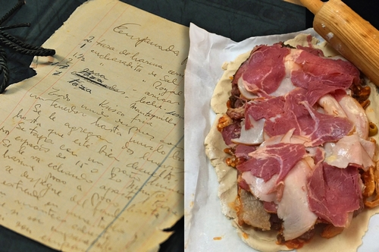
Hornazo, a festive pastry with assorted meats inside (Courtesy: Genie Milgrom)

Many dishes were things that Milgrom sees as more or less connected with Jewish holidays.
Cocido madrileño is a clear stand-in for a Shabbat hamin or chulent – the traditional lunch dish left on the fire throughout the night to avoid the prohibited cooking on the Sabbath. Other recipes appear perfect for various holidays as well, such as the dark fruit cake for Rosh Hashanah and orejuelas y pestiños (“ears and pastries”) for Purim. Sweets shaped like ears and other body parts are prepared for the holiday in many Jewish cultures, with the Hebrew term for hamantaschen being “oznei Haman” or “Haman’s ears”. Pestiños are a common Spanish pastry often associated with the period preceding Easter, roughly the same season as Purim.
Dulces en almibar are like donut holes covered in a special kind of flavored syrup. Whether intentional or not, they certainly seem Hanukkah-appropriate.
Milgrom also points out how many dishes there are that surprisingly contain no wheat flour, making them appropriate for Passover.
Finally, though distinct from Sephardic cooking, as mentioned above, there are a number of dishes represented that are indeed Sephardic classics. She highlights her grandmothers’ “Decorated Rice” (saffron rice with raisins, almonds and cinnamon) and the pareve flan-like Tocino del Ciello as Sephardic classics. Bollas and rosquillas are other common Sephardic pastries that appear in these pages, too.

Dulces en Almiba (Courtesy: Genie Milgrom)

While the descendants of Crypto-Jews may now be free to cook whatever they like, their recipes offer a window into generations of kitchens and lives, providing a tangible and tasty link to the past.

A version of this article first appeared on “The Taste of Jewish Culture“. It has been published here as part of Gesher L’Europa, the National Library of Israel’s initiative to share stories and connect with people, institutions and communities in Europe and beyond.

Reprinted from the November 19, 2020 email of The National Library of Israel.

Largest City in Africa
Gets Its First Rabbi
By Yehuda Mayteles

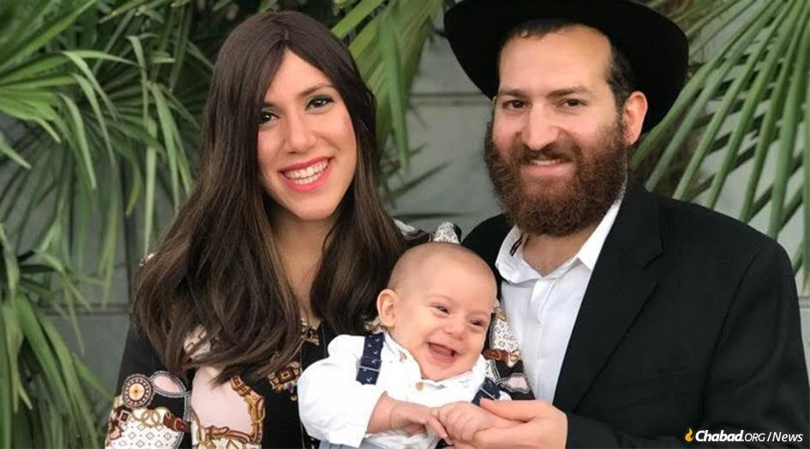
Rabbi Mendy and Mazal Sternbach, co-directors of a new Chabad center in Africa's most populous city of Lagos, Nigeria, with the continent's fourth-largest economy.

When Mendy Sternbach first traveled to Nigeria from Brooklyn, N.Y., in 2014 as a 21-year-old rabbinical student to help out for the High Holidays, he didn’t expect that someday he would be putting down roots in Africa. But year after year, something drew him back—and now he and his wife, Mazal, are about to embark on establishing what will be Chabad’s 11th permanent presence in sub-Saharan Africa, in the continent’s most populous city.
While simultaneously studying in New York and Israel to earn his rabbinic ordination and rabbinical judicial degrees over the past six years, Sternbach returned to Nigeria for almost every Jewish holiday. He occasionally remained for extended periods of time to assist Rabbi Israel and Haya Uzan, who established a Chabad center in the Nigerian capital of Abuja in 2012 and have since provided the necessities for Jewish life to the 1,000 or so Jews living in the country.
Despite the challenges of both a new continent and culture, Sternbach told Chabad.org that “the overwhelming support from the local Jews and the never-ending work,” gave him the impetus to return each year. “The community was always asking: ‘When will you be back?’ ” said the young rabbi.

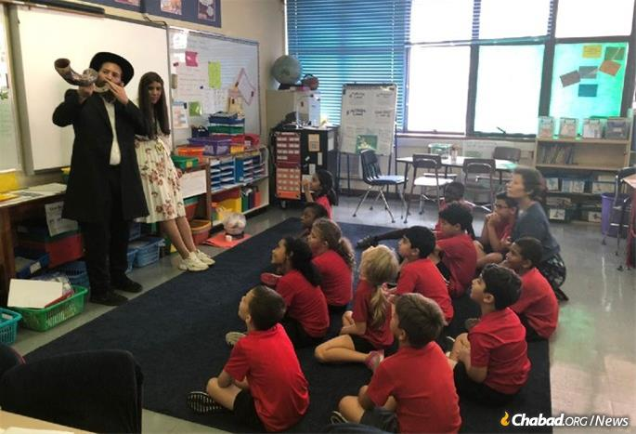
The Sternbachs teach about Rosh Hashanah in Chabad's new school.

Sternbach, who is 27, and his wife, who is 22, will now be opening their own Chabad House to serve about 450 Jewish residents in the coastal city of Lagos, Nigeria—Africa’s most populous city of 17.5 million and the continent’s fourth-largest economy.
“Nigeria has tremendous economic potential and with its growth, the Jewish community is expected to grow as well,” said Sternbach. “We will be here with the infrastructure in place, ready to serve their needs and achieve the directive of the Rebbe [Rabbi Menachem M. Schneerson, of righteous memory] to bring Torah study, the permanence of mitzvahs, and the love of G-d and Jewish tradition to every place in the world where Jewish people can be found,” he declared.
Following her graduation from Beth Rivkah high school in Yerres, France, and seminary in Montreal, Mazal Sternbach served as a teaching assistant in Wisconsin. “While in Milwaukee, I received a call from Rabbi Uzan asking me to come to Nigeria to help him with educational programs,” she said. “It was an amazing experience. The community in Abuja was so welcoming. I was involved in directing the preschool, an online school, running children’s programs, CTeen, Shabbat and holiday programs. Nigeria is such a unique place, and I feel so lucky to be a part of this beautiful project.”

Jewish children on a parade of pride in Lagos.

The Sternbachs were married in Paris in 2019 and are about to embark on establishing the latest Chabad center under the auspices of Rabbi Shlomo Bentolila, Chabad-Lubavitch emissary to Kinshasa in the Democratic Republic of the Congo and director of Chabad’s operations in 10 nations in Central Africa.
‘Chabad Brings Jews Together’
The Jewish population in Nigeria mainly consists of businesspeople and expatriates working for international corporations and aid organizations, primarily in the cities of Abuja, Lagos and Ibadan. Dozens of Israeli companies in the spheres of construction, infrastructure, high-tech, communications and information technology, agriculture and water management operate in the country. Solel Boneh (RCC), one of Israel’s largest construction and civil-engineering companies, has been carrying out major infrastructure projects in Nigeria and other African countries for decades.

Dozens of Israeli companies in the spheres of construction, infrastructure, high-tech, communications and information technology, agriculture and water management operate in the country.

Yair Serrano, a Chilean-Israeli businessman based in Ibadan—a large city 80 miles northeast of Lagos—has been living in Nigeria for the past nine years. He is the chairman of a company that provides agricultural equipment and technologies, including poultry vaccines, incubators, chicken coops and nutritional additives, to the local market. He said that he travels to Lagos for holidays to be among fellow Jews and to benefit from Chabad’s activities, but occasionally “Roving Rabbis” visit Ibadan as well.

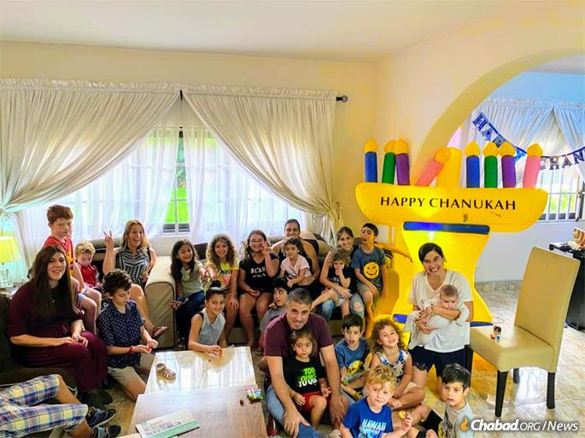
Chanukah is a special time for Jewish kids and their parents on any continent.

“I have lived in many places around the world and Chabad always brings Jews together, regardless of political affiliation or level of observance. Chabad connects us to our Jewish heritage,” said Serrano. “In the past, when RCC was involved in a local infrastructure project, there were more Israelis here (in Ibadan) and even a Jewish school. But by the time I arrived, most of them had left, and only five Jews now remain.
“Judaism is important to me, and Rabbi Mendy and I have a strong relationship. I am very appreciative of Chabad. It is not taken for granted that Chabad sends emissaries here, despite the many dangers and difficulties; it isn’t always so easy,” he added.
In 2017, Serrano hosted the printing of a Tanya in Nigeria as part of a project inspired by the Rebbe, who encouraged the printing of Chabad’s foundational work in every city with a Jewish population.

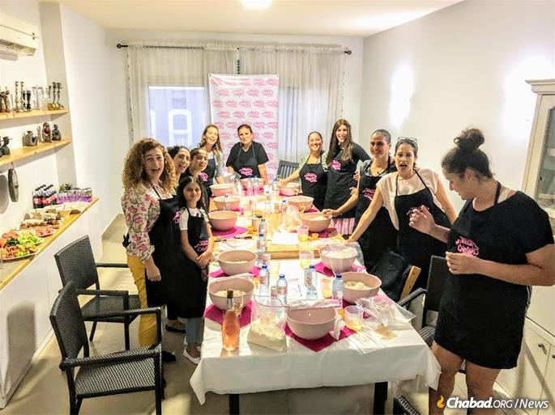
Jewish women gather for a challah bake.

The Chabad center in Abuja includes a synagogue, a Jewish day school and a mikvah (Jewish ritual bath). Rabbi Uzan imports kosher food and recently opened a supermarket stocked with imported kosher products from Israel and the United States with kosher poultry obtained locally.
Nigeria’s population is roughly divided among Christians and Muslims located mainly in the country’s north. The average Nigerian is religious and has very favorable views regarding Jews. “Anti-Semitism does not exist,” attested Sternbach. “The locals love Jews and often approach me in the street to ask for a blessing. They tell me that we Jews are ‘a light unto the nations.’ Local businesses are also eager to assist with Jewish programs and activities.”
“There are so many Jewish souls to light up. We have come to realize that this is our life’s work, and we are proud of it,” said Sternbach. “Chabad is the focal point of Jewish life in Nigeria. It brings Jews together. During our events, we often witness otherwise fierce business rivals sitting and talking together in friendship. That’s something that feels great to be a part of.”

Sternbach with local community leaders and businesspeople eager to assist with Jewish programs and activities.

Reprinted from the November 16, 2020 dispatch from Chabad.Org News.

You Can Thank Jews for
That Orange You’re Eating
By Emily Paster

Jews played a crucial role in the cultivation of citrus.

Winter is citrus season. The sweetest and juiciest oranges, lemons and grapefruits appear in stores just when we seem to need them the most. What could be more welcome on a gray January day than a sunny burst of vitamin C from your favorite citrus fruit?
Not only are citrus fruits delicious and healthy, but they also have a long association with the Jewish people. Humans have cultivated citrus fruits, which originally came from south and east Asia, for thousands of years. Indeed, we Jews are aware, if perhaps unconsciously, of the ancient connection between humans and citrus fruits because of how we celebrate the festival of Sukkot . An etrog — which in botanical terms is an ancient citrus variety known as a citron — is an essential part of that holiday observance. While the Bible does not mention the etrog by name, the citron was identified as the required “fruit of the goodly tree” as early as the second century B.C.E.
As Jews began to spread out into the Diaspora during the late Roman Empire, they had to ensure that, come autumn, they could still find a perfect etrog to use for this important religious observance. Thus, one of the many agricultural activities these settlers engaged in was cultivating citrons. (Interestingly, these early centers of Jewish population coincide with continued areas of citrus production in the Mediterranean today: southern Spain, Sicily and Calabria in Italy, the Nile Delta, the Levant and Algeria.) Many scholars attribute the continued cultivation of citrus fruits in Europe following the collapse of the Roman empire, and the ensuing chaos, to Jewish horticulturists whose need for the fruit was undiminished.

A Byproduct of These Early Jewish Settlers
The cultivation of other citrus species was a byproduct of these early Jewish settlers’ need for citron. Almost all citrus varieties are sexually compatible with one another, and they are highly prone to mutation. Such traits allowed their genes to mix naturally for thousands of years and made it feasible for humans to cross-breed the different varieties. Indeed, just about every citrus fruit you have ever seen comes from just three ancestors: the citron, the pomelo and the mandarin.
From the 10th century onward, citron trees served as grafting stock for other kinds of citrus. By the end of the 13th century, fruits that we would recognize as oranges and lemons were widely grown in the land of Israel and by the next century Jewish merchants, through their contacts in the Levant began importing them to Italy.

Thus began the long association between Jews and the citrus trade in the eyes of Europeans. Starting in the Middle Ages, Jewish merchants traveled from the Mediterranean to northern and eastern Europe with citrons to sell to their brothers and sisters living in colder climes.
This led to a thriving trade in all kinds of citrus, not merely etrogs, and not only to Jewish customers. Italian Jewish traders who settled in Germany used their contacts to import citrus from the Mediterranean to sell to any customers who could afford the high price. In 18th-century England, Jewish peddlers were known to specialize in citrus fruits.
Beginning in the 19th century, Zionist rabbis and other Jewish leaders began encouraging their followers to seek out citrons grown in Palestine instead of those grown around the Mediterranean. This was due in part to anti-Jewish riots on the Greek island of Corfu where many of the citrons destined for northern Europe were grown. Today, of course, Israeli farmers continue to grow and export citrus — more to Europe than to the United States, which has its own robust citrus industry — especially the famous Jaffa orange, which in the 1950s and ’60s was a symbol of pride for the young nation.

The Efforts of Jewish Farmers
So, when you peel a perfect round orange or squeeze some lemon into your tea this winter, know that it is in large part due to the efforts of Jewish farmers and merchants from centuries ago that today we enjoy such a wide variety of citrus fruits.
In that spirit, at this bountiful time of year, do not limit yourselves to the familiar lemons, limes and navel oranges. Explore the whole range of citrus fruits from blood oranges and Key limes to Meyer lemons, pomelos and kumquats. Your local grocery store should have a wide variety of these novel citrus fruits available through March. Here is a guide to some of the best of winter citrus for your enjoyment.

Blood orange: There are three types — Moro, Tarocco and Sanguinello — with a flavor that ranges from tart to semi-sweet depending on the type and season. Named for the deep, beet red color of their flesh, blood oranges are usually smaller than navel oranges and have a dimpled peel. Because of its unique color, the blood orange is often incorporated into recipes, from cocktails to preserves.
Cara Cara: Chefs love this pink-fleshed navel orange. It’s slightly sweeter and less acidic than a regular orange and has a very delicate berry flavor. Use this variety in place of oranges in any recipe or add them to a citrus salad for extra color and brightness.
Seville sour orange: This variety is sometimes called the bitter orange and commonly used in the production of marmalade. The Seville is tart and grown throughout the Mediterranean, but can be hard to find in the U.S. It’s also the a key ingredient in the orange-flavored liqueur Triple Sec.
Meyer Lemons: This lemon-orange hybrid is the darling of the citrus world. Its rind is a vibrant, deep yellow and has a strongly perfumed, almost herbal aroma. Its flesh is darker in color than a regular lemon and more sweet than tart, which means you can use the raw segments in a salad, much like an orange or grapefruit. Delicious in baked goods, marmalade or lemon curd.

The Story of the Key Limes
Key Limes: Smaller than its cousin, the Persian lime, the Key lime is particularly juicy and acidic. It has a smooth rind, a greenish-yellow color when ripe and lots of seeds. Key limes have a distinctive aroma and taste which make them a favorite of bakers everywhere. Of course, pie is what Key limes are best known for, but you can substitute Key lime juice in any lime recipe for a fresh twist.
Pomelos: Often the size of bowling balls, pomelos can look intimidating. The rind can range in color from yellow to green, and the pulp can be white, pink, or somewhere in between. The pith is very thick, so it’s best to cut away as much of the rind and pith as you can first before peeling away at its segments. Think of the taste of a pomelo as akin to a mild grapefruit—sweet and without bitterness. Pomelos are common in southeast Asian cuisine.
Kumquats: You can actually eat the skin of these tiny citrus fruits. About the size of a large olive, kumquats tend to be sweet on the outside and quite tart on the inside. You can slice them into salads, muddle them in a cocktail, candy them or even cook them down into a sweet and spicy chutney.
Buddha’s Hand: This citrus easily wins the prize for most bizarre looking. The fingerlike fruit has a complex lemon aroma and actually contains no pulp or juice—it’s made up of a yellow rind and white pith. The rind can be used in any place lemon zest is called for, or try candying the peel.

Reprinted from the January 17, 2018 website of The Nosher.
Remembering the
Rabbi of Buchenwald
By Rafael Medoff

The date was April 11, 1945, and what Rabbi Schacter was about to experience would change his life forever.
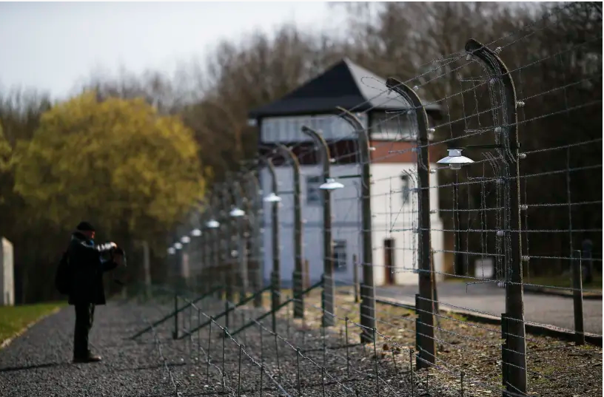
A visitor stands in front of a watchtower behind a fence on the grounds of the former Nazi concentration camp Buchenwald near Weimar (photo credit: REUTERS)

On a sunny afternoon 75 years ago this spring, Chaplain Herschel Schacter was drinking coffee with several officers from his unit, the Eighth Corps of the Third US Army, on the outskirts of Weimar, Germany, when “a friendly Colonel, a nice man” approached.
“You know, this may be of interest to you,” the colonel began. “We just got word that our troops penetrated a place called Buchenwald. It’s some kind of concentration camp, I think.”
The date was April 11, 1945, and what Rabbi Schacter was about to experience would change his life forever.
Schacter and his assistant, Private Hyman Schulman, drove five miles to the site. The German guards had fled as American forces arrived earlier that day. Trembling, Schacter stepped through the front gate. His eye “caught a glimpse of a tall chimney with billowing smoke still curling upward.” It was Buchenwald’s crematorium.

He Could Scarcely Believe His Eyes
“I scarcely could believe my eyes,” he later recalled. “There I stood, face to face with piles of dead bodies strewn around, waiting to be shoveled into the furnace that was still hot. It was just an incredible, harrowing sight. I stood there for a while in utter confusion and disbelief. I then began to really feel what this horror was all about.”
A GI led the rabbi to a nearby prisoners’ barracks.
“A foul odor hit me as I entered. I saw a series of shelves, hard cold planks of wood from floor to ceiling. There were hundreds of men and a few boys lying on stinking straw sacks, looking out at me from dazed and bewildered eyes, skin and bones, more dead than alive.”
Schacter was “overwhelmed, stunned, terrified, not knowing what to say or do. Impulsively, instinctively, I shouted in Yiddish, ‘Sholom aleichem Yidden, ihr zeit frei – Greetings, Jews, you are free!’”
Raised in the heavily Jewish Brooklyn neighborhood of Brownsville, Schacter earned his rabbinical ordination at Yeshiva University, and assumed his first pulpit in Stamford, Connecticut, in 1941. Then the United States entered the war and everything changed. Members of the clergy were exempt from military service.

After Pearl Harbor He Felt Uncomfortable Outside the Military
“But after Pearl Harbor, I felt uncomfortable that all the other young men were enlisting, and I wasn’t,” he recalled. “I couldn’t stand it.”
After completing a training course at the Army Chaplain School on the campus of Harvard University in Boston, Schacter was first stationed in New Orleans, and then San Juan, Puerto Rico. He conducted religious services for Jewish GIs, counseled them on personal matters, and gave classes.
The Caribbean would have been a pleasant place to spend the remainder of the war but in the wake of the Allies’ D-Day land
invasion of continental Europe, Schacter was anxious to join his comrades on the front lines. After repeated pleas to the Office of the Chief of Chaplains in Washington, he got his wish.
Soon Schacter found himself accompanying troops into newly liberated Holland. There he presided at the first bris (circumcision) by Dutch Jews since the war began. The guest of honor was a baby born a year earlier in attic in Maastricht, where a young Jewish couple had been hiding from the Nazis. In the weeks to follow, Schacter conducted Passover Seders for soldiers in units that were pushing through Germany.

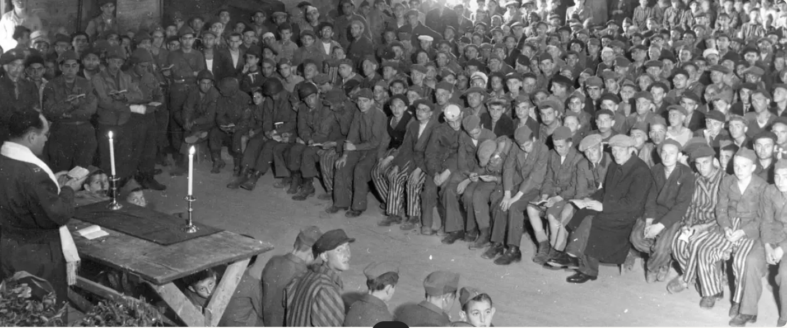
Chaplain Herschel Schacter leading survivors at the liberated Buchenwald concentration camp in a religious service in 1945.

“Just as the ancient Children of Israel had to cross the Red Sea to celebrate the first Passover, so have we crossed the Rhine to celebrate the first Passover in Nazi Germany since the rise of Hitler,” he wrote to his family. The Jewish soldiers “had tears of joy in their eyes when we tore down a swastika flag and put up a sign with a Magen David [Star of David] over the doorway” where the Seder took place.
APPROXIMATELY 21,000 Jews remained alive in Buchenwald on its day of liberation. When Chaplain Schacter entered their barracks, prisoner Moshe Avital later recalled, “We were afraid [because] we always associated military uniforms with the SS.”
But then they heard the rabbi call out “Yidden, ihr zeit frei!” and saw the Jewish chaplain’s symbol of the Ten Commandments on Schacter’s lapel.
“We crowded around him and hugged and kissed him,” Avital wrote. “And some asked him, ‘Why did you take so long to come?’”
They followed him as he proceeded from barracks to barracks, announcing the news of their freedom. At one point, Schacter found himself “paralyzed in front of a mound of corpses.”

Extracting the Child from the Pile
He noticed a small movement from among the bodies and stepped closer. The eyes of a young boy stared out at him. After extracting the child from the pile, Schacter asked him his age.
“I’m certainly older than you,” the boy replied cryptically. Schacter recalled: “‘Older than me?’ I asked, startled. ‘What makes you think so?’
‘Because you cry and laugh as a child, while I have forgotten how to laugh and I can’t even cry. So tell me, which of us is older?’”
The eight-year-old boy, known as “Lulek,” was Israel Meir Lau, who grew up to become the chief rabbi of Israel.
With the permission of his superiors, Schacter returned to Buchenwald every day for the next two-and-a-half months. Neglecting his army chaplain’s duties and ignoring the constant risk of communicable diseases, he devoted himself to nursing the survivors back to life. He conducted religious services, counseled the grieving and broken, and served as their liaison to the military authorities.

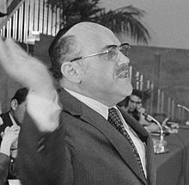
Rabbi Herschel Schacter speaking in 1971

Schacter compiled long lists of the survivors’ personal information, and worked with the Red Cross and Jewish relief groups to reunite the prisoners with their families. He also convinced US Army officials to set aside a nearby tract of land for a group of young men and women who established “Kibbutz Buchenwald,” a site for agricultural training in preparation for immigrating to the future State of Israel.
When the Swiss government agreed to admit several hundred children, Schacter bent rules and forged documents to include many additional passengers on the train, even hiding mothers in the train cars’ bathrooms so they would not be separated from their children.

Accused of Bringing More Orphans than Permitted
Schacter joined them on the long train ride to Switzerland, and emerged victorious from a tense standoff with border officials, who accused him of bringing more orphans than permitted.
The American Jewish military chaplains who were sent to Europe during World War II had no advance warning or training for dealing with survivors of death camps. Schacter rose to the challenges posed by extraordinary and unimaginable circumstances, and the survivors whom he impacted regarded him as having saved their lives.
Schacter’s months in Buchenwald deeply affected his own life as well. In the short run, he served as the voice of the survivors in a coast-to-coast speaking tour in 1946 that drew the American public’s attention to the plight of displaced persons, and the need for a Jewish homeland.
In the longer run, Schacter’s personal connection to the Nazi genocide inspired him to devote his life to Jewish communal service; first as a major figure in the revitalization of American Orthodox Judaism in the 1950s and early 1960s, then as an early leader of the Soviet Jewry protest movement, and finally as the first Orthodox rabbi to chair the Conference of Presidents of Major American Jewish Organizations.
Through his decades of community leadership, there pulsed a sense of commitment that had been nurtured in the crucible of Buchenwald, where Schacter had witnessed the ultimate, tragic toll of inhumanity.
The writer is director of the David S. Wyman Institute for Holocaust Studies in Washington, DC, and author of more than 20 books about the Holocaust and Jewish history. This essay was adapted from his forthcoming biography of Rabbi Herschel Schacter.

Reprinted from the May 9, 2020 email of the Jerusalem Post.

Two-Gun Cohen: Artful Dodger Turned Chinese Legend and Hero of Israel
By Daniel S. Lewy

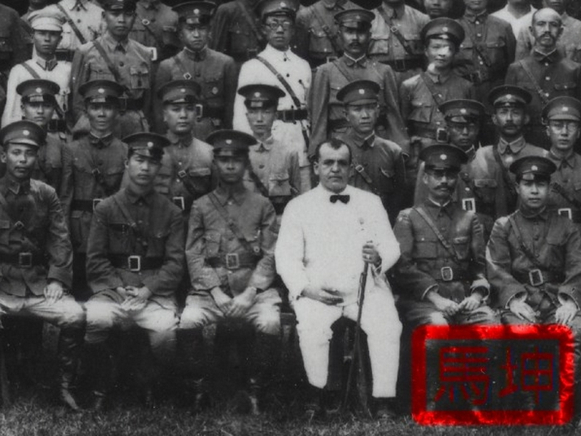
Morris "Two-Gun" Cohen – known as "Ma Kun" in Chinese – surrounded by troops, July 1926. Original image from the Collection of Josef L. Rich OBE

“It turned out that General Two-Gun Cohen wasn’t kidding when he said he had influence with the Chinese,” recalled Canadian Jewish Congress leader Saul Hayes. Not only did he know the Chinese members, but “he would get us the damnedest documents. I never asked how or why.”
One day while Hayes was walking down the street with Cohen they came across Wellington Koo, the Chinese ambassador to the United States, Vice Premier H.H. Kung, and Premier T.V. Soong.
“And, by G-d, the first thing I know is they embrace the man.”
It was April 1945, right before Nazi Germany surrendered and the thousand-year Third Reich died. Four-dozen nations had gathered in San Francisco to form the United Nations. Britain had controlled Palestine since they assumed stewardship of it following World War I, and many Jews were anxious about the future of the British mandate for the territory.

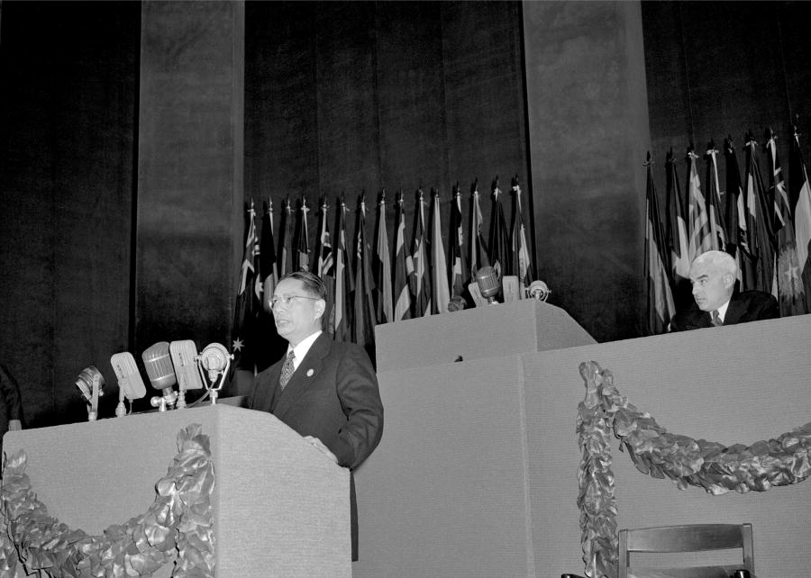
T. V. Soong, Chairman of the Chinese Delegation, addresses the First Plenary Session at the San Francisco Conference, on 26 April 1945 (UN Photo/Rosenberg; CC BY-NC-ND 2.0)

Representatives from such groups as the American Jewish Conference and the Jewish Agency of Palestine – along with prominent leaders like Rabbis Stephen Wise and Abba Hillel Silver – descended on the Bay City to lobby their cause.
Jewish organizations especially worried that Britain might abandon her commitment to establish a Jewish homeland. They sought to make sure the UN did not reduce or eliminate Jewish rights in Palestine under the 1917 Balfour Declaration – which states that Britain “view with favour the establishment in Palestine of a national home for the Jewish people” – or the 1922 League of Nations-approved mandate over Palestine. They therefore hoped for the insertion of a clause within the UN charter that protected the rights of minority groups like those of the Jews living in Palestine.
Yet they were not the only lobbyists there. An Arab delegation hoped that the council would only recognize the rights of the single largest group in each trusteeship territory. In Palestine, the Arabs made up the majority.
The Jewish delegates held planning meetings and prepared for the formal sessions, yet struggled to gain access to some delegations. One group the Zionists could not contact was the Chinese. Then Rabbi Israel Goldstein, the head of the Zionist Organization of America, recalled that Morris “Two-Gun” Cohen had settled in Montreal during the war.

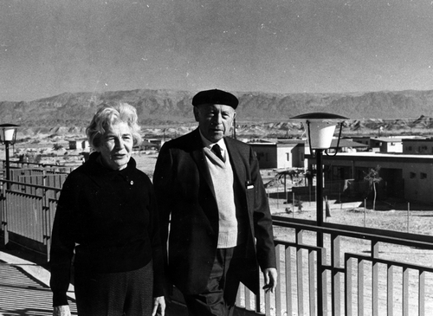
Rabbi Israel Goldstein visiting newly established settlements in the Negev, 1969 (Photo: Dan Hadani). From the Dan Hadani Archive, Pritzker Family National Photography Collection at the National Library of Israel

Goldstein had recently met the adventurer who had improbably become a general in the Chinese Army. The rabbi cabled him, “urging him to fly out to San Francisco and assist us with an introduction.”
Cohen happily obliged.
Cohen, who had spent two decades in China, knew many of that nation’s leaders and offered to introduce Jewish Agency leader Eliahu Elath and others to his friends in the Chinese delegation.
The group’s lobbying of all the national delegates paid off. Palestine remained a mandated territory, and Clause 80 – nicknamed the “Palestine Clause” of the U.N. Charter – protected the rights “of any states or any people” within the trusteeships.
As Saul Hayes later said:
“I am not suggesting that if we didn’t succeed there’d be no state of Israel… I am suggesting it would have taken a great many years of hard slogging if it had ever gone into the trusteeship division.”

From London’s East End to the Canadian prairies
Morris Abraham Cohen was an anomaly.
No one would have suspected that a man who started out as a juvenile delinquent would turn out so well. Born on August 3, 1887 in Poland into an Orthodox family, he arrived in London as a young child, and grew up in the East End of London. He was more of an Artful Dodger than a yeshiva bucher, and was arrested as a teenager for picking pockets. The authorities shipped him off to an industrial school for wayward Jewish kids.

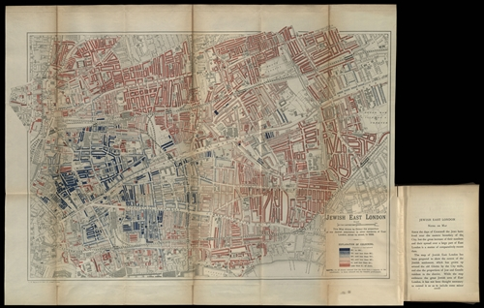
Map of East London color coded by percentage of Jewish residents, 1900. Black indicates a population that is 95-100% Jewish. From the Eran Laor Cartographic Collection, National Library of Israel.
Like many of those the British wished to be rid of, they then packed Cohen off to western Canada in 1905. On a farm outside the town of Whitewood, Saskatchewan he got to work planting crops, tending to the animals and helping with the chores. And for someone who would one day be known as “Two-Gun,” he also learned how to handle a pistol. But a year working the land was enough for Cohen, and he began wandering from Moose Jaw, Saskatchewan to Winnipeg, Manitoba.
He was a talker in a traveling circus, peddled questionable goods, and plied his trade as a card sharp. Not surprisingly, he regularly got arrested and incarcerated for everything from gambling and pick pocketing.

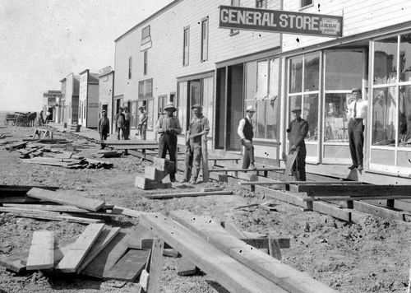
Robsart, Saskatchewan, ca. 1915 (Photo: John Asplund)

Becoming a Chinese legend
If it wasn’t for a fluke, Cohen would have been ignored by history. Cohen was a porky man who enjoyed Chinese food almost as much as he loved a shady hand of cards. One evening he walked into a Chinese restaurant-cum-late-night-gambling-den in Saskatoon, Saskatchewan. There he stumbled right into the middle of an armed robbery.
“I saw it was a holdup,” he later recalled, “but I wasn’t heeled – that is, armed – and I had to be careful. I closed in till I was too near for him to use his rod and socked him on the jaw. The fellow was out for the count.”
Such an act was unheard of. Few white men ever came to the aid of a Chinese man in early 20th century Canada. As a Jew, though, Cohen felt an affinity for the Chinese underdog. He knew what it was like to be an outsider, someone who society shunned.
Cohen’s selfless act immediately won him the respect of the Chinese community. His new Chinese friends spotted him wagering money and soon asked him to join the Tongmenghui, the political organization of the revolutionary leader Dr. Sun Yat-sen, which a few years later developed into the Guomindang. Cohen became a loyal member, learned of Sun’s teachings, regularly attended lodge meetings, started speaking at some of the get-togethers and gave generously from his gambling earnings to various funds.

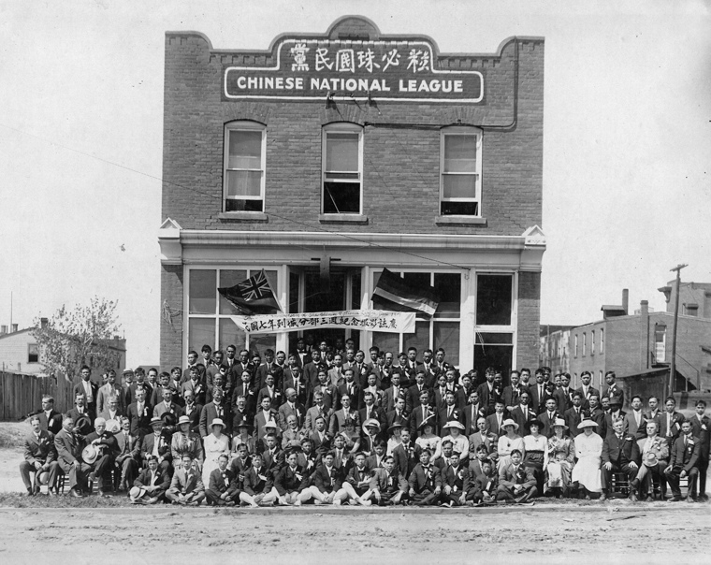Guomindang (Chinese National League) members and invited guests, 1918. From the Galt Museum and Archives, Lethbridge, Alberta, Canada

Yet even with his political awakening, Cohen continued to drift. He spent time in prison in Prince Albert, Saskatchewan and missed Dr. Sun’s fundraising visit to Canada. Cohen eventually rambled to Edmonton, Alberta, made money in real estate and tended to the needs of the Chinese as a spokesman for the local expatriate community.

World War I and on to China
When the glory days of the real estate bubble burst just prior to World War I, Cohen did what many recently unemployed men did, he enlisted.
In Belgium he and his comrades in the 8th Battalion of the Canadian Railway Troops built train tracks to rush troops and supplies to the front, and he oversaw some of the Chinese Labour Corps. There he painfully lived through one of the war’s worst slaughters during the Battle of Passchendaele.
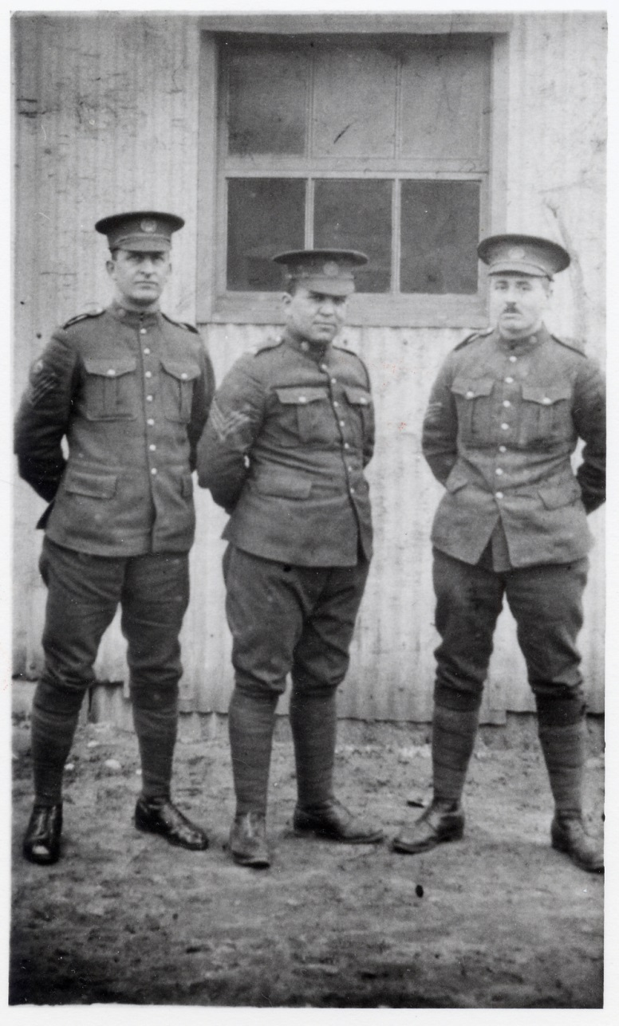
Acting Sergeant Morris Cohen (middle), ca. 1916. From the Collection of Victor D. Cooper

After the Armistice, Cohen became heavily involved with the Great War Veterans’ Association in Edmonton, and acted as a political advocate for his Chinese brothers.
Life, though, wasn’t the same after the war. The Canadian real estate market had not bounced back. Cohen felt unsettled, and wanted a change. So in 1922 he headed to Shanghai.
Once in town, he used his Guomindang connections and polished salesman ways to wrangle an interview with Dr. Sun and a job as a bodyguard to the leader and his wife, Soong Qingling.
As an aide-de-camp to Sun, Cohen quickly became one of the leader’s main protectors, and lived in Sun’s military compound when the Chinese leader returned to Canton.

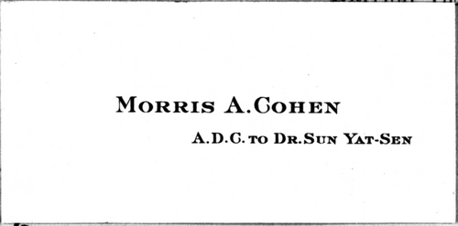
Cohen’s business card, early 1920s (Public Record Office, Kew)

During this period in the 1920s, warlords had divided up the nation. While Sun Yat-sen was known and respected across China, he controlled little and desperately sought to consolidate his position in the south of China. He was a dreamer who believed that he could conquer the nation and establish a democratic society. In a small way, Cohen tried to assist his boss in making that dream a reality. He helped supervise the other bodyguards, trained the men to box, taught them how to shoot, all the while thwarting attempts on Sun’s life.

General Two-Gun
During one attack on Sun, a bullet nicked Cohen’s arm. The injury gave Cohen pause:
“The bullet that caught me in the left arm had made me think. Supposing it had been my right arm and I carried my gun that side, I’d not have been able to use it. As soon as we got back to Canton I got me a second gun, another Smith and Wesson revolver, and I packed it handy to my left hand. I practiced drawing and soon found that I was pretty well ambidextrous – one gun came out about as quick as the other.”
His fashionable two-gun accessories attracted attention amongst the western community already intrigued by this Jewish Englishman who cavorted with the Chinese. They started calling him “Two-Gun” Cohen. A nickname was born.

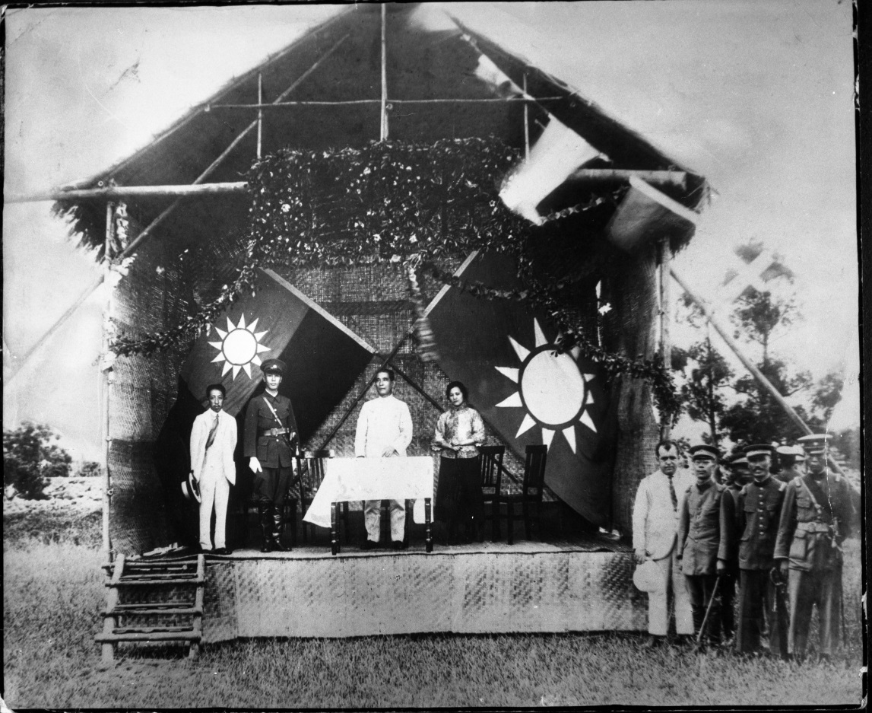
Cohen in a white suit at the dedication of the Whampoa Military Academy (on stage from left: Liao Zhongkai, Chiang Kai-shek, Sun Yat-sen, Soong Qingling), June 1924. From the Collection of Josef L. Rich

Alas, Sun died in 1925, never having realized his dream of unifying China. Cohen then worked for a series of leaders in Canton and Shanghai, from Sun Yat-sen’s son, the politician Sun Fo, to Sun Yat-sen’s brother-in-law, T.V. Soong. He also attached himself to various south Chinese warlords.
One of Cohen’s main jobs for his bosses was purchasing weapons. He was all over the place, visiting North America, South Africa and Southeast Asia, buying Lewis guns from England, Mausers from Germany, Zephy machine guns from Czechoslovakia and gunboats from Hong Kong.
He was promoted to the rank of Major General in 1935, and by then had become a regular fixture in the night life of Shanghai and Hong Kong, throwing banquets and squandering much of his earnings.

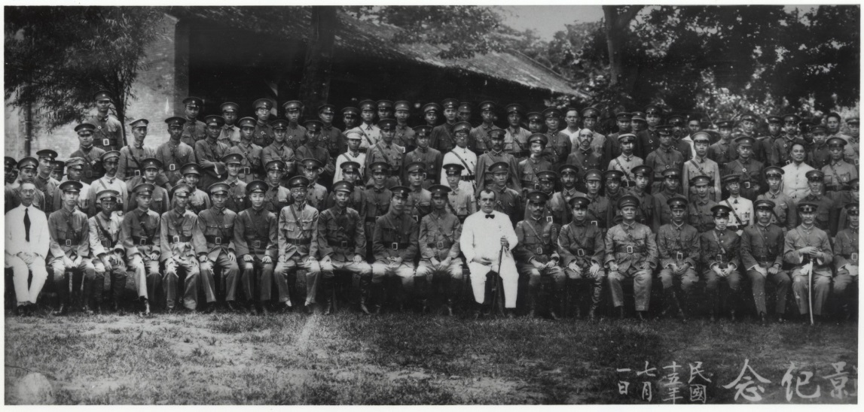
Cohen with the troops, July 1926. From the Collection of Josef L. Rich OBE

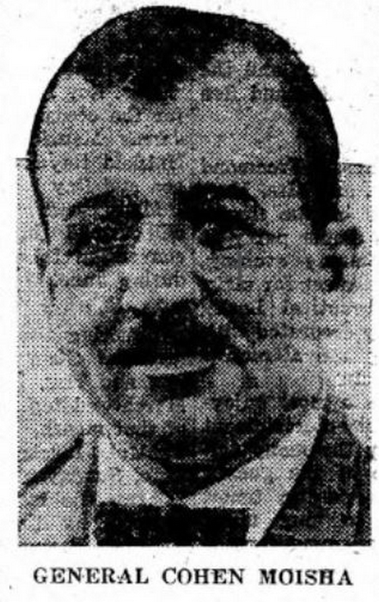

“His parents believe he is the real president of the country…” This quote and photo of Cohen appeared in a feature about him published in the B’nai B’rith Messenger⁩⁩, 6 May 1932. Available via the NLI Digital Collection

Socialite and Spy
Cohen also passed time at the Hong Kong Jewish Club, whiling away the time playing poker with friends and showing magic tricks to children. The New Yorker writer Emily Hahn had become friends with Cohen, and especially remembered that
“He was like a character out of a book. He was like something somebody wrote.”
With the start of World War II, Cohen was involved in arms buying and surveillance work to combat the invading Japanese army, and did work for British Intelligence’s Special Operations Executive.

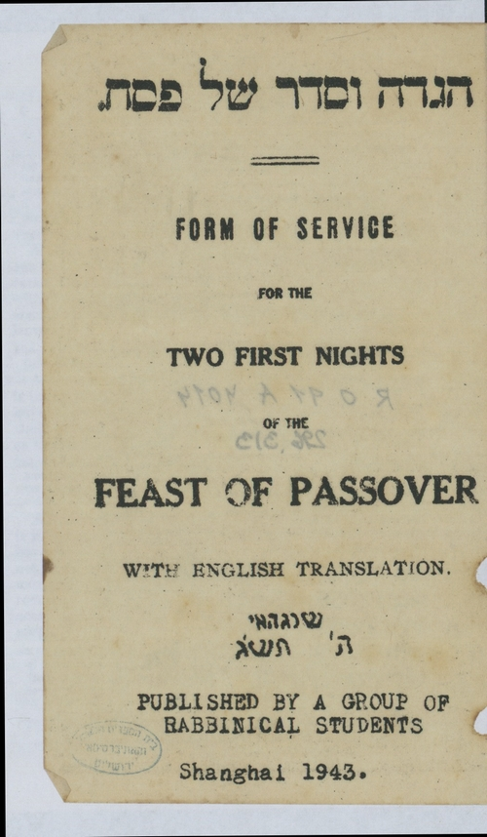
Haggadah printed and used in Shanghai, 1943. From the National Library of Israel collection

As the war spread in Europe, Jewish refugees streamed to Shanghai, one of the few places that did not require a visa to enter. With the Japanese controlling the surrounding territory, the city’s International Settlement had become a hostage community, and the Japanese forces anxiously waited to enter.
German, Austrian and Polish Jews inundated the city. In February 1939, 2,500 new Jewish refugees arrived in Shanghai. By the end of year the number had reached 17,000. Most needed assistance. Shanghai’s modest Jewish relief organizations could not cope with the influx of so many people, and the U.S. State Department wanted to process those heading for the United States.
Hoping to smooth out the procedures, the State Department pressured the American Jewish Joint Distribution Committee to start sending money for relief. The J.D.C. also dispatched the American social worker Laura Margolis to investigate and reorganize the refugee relief efforts.
Margolis landed in Hong Kong in May 1941. She spent a week in the colony as she tried to secure a spot on a Dutch ship heading north. With time on her hands, she visited the offices of the Far East Rice Bowl Dinner Campaign.
“When I got back to the hotel I found an invitation to dinner – at the home of Mrs. Sun Yat-sen. I would be picked up in the evening by a General Cohen,” she said of the unexpected arrangements. “He picked me up and we got to her home for dinner. It was a delightful evening, with both foreigners and Chinese.”
Margolis was to see more of Soong and Cohen:
“General Cohen and I became very good friends. He took me all over and became my Hong Kong escort.”
Similarly, when Ernest Hemingway and his wife, the correspondent Martha Gelhorn, came to China to report on the growing war, Cohen also showed them around.

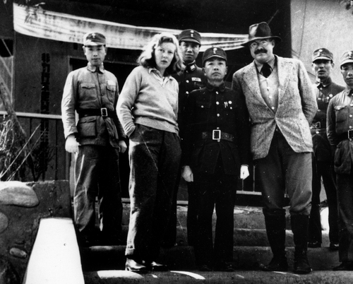
Martha Gellhorn and Ernest Hemingway in Chongqing, China, 1941. From the Ernest Hemingway Photograph Collection, John F. Kennedy Presidential Library and Museum, Boston
Cohen was in Hong Kong in December 1941 when the Japanese attacked, and escorted Madame Soong along with her sister Ailing – the wife of H.H. Kung – to one of the last planes out of the colony.
“I took the two sisters across to the mainland and saw them off,” said Cohen of that long evening.
“It was a pretty grim farewell. We all knew that it was likely to be our last. For once I found myself absolutely tongue-tied. I couldn’t think what the hell to say. We shook hands, and I just blurted out, ‘We’ll fight to the bitter end, anyway.’”
Madame Soong stopped on the ramp and gazed down at him. “We’ll fight too, Morris,” she told him, “but not to the bitter end. The end, when it comes, will be sweet!”

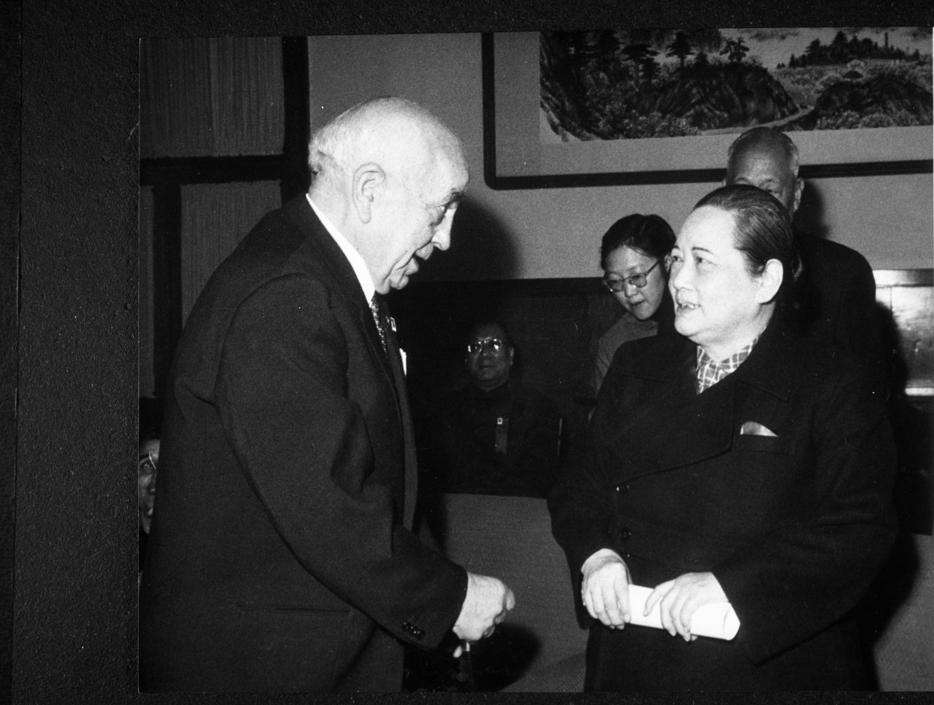
Cohen with Soong Qingling, 1950s. From the Collection of Victor D. Cooper

The Japanese quickly captured the city, and interned thousands in prison compounds. Cohen was clapped into Stanley Prison Camp on an isthmus at the south end of the island. There his captors badly beat him, and he spent his time there trying to keep a relatively low profile.
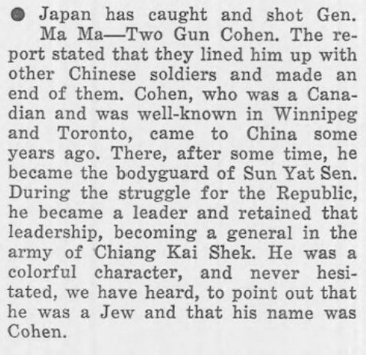
False report of Cohen’s demise published in The Sentinel, March 19, 1942. Available via the National Library of Israel Digital Collection

Between Canada and China
Cohen held Canadian citizenship, and in late 1943 the Japanese included him in a prisoner exchange with the Allies. He arrived in Montreal in December. The following summer he married Judith Clark – the owner of a high-end dress shop – at Temple Emanu-El.

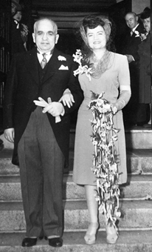
Morris and Judith Cohen on their wedding day, June 18, 1944. From the Collection of Josef L. Rich OBE
This was when Cohen’s active Chinese career ended, but it was also the start of his myth-making as he exaggerated his position in China and desperately tried to reestablish his position in the country.
It was difficult.
Mao Zedong and Chiang Kai-shek were battling for the soul of China, and there was no place for Cohen in the new political pot. Even so, his time with Sun and the reverence for the leader’s name guaranteed that he was always to be remembered as a loyal assistant to the father of modern China.

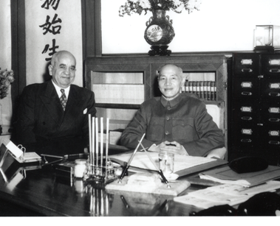
Cohen and Chiang Kai-shek, 1950s. From the Collection of Victor D. Cooper

Cohen’s link to Sun also gave him rare though limited access to both camps.
He spent about four months each year in China, mostly hanging out in Shanghai and Hong Kong, visiting old friends and speaking to anyone who would listen to his stories.
There were many stories.

Zionist and Jewish activism
Besides his work for the Zionists at the 1945 United Nations conference in San Francisco, Cohen assisted a Shanghai Zionist group formulate plans to bomb British sites in the event that the British did not pull out of Palestine, and in the late 1940s aided a number of Jewish Shanghailanders win their freedom after they were kidnapped by unruly Chinese troops.
In 1947 the United Nations approved the establishment of a Jewish state in Palestine.
The Arabs opposed the plan, and further fighting erupted between the Arabs and the Jews. Fearing that the surrounding Arab nations would attack once the British left in 1948, many Canadian Jews bought rifles, machine guns, mortars, airplanes and other war surplus for shipment to Jewish Palestine.
They packed the cargoes in crates marked “machine tools” and sent them via front organizations to the Middle East.

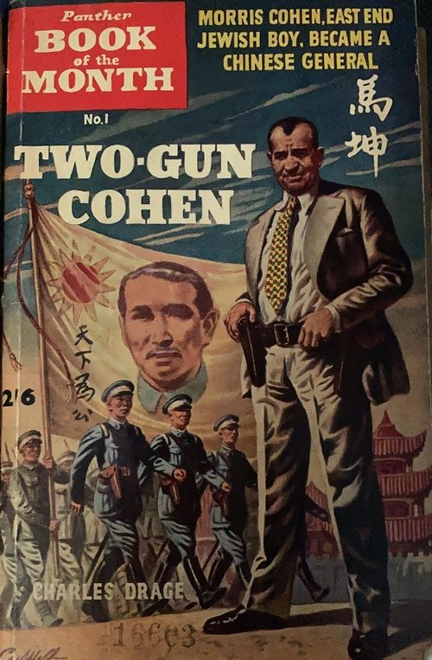
The book Two-Gun Cohen helped cultivate the myths surrounding Cohen’s life and exploits. From the National Library of Israel collection

Sydney Shulemson, the most highly-decorated Canadian Jew to fight in World War II, actively worked to round up troops and weapons for Palestine. In November, he heard that China had purchased 200 De Havilland Mosquito bombers from Canada. The legendary plywood and balsa “Mozzie” had a resilient fuselage and a Rolls-Royce engine, which made it so fast and maneuverable that the aircraft distinguished itself in its sorties against shipping and V1 flying bombs.
According to Shulemson:
“The Canadian government had a large number of them at the end of World War II… I remember reading that these had all been test flown, reconditioned and then disassembled, crated and shipped to China. It occurred to me that I had never heard that China had ever used them. I wondered whether it might be possible to acquire these for Israel. That could have comprised the whole air force.”

De Havilland Mosquitos

Shulemson met with Cohen, who called the Chinese Ambassador in Ottawa. When Cohen hung up the phone, he asked Shulemson, “Do you like Chinese food?” Shulemson said yes, and Cohen then told him, “Well we are having lunch with the Chinese ambassador in Ottawa tomorrow.”
Despite their efforts, nothing came of the plane deal. The Chinese government was too corrupt to be bothered.
“Eventually General Cohen told me not to pursue it. The planes had never been uncrated, but they could not be sold. Apparently the people who arranged the exchange were more interested in exchanging Chinese currency for Canadian currency.”

Back to England
Unfortunately, Cohen’s long periods away from Montreal took a toll on his marriage to Judith. By the time of his divorce in 1956, he had moved in with one of his sisters in Manchester.
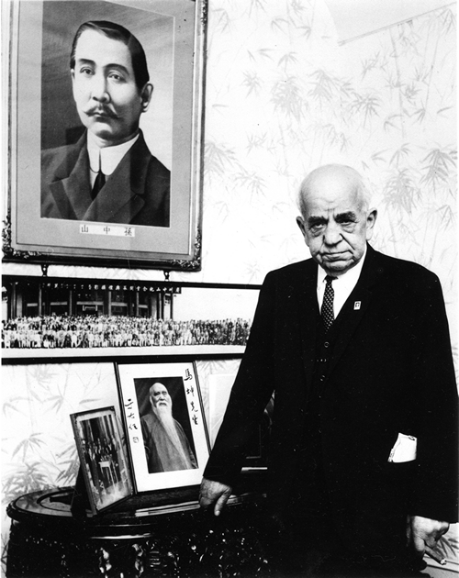
Cohen in Manchester, England, 1966. From the Cohen Family Collection

Cohen’s last visit to China was in 1966 as a guest of Premier Zhou Enlai for the 100th anniversary of the birth of Dr. Sun.
His battles finally ended on an autumn day in 1970. The man who during his lifetime was reported killed numerous times died peacefully in England, surrounded by two of his sisters, but far from his adopted home and his Chinese comrades. Relatives, acquaintances, and the press attended the Jewish funeral service the following day.
The funeral marked one of the few public occasions where Communist Chinese and Nationalist Taiwanese officials appeared together in public.
Even if these countrymen refused to accept each other’s existence as they stood side by side above Cohen’s grave, his old allies could not ignore their western brother.
Dr. Sun’s wife, Soong Qingling, could not forget Cohen either. Upon being contacted by his family, she sent a Chinese inscription to be carved alongside the English and Hebrew markings on his black granite tombstone. A final tribute to her faithful protector and friend.

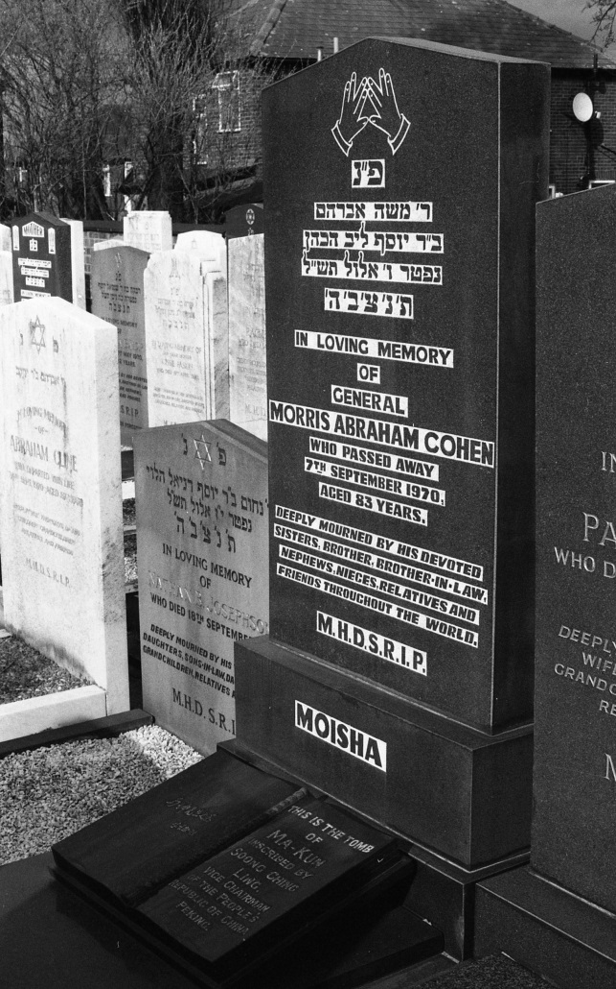
Morris “Two-Gun” Cohen’s tombstone, Manchester, England (Photo: Daniel S. Levy)

Daniel S. Levy is the author of Two-Gun Cohen: A Biography. In the fall of 2021, Oxford University Press will release his Manhattan Phoenix: The Great Fire of 1835 and the Emergence of Modern New York, which deals with that city’s transformation in the years leading up to the Civil War.
This article has been published as part of Gesher L’Europa, the National Library of Israel’s initiative to share stories and connect with people, institutions and communities in Europe and beyond.

Reprinted from the December 20, 2020 email of The National Library of Israel.

Not Your Grandmother’s Kosher Cheese
By Elliot Resnick

Approximately 2,200 years ago, Yehudis – the Chanukah heroine – used cheese and wine to induce the Greek general Holofernes to fall asleep in his tent, after which she chopped off his head and saved the residents of her city.
For most American-born Ashkenazi Orthodox Jews, cheese is an ordinary food not usually given much thought. But to food connoisseurs, a good cheese is not to be snuffed at, and the difference between, say, American cheese and a high-end blue cheese is just as great as the difference between a bottle of grape juice and an expensive French dry wine.

High-end kosher cheeses were hard to come by in America in decades past, but Brent Delman – founder and owner of “The Cheese Guy” brand – has aimed to change that. The Jewish Press recently spoke to him to learn more.
The Jewish Press: On your website, you note with pride that you make “artisinal cheese.” What’s artisinal cheese?
Delman: It’s cheese made using traditional methods that very often go back many generations. The cheese is often hand-crafted and involves lots of manual labor. So it’s higher quality, a lot of attention is paid to small details, and the cheese is made in small batches as opposed to being mass produced.

When and why did you start your cheese business?
About 18 years ago. I was in the specialty food business and marketed and sold many specialty cheeses from around the world. I personally have a passion for these cheeses, so when I became kosher about 20 years ago and realized there was a lack of good kosher cheeses available, I decided to [do something about it].
In the last two decades, the quality of kosher wine has improved, arguably due to the increasing number of baalei teshuvah. Is a similar development playing out in the world of kosher cheeses?

Many Young People Have Discerning Palates
Absolutely. There’s been a surge in the number of young people who have discerning palates and disposable income. Baalei teshuvah have probably eaten some of these [higher end] cheeses and [want to continue eating them now that they keep kosher].

Brent Delman

Also, people are traveling more – or were prior to Covid – and when they travel to Europe and elsewhere, they see all these wonderful products available out there and want to [have them back home] in the kosher marketplace.
You make some of your cheeses in Italy and Argentina, correct?
Right now, none of them are made in Argentina, but in Italy, yes. I also make cheese in Spain, Denmark, and New Zealand. I started out as a small company, so I was primarily partnering up with people in upstate New York and Vermont. But then the company expanded and I partnered up with small-batch artisanal producers in Italy and on Amish farms in Ohio, where I grew up.

Many Italian Chesses Come from the Island of Sardinia
Many of the Italian cheeses come from the island of Sardinia, and I have a business partner in Italy whom I go to visit a couple of times a year. We meet with farmers and put together a production [plan]. We then oversee the cheese production, and it’s shipped to me when it’s young; I then do the aging on the cheese here in the United States.
Why does the cheese have to be made in Italy? Why can’t you make it here?
The Italians are known for producing some of the best cheese in the world. They have traditional methods – methods that have been handed down over the course of many, many generations.
There’s also a concept in food production in general – not just cheese – called “terroir.” It’s a French word, which mean the soil, the microbes in the air, etc. [The quality of the cheese can depend on] the breed of animals grazing on specific fields in a particular area.

The Best Sheep Milk Comes from South Italy
Also, many of my cheeses are made from sheep’s milk, and some of the best sheep milk in the world comes from southern Italy. There isn’t a whole lot of sheep milk available in the United States.
So these cheeses wouldn’t taste the same if they were made here, in other words?
It depends. Part of [the reason some of them can’t be made here] has to do with their names. I often give the example of Champagne: Legally, you’re not allowed to produce Champagne in, say, California. It has to come from the Champagne region of France. And why is that? Part of it is marketing, but it’s also because there are certain perceptions associated with the name that people respect.
It’s true of the best quality of other products – like Swiss watches or Belgian chocolate. Can these things be duplicated? Possibly, but there are reasons why regions in the world are known for certain products.
So, for example, there’s a cheese called Pecorino Romano. That’s a protected name. “Pecora” means sheep in Italian, so any time you hear “Pecorino Romano,” it’s a sheep milk cheese that has been aged for an extended period of time, and it comes from a couple different regions in Italy.
One of the key ingredients in producing a traditional Pecorino Romano is animal rennet [which can’t be used to make kosher cheese], so my partner and I went to the Italian and European consortium and asked, “Can we have permission to produce this cheese with the same methodology and milk, and in the same equipment, but with non-animal enzymes and rennet?”
They said, “Go ahead, and then bring it back to us and show us how it comes out.” We did, and they thought it was fantastic cheese, so they gave us permission to call it Pecorino Romano.

Is getting a hechsher for your products difficult?
Well, many of the ingredients – like [some of the] enzymes and bacterial cultures – were never used in kosher production before, so we had to do a lot of research, and I asked a lot of questions from people like Rabbi Avrohom Gordimer from the OU.
Also, all of my cheeses are produced in year-round non-kosher facilities, so that often means completely isolating our production run, aging the cheeses in separate rooms, or purchasing brand new cheese-making and cheese-aging equipment. So there are a lot of hurdles that have to be overcome in order to make a kosher version of a lot of these cheeses.
Is making kosher cheese harder than making other kosher food?
In halacha, the foods that require the most supervision are meat, wine, and cheese. Now, within the cheese category, not everything is as difficult to make as my cheeses. For example, fresh ricotta, cream cheese, sour cream, etc. do not require the addition of rennet and therefore require much less supervision.

Rennet is a big issue. Most non-kosher artisanal cheeses are made using animal rennet, which is an enzyme that comes from the lining of a stomach of a calf or lamb. We don’t use animal rennet, though, because it’s halachically permissible only under very extenuating circumstances. We use a non-animal rennet.
Up until about 30 years ago, non-animal rennet wasn’t even available in the marketplace. It’s only because of developments in the last 20-30 years that I am able to produce some of my cheeses.
Another problem is that many salty cheeses – like feta or blue cheese or Swiss cheese or some of the Italian cheeses – are what are considered “brined cheeses,” so after they’re produced, they soak in a salt water solution. This solution develops bacteria, and that bacteria is an asset to the production of good cheese.

If we’re going into a non-kosher facility, however, we can’t use the same brine as the non-kosher cheese, so we have to produce our own brine tanks, and that’s another challenge.
How many different cheeses do you make?
Approximately 40.
What percentage of them are chalav Yisrael?
About a third.
The logistics and expense of making cholov Yisrael cheese is often prohibitive. You have to have multiple mashgichim sitting for many, many hours, which gets very costly. And then, what if the cows or goats don’t produce enough milk in one day for a cheese production?
Also, the logistics of trying to get mashgichim out to specific farms in a neighborhood is very challenging. If it were done on a mass scale, it would probably be different, but when you’re talking about artisanal productions, it just doesn’t make sense.
Are there are other companies that produce the kind of high-end cheeses you make?
There are a couple, but in the United States, I have a unique niche. I actually have a cheese cellar – a cave in the basement in my house – where I experiment [with various products].
Some people specialize in certain items. For example a couple of French producers specialize in French kosher cheeses and a couple of Israeli producers specialize in specific types of Israeli style cheeses, but nobody has the breadth of selection of artisinal kosher cheeses in the world like I do….
I like to think that I’ve done for the cheese world what the Herzogs did for the wine world. The Herzogs were sort of the first to bring kosher wine in America to the next level. I hope I’m able to do that for the kosher consumer in the cheese world.

Reprinted from the December 18, 2020 edition of The Jewish Press.

The Engineer Who Saved Shabbos: Kosher Refrigerators and Ovens
By Rabbi Yair Hoffman

What this man and his three teams of engineers have done is nothing short of an engineering miracle.

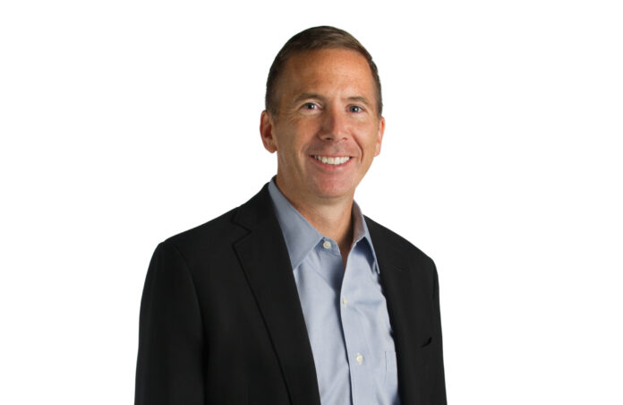

He graduated from the University of Connecticut’s School of Engineering in 1989 with a degree in Mechanical Engineering and a love for helping people out. He is the CEO of GE Appliances which employs over 12,000 people, among which are some very capable teams of engineers. His name is Kevin Nolan and he has invested thousands and thousands of man-hours of his company to meet the Shmiras Shabbos needs of the Torah-observant community.
Why did he do it? Mr. Nolan told the Five Towns Jewish Times, “As a company we follow the zero distance philosophy, which means that we want to be zero distance to all our customers and consumers to learn about their needs, understand their expectations and to be able to develop relevant solutions.”
Mr. Nolan continued, “We saw a unique need in the Jewish community that only we could satisfy better than the competition. We came together as a big team and created a unique product that was specifically designed for this community. This is zero distance in action.”

TWO SIDES TO TECHNOLOGY
For the Torah observant Jew, there are two sides to technology. There is the fact that advances in technology can save us much time, money, and energy. But sometimes, technology can cause the Torah observant Jew some serious halachic quandaries – particularly in regard to Shabbos observance. The modern day keys to hotels is just one area where this applies. As a child, I was once stuck in a restroom until Motzaei Shabbos because of an automatic light. It was a relief to read later in life that Rav Reuvain Grozovsky zt”l had the same quandary.
GE Appliances CEO has accomplished two remarkable engineering feats.
They created an entire line of refrigerators that are fully Shabbos compliant reducing any possible question of chillul Shabbos – according to all Poskim. Some of this line was introduced two years ago.
They created an entire line of ovens that can enhance Oneg Shabbos. This has just been introduced.
Both the refrigerator and the oven have a Shabbos Idle Mode that requires a start button to be hit after a pre-Shabbos warning begins four hours before Shabbos. But before we get to a discussion of these two engineering miracles – let’s get some essential history and background.

REFRIGERATORS – OLD PROBLEMS AND NEW PROBLEMS
Safe home refrigerators came into general household use in the late 30’s and 1940’s. With the original refrigerators, that lasted into the late 80’s and early 90’s, there were some halachic concerns. Four of Klal Yisroel’s leading gedolim addressed these concerns – The Chazon Ish zt”l, Rav Henkin zt”l, Rav Moshe Feinstein zt”l, and Rav Shlomo Zalman Auerbach zt”l.

THE MAIN QUESTION REGARDING OLD REFRIGERATORS
When the refrigerator or freezer door is kept open, warmer air comes in. This could cause the compressor, which cools the air, to be turned on. Is doing this on Shabbos a Torah prohibition or a rabbinic prohibition? Is opening the door considered a direct action, or a grama, a secondary result of a primary action, which under certain circumstances would be permitted?
The Chazon Ish ruled that it is forbidden to open the refrigerator at all, whether the compressor is on or off. (Cited in HaPardes, Cheshvan 5719/1958)
Rav Eliyahu Henkin, zt’l, ruled that one can only open the refrigerator when the compressor is on and it is forbidden to do so when the compressor is off. This was also the view of Rav Elyashiv, zt’l, as cited in Mitbach K’halacha, page 303.
Rav Moshe Feinstein, zt’l, ruled that one can technically open the refrigerator even when the compressor is off, but it is preferable to wait and only do it when the compressor is on. (Igros Moshe, OC Vol. II #68)
Rav Shlomo Zalman Auerbach, zt’l, ruled that one can open the refrigerator door without a problem, whether the compressor is on or off. (Minchas Shlomo Vol. I #10)
In the United States, some followed Rav Henkin zt”l, others followed Rav Moshe zt”l, but the vast majority eventually followed the view of Rav Shlomo Zalman Auerbach zt’l. His three-fold rationale was based upon a combination of three factors:
Causing the compressor to go on involved, in his view, only a rabbinic violation;
Opening the door allowing surrounding air to enter was a grama on a psik reisha;
The compressor did not always turn on.
On account of avoiding the negation of Oneg Shabbos, taking delight in Shabbos, Rav Shlomo Zalman allowed opening the door – even when the compressor was off. The issue may be dependent upon whether Oneg Shabbos is a biblical Mitzvah or a Rabbinic one. The Mishna Brurah in his Shaar HaTziun 242:1 writes that the Ramban holds that it is biblical, while the Sefer HaChinuch (#297) holds that it Rabbinic (as does the Beis Yoseph in Siman 487).

LIGHT BULB IS BIBLICAL
It is important to note that all of the early poskim agreed that it is a biblical prohibition to open the door if it will cause the inside light to go on, so the common practice is to loosen the light bulb, either permanently or before each Shabbos and yom tov, or to keep the switch covered so that it can’t be automatically released when the door is opened.

THE NEW HALACHIC CONCERNS
That was back then, however, when the only question was causing the compressor to turn on. Now, on account of the new technology of computer chips and sensors, there are numerous other issues:
Modern refrigerators have door sensors that detect every time the door is opened and report back to the computer.
Modern refrigerators have instantly reactive digital thermostats. The modern-day thermostats use a number of sensor technologies such as bimetallic mechanical or electrical sensors, electronic thermistors, semiconductor devices, and electrical thermocouples. These can and often do control the defrosting and cooling apparatuses instantly.
Manufacturers have now started using adaptive defrost controls where the heating coil of the defrost mechanism is directly connected to the temperature settings and thermostats. These controls measure compressor runtime and/or number of door openings and then automatically run the defrost cycle. For example, Maytag and Whirlpool models automatically run the defrost after four hours of compressor time.
The newer electronic damper controls are now controlled by heat sensors attached to computer chips. The controls of the damper, like the defrost cycle, are no longer mechanical – they occur with immediate repercussions when the refrigerator is opened.
The early thermostats in refrigerators were based upon mercury thermometers with electrodes inserted directly through the glass, so that when a fixed temperature was reached, the contacts would be closed by the mercury and the compressor would turn on. These were accurate to within one degree and were halachically more permitted.
Now, however, they are significantly more problematic.

TWO PAST EFFORTS
In Israel, rabbanim and the engineers of Israeli refrigerator manufacturers have created Shabbos-mode overrides to address these problems. By and large, these do address the halachic concerns. In America, initially, it was not so feasible.

THE STAR-K SHABBOS MODE
There were, in recent years, two separate efforts to address the new technology issues. One of the first organizations to do so, was the Star-K. The Star-K worked with manufacturers to develop models with a “Shabbos mode.” These models addressed the issue of the defrost cycle, but they did not address a number of the other issues. In the early Shabbos Mode refrigerators, the computer was still constantly taking readings and electronic information. The Star-K approved Shabbos mode was relying on a leniency that a computer may be utilized as long as the digital display was not seen.
Other poskim, however, have questioned this leniency, some even stating that the use of a computer is either a biblical prohibition–of writing or of makeh b’patish.
This author reached out to Rabbi Avrohom Mushel from the Star-K. He explained that Rav Heinemann, shlita, spoke to Rav Elyashiv, zt’l, who said that as long as the refrigerator does not take any action that is no more than a grama when it takes in any information, then there is no violation being performed. Rav Heinemann is of the opinion that these are still considered a grama and are therefore not forbidden.
There are a number of debates as to what are the parameters and limitations of the term Grama. Aside from this, when Rav Elyashiv, zt’l, was consulted by poskim in Eretz Yisrael, however, he indicated that a computer collecting information would be considered a serious problem, as a letter he had signed indicates. The fact of the matter is that it was not uncommon for Rav Elyashiv to at times be quoted in a contradictory manner.
This author spoke to Rav Hershel Schachter, shlita, who held that recording the information on a computer would, under many circumstances, at least be considered ksiva miderabanan – rabbinically forbidden writing. He also felt that there may be issues of “davar shemiskaven–the person intends for it to happen” since it is beneficial for him–even on a rabbinic violation. Lehavdil bain chaim l’chaim, Rav Yisroel Belsky, zt’l, actually pushed to have timers on refrigerators. He would quote his grandfather, Reb Binyomin Wilhelm, who used to sell timers in his hardware store. Rabbi Belsky sai that they called it “the Rav Henkin switch.” He further told one of his talmidim who was concerned about the problem of the new refrigerators, “Until a timer comes out, open it with a shinui. When the timer comes out, purchase it.”
The Star-K models of ovens do have a one-time only opening policy, but unfortunately, this is not so well-known. It is a Mitzvah, of course, to spread this information.

THE PRE- GE APPLIANCES TIMER
A few years ago, there was a timer that was marketed by Zman Technologies and is now off the market. It was a bold and noble attempt to address the halachic issues. Alas, a number of people ended up with spoiled meat and broken refrigerators, including this author.
But, we all knew the risks.
The old timer essentially worked by shutting off the refrigerator for four 6-minute periods every hour. There was a green light which indicated when you could open the refrigerator or freezer and a red light indicated when you could not. That timer contained a 40-year calendar for Shabbos and yom tov and did not need to be reset for the life of the refrigerator once it was installed.
There were a few flaws. The product was lab-tested but it was not sufficiently field-tested. In many of the models, food in the freezers became soft by Motzai Shabbos and some of the refrigerators stopped working altogether. Also, use of the timer negated the warranty on many of the refrigerators. The statement of Chazal (Mechilta 19:5) that, “kol haschalos kashos – all beginnings are difficult” was proven true once again. Another approach was needed.

GE APPLIANCES APPROACHED
Michael Gross, CEO of AJ Madison Home and Kitchen Appliance Store in Brooklyn, knew the Chief Technology Officer of GE Appliances and introduced Rabbi Ortner of the OU to him. Eventually, Zman Technologies and the OU, approached Mr. Nolan who became the Chief Executive Officer of GE Appliances, and the rest was history. Three teams of GE Appliances top engineers came on board: the oven team, the refrigerator team, and engineers assigned to develop the “Shabbos Keeper” plug-in.
Now, with the GE Appliances engineering teams on-board, all the old problems and all of the new problems have been entirely addressed.
Altogether, Mr. Nolan requisitioned some 75 to 100 engineering team members. This, in itself, was a miracle. The Shabbos Keeper was now to be manufactured for Zman Technologies by GE Appliances itself. [It can be purchased either through Zman Technologies or through the GE Appliances website.]

ACHIEVING THE IMPOSSIBLE
The engineers achieved the impossible – a full override on every single sensor and computer signal – both on the refrigerators and the ovens. Essentially, on Shabbos, the refrigerators go back to the way they were in the 1950’s – without the compressor problem. All halachic issues were addressed. Hisachdus HaRabbonim also joined in putting their stamp of approval on the product. And the technology also involved a Shabbos and Yom Tov timer that works until the year 2050.
The ovens have a time cycle – essentially, making them into “dumb hotplates” that are kept not to go above a certain temperature. They implement a time cycle system rather than a temperature sensitive system. Different models, of course, have different reactions and, for now, one should get the specific Shabbos Keeper module for each particular unit. This is true for both electric and gas model ovens too. It should be known that the OU and Zman are continuously field testing the products.
For both the refrigerator models and the oven models, the inside light is always on for Shabbos, but dimmed. Also, the override is complete – so even those who are adherents of the Chazon Ish’s view that the completion of a circuit on Shabbos even with no or minimal current electricity is forbidden will have no halachic issues.
The ovens have both hot starts and cold starts and there are five pre-programmable cycles. When it comes to Yom Tov – there are different time cycles that are programmed in it – up until the year 2050. There is a one button shut-off that puts the oven into Shabbos idle mode. There is no way to get around the button to get it to normal weekday mode – so the issues of shema yechateh b’gh’chalim has been addressed. Although one may not press the button on Shabbos, the concern of Chazal was for stoking the flames to make the fire hotter – not for making it go lower.
The one button shutoff takes it back to Shabbos idle. The element is shut off. One can only cancel out the enhanced Shabbos mode, but not the idle mode. It only goes back to the weekday mode at the end of Shabbos.
How do they field test to make sure that there are no kinks in the system? There is a way to artificially simulate a fast forward feature in order to better test the system. They also incorporated more field-testing in real homes.

THE PRO-LINE
Also, for the caterers out there, GE is coming out with a Pro-Line in the spring – the Pro-Line will have 36 inch ovens as well as 48 inch ovens. This can accommodate the eighteen by twenty-six inch full size sheet pans as well. It won’t be available for Pesach yet, but this line will also have the Shabbos modes too.

IS THERE AN OBLIGATION TO BUY A FULLY
SHABBOS COMPLIANT REFRIGERATOR?
The question of the day is whether or not one is obligated to purchase a fully Shabbos compliant refrigerator – now that it is available. This author is the opinion that when one is purchasing a new refrigerator – there is an obligation to purchase one of the Shabbos compliant models made by GE Does one have to get rid of the old refrigerator? If one wishes, one can rely on opening it with a shinui and by taping shut the button near the door.
Many of the sensors are connected to that button and we have a situation of a safek – a doubt on what are probably Rabbinic issues. But if one can afford it, it is certainly praiseworthy to replace the refrigerator. If one wishes to enhance their oneg Shabbos with piping hot food – one could purchase one of the new line of ovens as well.

CONCLUSION
The Torah community certainly owes a huge debt of gratitude to both Kevin Nolan and the GE Appliance engineering teams. A certain tagline comes to mind: GE – We bring good things to life

Reprinted from the March 3, 2021 edition of the Five Towns Jewish Times. The author can be reached at Yairhoffman2@gmail.com.
How Faith and Radical Optimism Restored My
Mind, Body and Soul
By Rosi Behar, in collaboration with Monica Haim

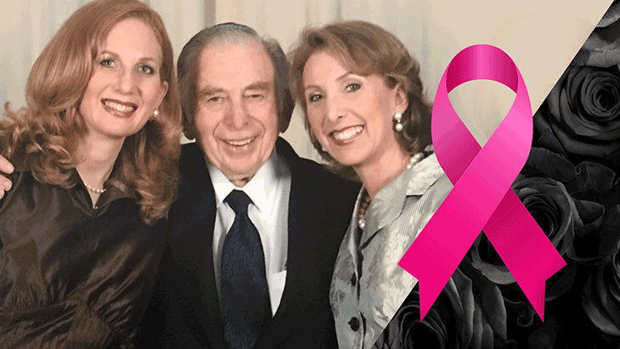
My journey into the uncharted territory of cancer.

In 2005, my mother is diagnosed with pancreatic cancer and passes away 18 months later. It feels as though the sun itself has slipped right out of the sky.
Here we all are – my siblings and my father – trying to move through the world underneath this new veil of darkness.
Then, just two years later my brother, the youngest of us all, is diagnosed with a brain tumor that keeps him sick for three grueling years, and ultimately takes his life in August 2011, leaving a wife who is like a sister to us and three young children totally heartbroken. This back-to-back loss of our mother and brother is like a primal wound doused with all the salt of the world, a double whammy to the soul, a cruel joke doled out from the ethers that leaves two giant gaping holes in our hearts.
Besides the pain of such tremendous loss, there is the logistical fallout, especially for our father who planned his entire life as if he would be the first to go, leaving my brother as the de facto man of the house to ultimately lead the charge. Caught in this tangle of sorrow and challenge, my dad’s own health begins to decline, and two years later, in December 2013, we lose him, too.
We are three sisters left in the world, parentless and brotherless, setting off on a new chapter of our lives, traveling back and forth from Miami to Peru, where we were born, trying to reconcile our piercing grief with our attempt to understand and manage our family business. It's incredibly difficult, but at least the three of us are together, healthy, with our own respective families, and we are determined to move forward in our lives.

A Small Lump
During the heat of one August, eight months after my father passed away, I feel a pain beneath my right breast, right where the bra wire sits. It must be a bruise, I think to myself, but don’t recall bumping into anything or hurting myself in any way. And since I’ve just had an uneventful mammogram in May, I know there’s nothing to really worry about.
Nonetheless, I go to the doctor just to be safe, and she does a sonogram. “I don’t see anything. You probably just over-stretched a muscle,” she says, and sends me on my way. So, I travel to Peru with my sisters, but ten days later when I come back on a Friday, the mystery pain is still there, except now it isn’t simply pain – it’s a little lump.
That very Monday I return to the doctor, hoping (praying) that she’ll still determine it’s nothing. “What are you doing back here?” she asks, puzzled.
“I just want to get a final verdict on this so that I don’t obsess about it, and then I promise I’ll drop it,” I say.
“Okay, let’s have a look.” She proceeds to examine me, using the sonogram probe to follow my finger to the spot on my right breast, and stops, the expression on her face changing abruptly from calm to concern, like a sunny day in the tropics that suddenly goes dark. “Oh my G-d. I see it...and I don’t like it.”
“Oh my G-d. I see it...and I don’t like it.” Eleven words that change everything.
She takes me into another room for a needle biopsy. At noon the next day she calls to confirm what we’d both feared but couldn’t believe – cancer – and tells me to come back to the office to speak face to face. With my husband Saby beside me, the two of us sit across from her desk, dumbfounded, a flurry of questions flying over us like specters. How could this be happening now if I had a clean mammogram in May? How could the sonogram of ten days ago not have sounded an alarm?
She explains that the lump is positioned in a very difficult location to spot, and we both come to realize that for better or worse, it was my bullishness about the weird little pain that has brought us to this moment.

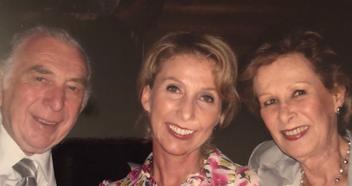
My parents and me

The doctor calls her colleague at Baptist Hospital, who will conduct a lumpectomy two days later. But before that surgery I am advised to consider waiting for the results of a genetic screening to determine if I am BRCA positive, an inherited mutation in one of my genes, which would mean I have a much higher risk of developing breast cancer or ovarian cancer compared with someone who doesn't have the mutation. Knowing that will help dictate the nature of the surgery, and potentially mitigate the need for a second, more elaborate surgery.
But regardless what the genetic screening might reveal, I don’t want to have to wait three weeks for a test result in order to have the lump removed. I want it out of my body now. Sure, I’ll do the testing, but I won’t wait around. If I have to have a second surgery down the line, so be it – but in this moment, the lumpectomy feels like an urgency, and I waste no time in having it done.

Triple Negative
Two long weeks later, the lumpectomy results come back – the bad news: it’s “Triple Negative,” a type of breast cancer that is aggressive and difficult to treat; the good news, it’s only stage one. Shortly after, I also receive the results of the genetic test and learn that I am BRCA1 positive.
I could have never imagined a medical reality for myself that would include both stage one breast cancer and BRCA1 positive, however I have no choice but to launch myself into a mode of unflinching action, because as difficult as it is to confront this new reality, I also intuitively understand that having an optimistic attitude is going to be the very thing to gently anesthetize this situation – for myself, my husband and my children (for whom I still have to be a mother no matter what goes on), and everyone around me.
With the recent loss of both our parents as well as our dear brother, the prospect of telling my sisters that now I, too, have cancer feels as devastating as the illness itself. So, I take it upon myself to hold it together, to radiate hope and determination, if only for their sake. I know this show of strength and courage will hold everyone together. I know that adding a positive outlook to this very troubling moment will be like adding sunlight to a wilting plant. And that staying hopeful will basically be rooting for myself, and re-rooting myself.
In addition to starting chemotherapy, I start to explore the protocols for a double mastectomy, because I learn that when you're BRCA1 positive your chances of having breast cancer again increase by almost 80%. And I don’t want to live my whole life having to do an MRI every three to six months; I might as well just get rid of it. Here’s that bullishness again, a gift for which I thank G-d. My action-trigger. My go-mode. My love for life.

How Can Things Possibly Get Worse?
Because I am BRCA 1 positive and at an increased risk of developing cancer, the doctors tell me I should consider having my ovaries removed. “When you’re finished with your chemo; when you’re finished with your double mastectomy; when you’re finished with your reconstruction, and when you're well into your recovery, you might want to remove your ovaries as a precaution.” But yet again, something inside tells me not to wait, a sense of urgency from somewhere deep in me that knows to perk up and take the wheel.
I’d rather have the option to avoid a whole other round of chemotherapy should anything turn up, and simply bid farewell to my ovaries right now. So, I make an appointment with a gynecologic oncologist in Hollywood, Florida, who will see me in a week. Around this time I also meet with Dr. Elisa Krill Jackson, a breast cancer oncologist, whom I like very much and bring onto my team, and who right away suggests what I was already planning to do, “Remove your ovaries before we start chemo...just in case…”
“Thank G-d,” I say. “That is exactly what my instinct was telling me to do...I already have an appointment with the surgeon.”
One week later I am under the knife to remove my ovaries, a relatively simple outpatient procedure that I’ve chosen to undergo mostly for precautionary reasons. When the doctor, in the midst of the surgery, finds cancerous tumors in not one, but both of my ovaries, his jaw literally drops.
What began as a seemingly innocuous little mystery pain in my right breast has now turned into a full-throttle, life-or-death medical obstacle course.

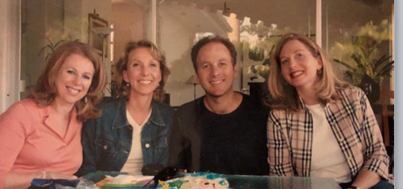
Four siblings

I’m diagnosed with Ovarian Cancer, Stage 1C. And before I can make sense of any of it, I realize that what began as a seemingly innocuous little mystery pain in my right breast has now turned into a full-throttle, life-or-death medical obstacle course, with the notion of it’s probably nothing now ringing siren-like in my brain as it’s actually everything. Instead of allowing myself to free-all into a state of panic and dread, right away I start to visualize myself as a successful survivor, ready to do anything the doctors suggest, prepared to be the best soldier in the battle of my own survival.
My oncologist prescribes six rounds of chemotherapy for about four months, during which I fare pretty well, all things considered. Then I have a double mastectomy and once I recover from that, I am able to finally have the reconstruction done. Thankfully, my breasts have been fine ever since.

Have You Checked Your Pancreas Today?
But in August of 2018, four years after my diagnosis of breast and ovarian cancers, one year short of the five-year milestone for cancer survivors, another discovery floats to the surface, another sliver of seemingly random circumstance that lights another match. I learn that in addition to my mother having pancreatic cancer, two of her first cousins have been diagnosed with it – and since I know I am BRCA1 positive, inevitably my inner alarm goes off again and I decide to get checked, just to be safe.
I talk to my oncologist and she agrees it is a good idea to get a baseline checkup of my pancreas and calls up a specialist for an ultrasonic endoscopy, but the earliest appointment they can give me is in December, five months away. Okay, I think to myself, I’m not in a rush. I’m just being proactive because of what I learned about the cousins. In December, the doctor’s office calls and they push my appointment to February. Fine, no rush.
Finally, February comes and I see the doctor. He decides to start with an MRI, and as if my luck was etched from the very essence of worst possible odds, he finds a mass in my pancreas.

Had No Prior Symptoms
I had no prior symptoms – nothing. This precautionary test was yet another action taken at the behest of that nagging sense of urgency that kept telling me, throughout the months and years, to keep taking action.
“This mass looks benign,” the doctor tells me when I go back in to discuss the follow-up. “I recommend we simply follow up with another MRI.”
“Doctor, with all due respect, does the mass belong there?” I ask, relieved about his initial assessment, but not enough to stop pushing the issue. “Because if it doesn’t belong there, benign or not, I don’t want it there. I want to have it removed.”
“Why would you do that?” he asks.
“Because that’s how I am,” I reply, the survivorship in me like the captain of a vessel.
The next week I consult with a surgeon. We sit in front of the screen and go through the whole thing all over again. “Yes, I see it,” he says. “It’s here. I have read all about your history, but I have to tell you, this mass indeed looks benign,” and he tries to give me an elaborate explanation of why he thinks this is so.
“I don’t care,” I say. “I don’t want it there.”
“Are you sure?” he asks. “I don't want you to wake up from surgery to discover that I had to take a significant part of your perfectly good pancreas when I really didn’t have to.”
“Yes, I’m sure. Take it out.”
“Okay I will do it, but then I want you to have a biopsy before I do the surgery.”
“Fine,” I said, intent on just moving the thing along.
I undergo the ultrasonic endoscopy for the biopsy, and while I am under anesthesia, much to the doctors’ surprise, he discovers that the mass in my pancreas is in fact cancer. Right in the midst of the procedure, he starts calling around furiously: he calls the lab in the hospital, he calls my oncologist. He just can't believe it. He calls everybody that knows me because he cannot believe that he’s going to have to give me this news when I wake up. I am formally diagnosed with early stage adenocarcinoma pancreatic cancer.

There’s No Time to Waste
I schedule the laparoscopic surgery immediately with the surgeon who requested the biopsy, as there’s no time to waste. But given all the prior uncertainty around the mass, and after receiving friendly strong advice from people knowledgeable on pancreatic cancer, I postpone the surgery and decide to get a second opinion. One of my cousins with pancreatic cancer lives in Washington DC and had his surgery with one of the best surgeons in the field for this type of operation. I have a consultation with him at Johns Hopkins Hospital and decide to have the surgery there.
On March 8, 2019, the day of the surgery, as I sit in my gown with the IV needle locked and loaded in my arm, the doctor looks at me seriously and says, “Listen, we’ve looked very carefully at the other CT scans,” because by then I have had a PET scan in Miami and John Hopkins, “and they didn’t seem to see anything else. But now I’m hearing that the radiologist here sees a lesion in your liver that I have to check just in case. If this lesion happens to be anything, I will abort the surgery and we'll close you up, because it will be more important that you start with chemo than to wait for the recovery, which is a minimum of eight weeks.”
“Okay,” I said. “I understand,” now accustomed to worst-case-scenarios, but terrified that this time it would be even worse than that. And when I wake up from the surgery, I learn that the cancer has in fact metastasized to my liver, the news of which is told to me by my husband, my sister and brother-in-law, who are there with me and have had a chance to digest the news while I was under. I have gone from having nothing, to a benign mass, to early detection and finally to Stage 4 pancreatic cancer. “Go do your chemo,” the doctor says. “If you respond well, come back to me and I promise I’ll do your surgery.” Under standard of care, for the most part surgeons do not operate patients with stage IV pancreatic cancer – which makes his remark extremely relevant.

Hitting Rock Bottom
People always talk about the proverbial rock bottom. This is, without a doubt, mine. A low point so desperately low that I feel swallowed whole by the possibility of moving forward. It is a tangle of sadness and fear that crushes me emotionally, to the extent that I cannot even recognize myself. A despair. A hopeless panic. A deep knowing of the fact that I lost my own mother to pancreatic cancer. Inasmuch as I have been able to take the previous diagnoses with more optimism, this time it feels different.
It is a tangle of sadness and fear that crushes me emotionally, to the extent that I cannot even recognize myself. A despair. A hopeless panic.
About a week later I get back to Miami and immediately begin my twelve rounds of chemotherapy. There are two main protocols for pancreatic cancer, and since I’d previously undergone chemo, my doctors want to hone in on the right protocol and decide by identifying which medication has the most virgin effect on my body.

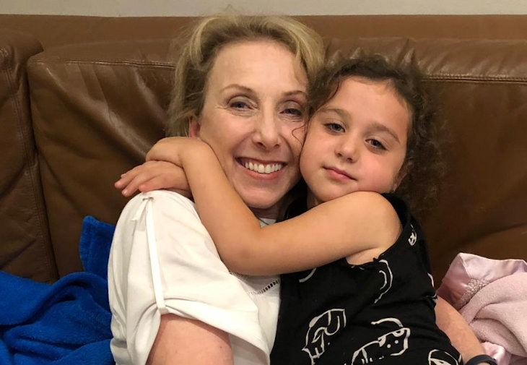Embracing life

My emotional landscape is bleak and the logistics of my treatment are intense. But along with all the medicine and medical intensity comes something else. The same part of me that knew back when I had breast cancer that optimism would be the key to getting through this mess now starts to see that it’s this very optimism that has to not only kick in – but really switch into a higher gear.
One day, with the help of G-d, about two weeks after my first treatment, I wake up from this place of hopeless dread and desperately start seeking for tools to become myself again, the tremendous mind over body attitude I impressed myself with in my previous fight and consciously make the choice to activate every single one of my resources to get my mind right – to fight for my life.
I reconnect with G-d, I look around at my family and friends, I start listening to everyone's advice, I open my heart to the love and prayers coming my way and begin to feel tremendously grateful in the midst of some very dark days. And all of a sudden, I find the strength to do my part. It may be rock bottom, but I refuse to have a crash landing.

Belief as Biology
Suffering is part and parcel of the life experience. Of course, we have joy and rapture, but not without the innate flipside of pain and misery; of feelings so catastrophic that they feel like little deaths themselves. Yes, suffering is an unequivocal universality – but it is our management of suffering that ultimately charts the course of the experience. Is cancer a tragedy and a crisis? Well, that’s only one side of the coin because it becomes clear that for me cancer is also now a window into self-optimization, an anatomical education, a testament to the deep, rooting love of my husband and family, and a personal call to rise.
And somehow, through the blur of patient exhaustion, the most important lesson starts to become revealed: that if I am to be a soldier in the battle for my survival, it truly is my attitude that will have to rise up and serve as the great general of this brigade. So, I confront my attitude like a coach would their star player: Come on, you. You are a warrior. You’ve got this, I say to it. You can shine 7like the sun no matter how dark it gets, I tell it. And it is with that level of radical optimism that I walk into the unknown.
My mantra becomes: the only thing I have control over is my attitude. Because if I allow the first line of my thoughts to be consumed by medical statistics and the doctors’ opinions about my condition, my own mind will be the first obstacle to my cure and recovery. So, I’ll need tools as well as fellow cancer patients with whom to talk and share, empathetic sounding boards that can be at once a safe place to vent, cry, laugh and lift up.
Around this time, I become aware of a WhatsApp group formed by members of my family called “Team Rosi.” It includes all kinds of individuals – from super close friends and relatives, acquaintances from my past and everything in between – who have chosen to participate in prayers for my health by each one doing their little part to recite the Book of Psalms in its entirety as a group, every single day. Like a digital wave of energy that colors each morning with hope, rooted to the divine words of some of our most beautiful ancient texts. This collective gesture of hope manifested in this sacred expression feeds my soul with forward momentum. Their belief carries me up and their intention propels me forward.
With the help, guidance and support of so many close friends and relatives, I keep building my survivorship toolkit, physically, spiritually and emotionally: and as I move through the challenges, I choose grit instead of grief. In the place of pity, I opt for purpose. I am determined to remain active, not reactive. I start to live in a constant mode of self-optimization, which I assume is triggered by my desperate wish to live, to be with my family, to see my grandchildren grow, to fulfill so many future plans that I share with my husband.
I understand that if I want my chemo to work, I have to be my own cheerleading squad. I have to rally the forces of my whole person – mind, body and soul – to provide the place where God can make the medicine prevail. I have to step in and be the vehicle that sends the perfect messages to each and every one of my cells.

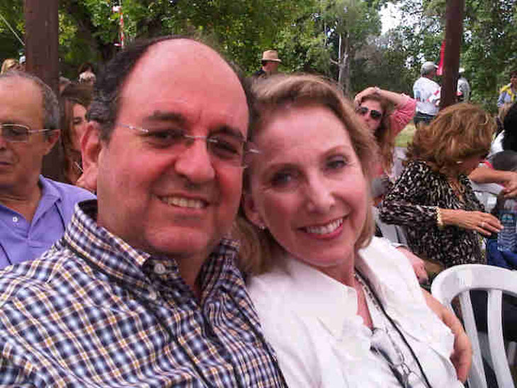My beloved husband, Saby, and me

As I move through the challenges, I choose grit instead of grief. In the place of pity, I opt for purpose.
I begin to own my healing and recovery as a matter of personal duty – it becomes the engine of my purpose. I don’t count on the medicine alone to bring me health. Instead I transform my life into a living kind of medicine. For starters, I am blessed to be surrounded with positive, loving and supportive people which I believe is the immediate forcefield one needs for this type of battle.
In my husband, Saby, I find resilience and direction; in my children, motivation; and in the eyes of my grandchildren, hope. The force of this love is so strong that it powerfully mobilizes my wellness to the very top of my priorities, holding there in its powerful embrace. When I feel down, a smile from one of these loved ones is like fresh water to a bloom. Their belief in me becomes my belief in me.

“Man’s Search for Meaning” by Viktor Frankel
I read The Choice by Dr. Edith Eva Eger, a holocaust survivor and renowned clinical psychologist who invites the reader to, as the book’s subhead very well notes, embrace the possible. To extract wisdom from trauma, and hope from belief. I also read Man’s Search for Meaning by Viktor Frankel, the Holocaust survivor who, in this seminal work, outlines his healing psychotherapeutic method that involves homing in on a purpose in life for which to feel positive, and then visualizing that outcome.
“Ultimately, man should not ask what the meaning of his life is, but rather must recognize that it is he who is asked,” Frankel wrote. “In a word, each man is questioned by life; and he can only answer to life by answering for his own life; to life he can only respond by being responsible.”
My body, despite itself, indeed becomes my temple. I feed it with the kinds of nourishing foods that I know will optimize my cells. And just as I feed my brain with healing content, I likewise nourish my spirit and body. I do my daily prayers, read Psalms and meditate.
But the highest level of my healing manifests as service, as I talk to cancer patients that reach out to me and I am able to be a lighthouse for them in the throes of the storm as others have been for me. I know that by participating actively in the empowerment of other patients, I empower myself. In giving of myself, I fill myself up.
As I begin to feel more positive, active and optimistic about my future the truth about wellness starts to become abundantly clear: doctors can only do one part of the job – the patient has to do the rest. Well, the patient and their support system, which in my case is the team of my family, community and my beautiful circle of friends whose overwhelming amount of prayers fueled me with love and strength to keep moving forward.

We Are the Captains of Our Individual Healing
Every oncologist I see during my chemotherapy sessions tell me to not even think about the surgery at the end of my treatment. The negativity is so palpable that I begin to doubt what the doctor at Johns Hopkins promised.
So, in July, at around the eighth round of chemo, I return to Johns Hopkins perhaps a bit prematurely, hellbent on having that surgery done. The doctor confirms that he will perform it because I am responding well to the treatment, and we decide to wait to finish all twelve rounds of chemo.
After seven incredibly intense months of chemo, exhaustion, and a lingering angst over the ultimate fate of this forthcoming surgery, I finally see the surgeon again in December of 2019. “I’m going to go in. And no matter what I see this time, I won’t abort the surgery,” he says. He goes in and checks everything, using the same surgical cut that I’d already experienced, starting at my breast and going all the way to my belly button. He removes the tumor at the tail of my pancreas, assesses my liver, removes my spleen, and he takes out 33 lymph nodes, out of which two are positive.

Needed Eight Weeks to Recover from the Surgery
It takes me about eight weeks to recover from that surgery, after which my whole medical team assesses my pathology reports and status – which appears to be cancer free at the moment – and they agree that I should start a maintenance program taking a pill form of chemo, which is a PARP inhibitor that was discovered in Israel and approved by the FDA in December 2019 to treat patients who are BRCA positive, have late stage pancreatic cancer and responded well to chemotherapy treatment .
I consult with a doctor at Sloan Kettering who I’d seen before, and she confirms: “You have three options: do nothing, do chemo or take the pills.” But at the risk of redundancy, and now obsessed with second opinions, I consult with a doctor at Bruckner Oncology in the Bronx, whom I’d also seen before, and he says:
“I hate to say this, but I completely disagree. I think you should do six more months of chemo again and then take the pills.” This makes a lot of sense to me, so I jump on it. I know I won't be able to sleep at night until I have a final cleanup, and while no one wants to have to undergo more chemo, I know I have to keep doing this. Given the disagreement between my various doctors, I make a Solomonic decision: I go with the assessment of the Bronx doctor, but I do the type of chemo advised by my doctor in Miami. After four rounds of chemo, I begin the maintenance treatments with the PARP inhibitor pills.
It begins to dawn on me that no matter the caliber of institutions where you consult – from the likes of John Hopkins to Sloan Kettering – in the end, you are the sole conductor of your own healing, the one who lays the groundwork for possibility and hope. Some might say, for example, that it was overkill for me to consult with three different doctors after my surgery, but after the trajectory of my experience, this Cirque-du-Soleil-like experience of cancer, I operate with a certain amount of PTSD (Post Traumatic Stress Disorder), an innate caution and hyper-awareness of my body, which I would argue has also been the thing that’s kept me alive. As I see it, this hyper-awareness fuels the intentionality with which my healing continues to be possible. It’s the secret sauce of my stamina.

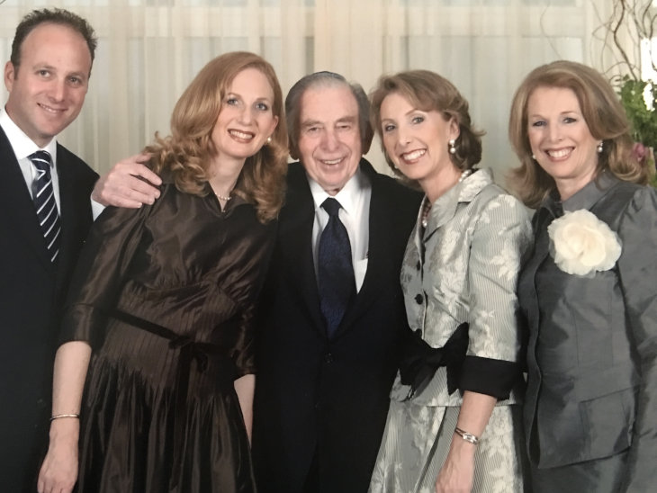My father zt"l, my two sisters, me (second right) and my brother zt"l

I don’t know what the future has in store for me, but I do know that medicine comes in many forms, that maybe by working with what I’ll call one’s personal frequency, we can somehow guide and assist our own healing. Modalities such as yoga, and spiritual practices such as regular prayer are obvious ways to raise one’s frequency.
Laughter, too, is an easy and reliable tool. It seems to be that when we laugh we alter the biochemistry in our body, loosening the debris of pain and hardship from our soul and instead filling it with lightness and joy. Whether it’s watching funny films, which I could do more of, or even taking a laughter yoga class, which I still plan to do – relaxing into the simple pleasure of a good laugh is exactly the type of surrender that gives space for real healing.
Another critical nuance of healing is honesty, unconditional transparency. For me, it means never keeping secrets about my illness, or requesting that from my family which would only add to the toxicity of the situation. It would darken an already dark scenario. I choose full disclosure, openness and acceptance. I do not stifle the fact of the illness or my feelings around it, and instead I make it a point to talk about things, to vent and ideally to help others like me who might be going through similar challenges.

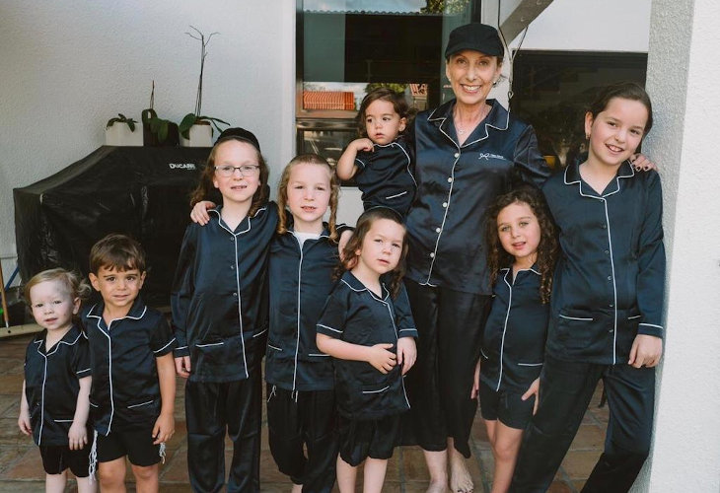My grandchildren and me

Having a positive attitude does not mean negating what I am going through, but rather accepting my reality and making the best of it.
I do have difficult days where I have to deal with the dark thoughts and emotions that surface, and I allow myself to linger in that sad and depressing state for some time, but with the intention of sorting out my thoughts and feelings and exiting from that slump.
Having a positive attitude does not mean negating what I am going through, but rather accepting my reality and making the best of it. I live my life in the present while at the same time have projects and plans that keep me looking toward a bright healthy future. I strive to live my days without a sense of entitlement and desire for perfection, but rather with joy and thankfulness. I believe that a terrible diagnosis does not have to close doors. From its darkness comes the light of opportunity and self-growth. Isn’t it amazing to see the beauty of life somehow hidden in its flaws?

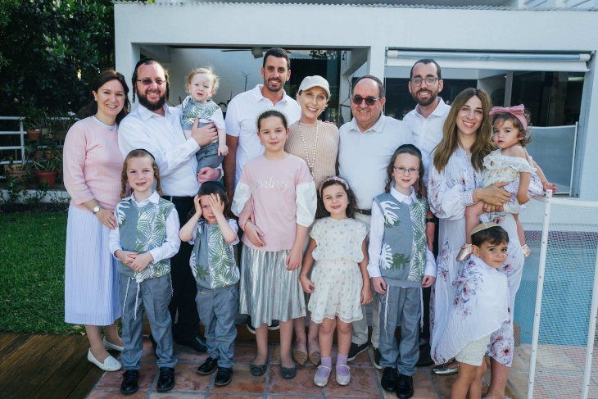Our immediate family

Do I ask G-d why? Perhaps. But what I really ask is, “What does G-d want from me? Where should I focus? How should I spend my time? What changes do I need to do? What good has to come from all this?" And as I untangle these answers, there has been a lot of learning and personal growth.
I live everyday with an appreciation that is hard to describe. God has been, is and will always be my inspiration and my companion. In every prayer and blessing I am acknowledging God’s presence in this world and empowering myself to not be self-centered as I take responsibility and make valuable choices that affect my future.
And as I accept my challenges I try not to obsess about the outcome of my decisions because I know G-d is there holding my hand as my partner in my unfolding reality. So, when I wake up every morning and the first thing I say is the Jewish prayer Modeh Ani, “I give thanks before you, King living and eternal, for you have returned within me my soul with compassion – abundant in your faithfulness,” I am verbally acknowledging G-d’s gift of restoring and entrusting my soul back to me morning after morning, and it comes out so sincere, from a place so deep inside of me I can almost touch the gratefulness... I would dare say it is the highlight of my day and the closest I ever get to G-d.

Faith Appears as a Sort of Courage
Faith appears as a sort of courage to live with the messy fluid uncertainty.
And with each day I re-learn that faith is not the same as certainty. Instead, faith appears as a sort of courage to live with the messy fluid uncertainty. Faith does not mean having the answers – it means having the courage to ask the questions. It means cozying up to the unknown, staring into its ugly vastness and filling it with all the love in your heart.
With this wellspring love, I am able to face the challenges that bubble up. Throughout the journey there has been a ripple effect of positivity. A domino flow of initiative. A causal nexus of progress, and a chain reaction of self-advocacy, radical optimism and unflinching survivorship. What once felt like concentric circles of pain and problems have become ongoing reverberations of promise and purpose. The fear of not being here has deepened my sense of presence. The series of unknowns has sharpened the love I feel toward what I do know. The feeling of isolation made me feel closer to my people. And the sense of hopelessness has, in time, built up my determination into the rock on which I can build the rest of my life.
And so, when I light my candles on the eve of every Shabbat, and spend those sacred moments in connection with the Divine, I know that my life has not been a vicious circle at all – but rather a beautiful and complex infinity of hope.

Reprinted from the March 13, 2021 website of Aish.com

